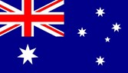 | Australia
Australia invested 90% of its bilateral and regional aid in Indo-Pacific region for promoting prosperity, reducing poverty, and enhancing stability in the world. Australia had included Nepal in its development cooperation program in 1979.
Bilateral Relations
Nepal and Australia established diplomatic relations on 15 February 1960. Australia opened its residential Embassy in Kathmandu at the level of Chargé d’Affaires in 1984, which was subsequently upgraded to the Ambassadorial Level in 1986.
Nepal established its residential Embassy in Canberra in March 2007 which was formally inaugurated in September 2007. In addition, Nepal also has Honorary Consulates General/Consulates in Brisbane, Melbourne, Sydney, Perth and Adelaide.
On 20 May 2003, the Governments of Nepal (GoN) and Australia concluded a Memorandum of Understanding (MoU) on Development Cooperation. Australia maintains its Australian Embassy in Bansbari, Kathmandu. HE Felicity Volk is the Ambassador to Nepal at present (November 2021).
Development Cooperation
In 2020 Nepal and Australia celebrated 60 years of diplomatic relationship based on long standing history and cordial support although Australia had included Nepal in its development cooperation program in 1979.
At that historical time, Nepal received assistance from Australia in areas of forestry, livestock development and manpower training. The MoU agreed in May 2003 between the GoN and the Government of Australia (GoA) provides strong grounds for cooperation in development programs in line with Nepal’s goals of economic development.
Australia also supports the World Bank-managed multi-donor trust fund designed to strengthen the Government of Nepal’s public financial management institutions.
The Australian Volunteer Program is currently comprised of the Australian Volunteers for International Development (AVID). Volunteers work with local people to share knowledge and develop sustainable skills. Australia Awards both long-term scholarships and short courses in line with Nepal’s development priorities.
Australian Major Support to Nepal by Sector
The top five sectors of Australian support to Nepal during the last five-year period are:
- Policy and strategic,
- Health,
- Drinking water,
- Education,
- Livelihoods, etc.
Policy and strategic areas have got the highest level of support during the fiscal year 2020/21. Likewise, education and health sectors have got important level of support throughout the five-year period.

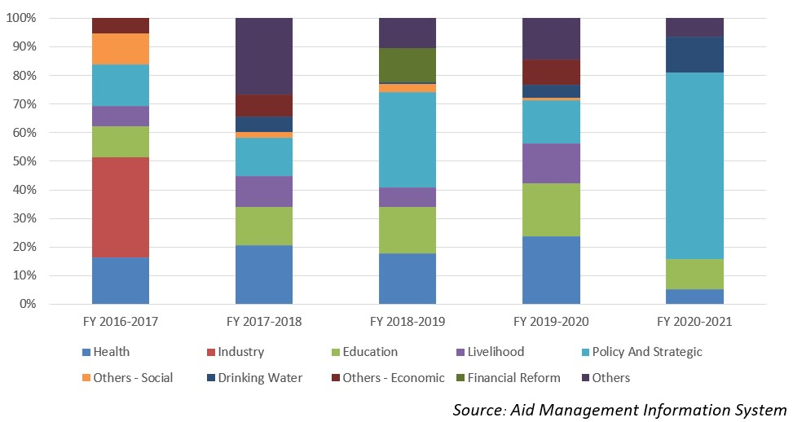
Australian Disbursement to Nepal during FYs 2016/17-2020/21 (in US$)
Over the last five-year period starting from FY 2016/17 to 2020/21, the Australian government has agreed to provide more than US$ 75.75 million. Similarly, it has disbursed US $ 73.55 million of ODA to Nepal in this period. However, there is not direct relationship between the year and the agreement amount the disbursement amount.
The table below reveals that the highest level of agreement and disbursement took place in fiscal year 2017/18. The lowest level of disbursement was made in fiscal year 2019/20, of an amount of US $ 14 million.
Fiscal Year | Agreement Amount | Disbursement
2016/17 | 11,657,170 | 18,559,851
2017/18 | 23,633,379 | 20,884,676
2018/19 | 20,503,863 | 15,000,392
2019/20 | 13,659,270 | 13,975,955
2020/21 | 6,294,363 | 5,137,227
Source: Aid Management Information System
Note: The Agreement Amount is not comparable with disbursement because disbursement here accounts for disbursement of each fiscal year only, whereas Agreement Amount refers to the project cost over the period (not only for single fiscal year but also beyond).
Coincidently, the lowest level of Australian aid commitment was supported by the lowest level of disbursement in fiscal year 2020/21. The average annual Australian disbursment comes to US $ 14.7 million over the five year period.
Development Cooperation Strategy
On 20 May 2003, the Governments of Nepal (GoN) and Australia concluded a Memorandum of Understanding (MoU) on Development Cooperation. Australia is committed to strengthening governance and enhancing emergency preparedness, with a focus on supporting local communities and those most vulnerable. Australian development programs in Nepal are focused on 3 pillars: health security, stability and economic recovery.
Updated
Social Sector/ IECCDJanuary 2022

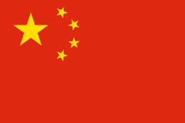 | China
Chinese aid, according to the first White Paper (2011), is a model with its own characteristics and falls under the category of South-South Cooperation. The first “Agreement between China and Nepal on Economic Aid” was signed in October 1956. From the mid-60s, the Chinese Government has been pledging grant assistance to the Government of Nepal under the Economic and Technical Cooperation Program.
Bilateral Relations
The history of Nepal-China relations can be traced back to the 5th century; modern day diplomatic relations were established on 1 August 1955. The People’s Republic of China opened its residential Embassy in Kathmandu in July 1960 and Nepal opened its residential Embassy in Beijing in September 1961. At present, Ms. Hou Yanqi is the Chinese Ambassador to Nepal.
Development Cooperation
Nepal-China economic cooperation was initiated with the formalization of bilateral relations in the 1950’s. The first “Agreement between China and Nepal on Economic Aid” was signed in October 1956. Since then, China has been providing financial and technical assistance to Nepal, which has greatly contributed to Nepal’s economic development. From the mid-60s, the Chinese Government has been pledging grant assistance to the Government of Nepal under the Economic and Technical Cooperation Program.
China has supported the construction of major roads in Nepal, including Araniko Highway, Kathmandu Ring Road, Syaphrubesi-Rasuwagadi Highway. China has supported the Sunkoshi Hydroelectricity Plant, the Sunkoshi-Kathmandu Electricity Transmission line and Upper Trishuli 3A Hydroelectric Project.
China has been supporting the post-earthquake reconstruction projects in Nepal. Out of 25 Reconstruction projects, 12 projects were completed and the rest are in ongoing process.
The Chinese cooperation in the health sector includes the establishment of B.P. Koirala Memorial Cancer Hospital in Bharatpur, the Civil Service Hospital in Kathmandu and the National Ayurveda Research and Training Centre.
The major on-going projects of Chinese support are: Pokhara Regional International Airport, the Public School Recovery Projects in Rasuwa and in Dolokha, Nine-storied Basantapur Tower Restoration Project at Durbar Square of Kathmandu, etc.
The signing of a Memorandum of Understanding (MoU) on cooperation under the Belt and Road Initiative (BRI) on 12 May 2017 in Kathmandu, has opened up new avenues for bilateral cooperation including upgrading its vital infrastructures, improving cross-border connectivity with China and enhancing people-to-people relations.
China’s Major Support to Nepal by Sector
The five major sectors of China’s support to Nepal during the last five-year period are:
- Energy development
- Economic and Technical cooperation
- Air transportation
- Reconstruction
- Emergency COVID-19 Support
In fiscal year 2020/21 the energy sector was the top priority sector of the Chinese support whereas in fiscal year 2019/20 the focus was on air transportation sector.
Chinese aid disbursement during FY 2016/17 to 2020/21
Over the last five-year period from FY 2016/17 to FY 2020/21 a total of US$ 380.45 million of aid was disbursed to Nepal by China. The volume of disbursement, was the highest in fiscal year 2018/19 totaling US$ 150.37 million than the annual average disbursement of the five-year period.
S.N. | Fiscal Year | Aid Disbursement (in US$) for Different Projects  (Grant, Interest-free loan & Concessional loan)
1. | 2016/17 | 41,244,254
2. | 2017/18 | 58,727,078
3. | 2018/19 | 150,370,540
4. | 2019/20 | 93,026,787
5. | 2020/21 | 37,081,650
(Source: Consolidation with Embassy of the People’s Republic of China)

Exim Bank funded projects (FY 2016/17 to FY 20/21)
S.N. | Project Name | Remarks
1 | Procurement of Aircrafts from China (1 MA 60 3 Y12E) | Completed
2 | Pokhara Regional International Airport | Ongoing
3 | Upper Trishuli 3A - Kathmandu 220kV Transmission Line and 132kV Line Bay Extension Works Project | Completed
4 | Upper Trishuli 3A Hydroelectric Project | Completed

Development Cooperation Strategy
Nepal and China signed four separate bilateral Agreements on Economic and Technical Cooperation on 23 December 2016, 15 August 2017, 21 June 2018, 29 April 2019 and 26 March 2022 for providing Chinese grant each year to Nepal for implementing post-disaster reconstruction projects, livelihood projects and other mutually agreed projects. The Chinese financial and technical assistance to Nepal has contributed to Nepal’s development efforts in the areas of infrastructure building, industrialization process, human resources development, health, education, water resources and sports etc.
Updated
Governance Sector/ IECCD
July 2022

Finland
Finland’s international Development Policy aims to support developing countries’ efforts to eradicate poverty and inequality. Nepal was among one of the ten biggest partner countries as a recipient of the funds in 2016.
Bilateral Relations
Nepal and Finland established diplomatic relations on 21 September 1974. The Finnish Embassy was opened in Kathmandu at the Chargé d’Affaires level in 1992. The Embassy was upgraded with the appointment of its Ambassador from September 2011.
Nepal has no residential Embassy in Helsinki. The Nepalese Embassy in Copenhagen is concurrently accredited to Finland. At present Mr. Pertti Anttinen is Finland’s Ambassador to Nepal (November 2021).
Development Cooperation
Finnish cooperation with Nepal commenced in 1982 with grant assistance of 6,000 MT of chemical fertilizers. Presently Nepal is one of Finland’s primary long-term development partner countries.
The Finnish development program in Nepal focused mainly on energy, forestry and water resources. Nepal has also received assistance from Finland for the detailed engineering design of the Kali Gandaki Hydropower Project, rural electrification, and the multi-fuel diesel plant.
According to the Country Strategy for Development Cooperation Nepal 2016-2019, Finland’s focus of support to Nepal is on access to clean drinking water and sanitation, developing education, and improving the influence of women and other vulnerable groups.
More recently, Finnish development cooperation has shifted towards a focus on alleviation of poverty, environmentally sustainable development, disaster risk reduction, and the promotion of democracy, human rights and a participatory system of governance.
Finnish Major Support to Nepal by Sector
Major sectors of economy supported by the Finnish aid during the last five years are:
- Education
- Local Development
- Women, Children and Social Welfare
- Labor
- General Administration
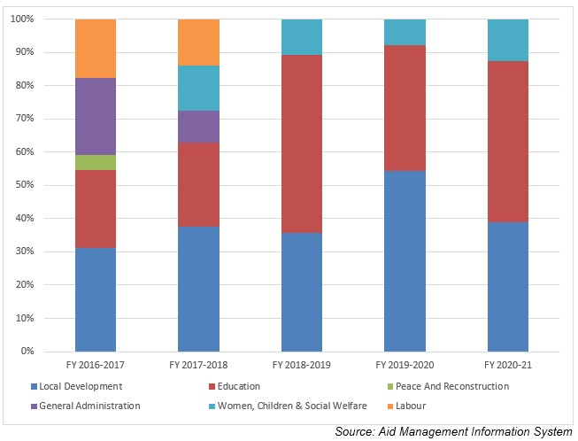
Finnish Aid Disbursement during FYs 2016/17 – 2020/21 (in US $)
Over the last five year period beginning from FY 2016/17 to FY 2020/21, a total of over US$ 59.0 million of Finnish ODA was disbursed to Nepal. The highest level of aid disbursement from Finnish Government was made in fiscal year 2019/20 amounting to US $ 13.9 million.
The average annual disbursement of the last five year period is US $11.8 million. During the last five year period Finland agreed to provide US $ 12.0 million to Nepal. The least amount of agreement was made of an amount of US $ 10 thousand in fiscal year 2017/18 whereas no events of agreement took place in fiscal year 2019/20. There is no direct relationship between the fiscal year, agreement amount and the disbursement amount.
Fiscal Year | Agreement Amount | Disbursement
2016/17 | 2,701,810 | 9,520,502
2017/18 | 10,000 | 12,779,120
2018/19 | 4,562,000 | 10,615,868
2019/20 | 0 | 13,910,781
2020/21 | 4,825,920 | 12,202,386
Source:Aid Management Information System
Note: The Agreement Amount is not comparable with disbursement because disbursement here accounts for disbursement of each fiscal year only, whereas Agreement Amount refers to the project cost over the period (not only for single fiscal year but also beyond).
Development Cooperation Strategy
Local development is one of the highest priority sectors of cooperation during the decade followed by the education sector. Finland’s contribution to RWSSP-WN II is 13.7 million euros for 2013-2019.
RVWRMP III (2016-2022) covers 10 districts in Provinces 6 and 7, aims to achieve universal access to basic WASH services, and improved livelihoods with the establishment of functional planning and implementation frameworks for all water users and livelihoods promotion in the project area.
Finland supports two programs: the School Sector Development Programme (SSDP) and the Technical Assistance for Soft Skills Development (TASS). Finland’s contribution to SSDP is 20 million euros for 2016-2020 and to TASS-project 1.7 million euros for 2016-2019.
Updated
Social Sector/ IECCDJanuary 2022

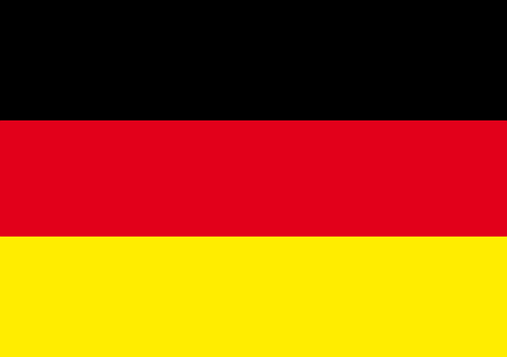 | Germany
The German economy is the largest in Europe and the fifth largest in the world. It is one of the top 5 countries in the world in terms of providing the highest amount of ODA (in absolute terms) in 2020.
Bilateral Relations
Diplomatic relations between the Government of Nepal and the Federal Republic of Germany were established in 1958. Germany has been maintaining an Embassy in Kathmandu since 1963. Dr. Thomas Prinz is the current German Ambassador to Nepal (November 2021). Similarly, Nepal has also maintained its Embassy in Berlin, Germany.
Development Cooperation
Nepal is an important partner country of German Development Cooperation. Over 50 years, Germany has contributed to the improvement of the lives of the Nepali people with support to the country’s political, economic, environmental and social development.
Since the commencement of bilateral development cooperation in 1961, a total of Euros 1.1 billion (US$ 1.3 billion) has been committed for bilateral projects. On behalf of BMZ, FC through KfW started in 1963, and TC through GIZ has been active since 1975, before the opening of its office in Kathmandu in 1979.
The priority areas of Nepal-German cooperation are sustainable economic development and trade, renewable energy and energy efficiency, and health. BMZ pursues a biennial commitment cycle in Nepal and allocates the amount of assistance accordingly. Furthermore, annual consultation and negotiation has remained as a Nepal-Germany joint mechanism for development cooperation.
Major Support of Germany to Nepal by Sector
The followings are the top five areas of German support to Nepal in the last five year period.
- Health
- Energy
- Alternative energy
- Urban Development
- Local Development
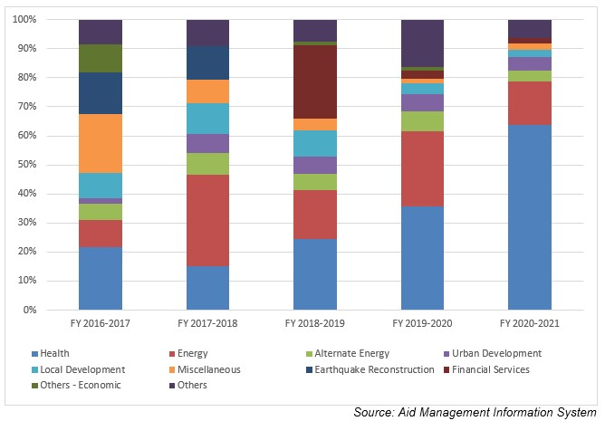
German Aid Disbursement during FYs 2016/17 – 2020/21 (in US $)
Over the last five-year beginning from FY 2016/17 to FY 2020/21, German Government has disbursed a total of US$ 147.3 million to Nepal. The highest disbursement, amounting to US$ 36.1 million was supported in FY 2018/19. While the lowest level of disbursement of US $ 25.0 million was made in fiscal year 2016/17, which is less than the average annual disbursement of US $ 29.4 million in the last five years.
In the last five year, German government has agreed to provide a sum of US $ 142.5 million to Nepal. The highest level of support commitment was made through the agreement made in fiscal year 2017/18. However, there is no direct relationship between the year of agreement, agreement amount and disbursed amount though disbursements are based on the agreed amount.
Fiscal Year | Agreement Amount | Disbursement
2016/17 | 10,812,544 | 25,058,320
2017/18 | 55,316,489 | 28,902,395
2018/19 | 37,255,306 | 36,115,866
2019/20 | 6,596,958 | 26,091,090
2020/21 | 32,574,960 | 31,170,430
Source: Aid Management Information System
Note: The Agreement Amount is not comparable with disbursement because disbursement here accounts for disbursement of each fiscal year only, whereas Agreement Amount refers to the project cost over the period (not only for single fiscal year but also beyond).
Development Cooperation Strategy
Health and the energy sectors are the top priority sector of cooperation of the German Government. Financial and Technical support to the Health Sector SWAp is on-going. Since 2007, Physikalisch Technische Bundesanstalt (PTB) has been active in Nepal.
The Energizing Development (TC) Project works to promote sustainable access to grid electrification under community management and ownership in rural areas as well as access to credit financing for off-grid micro hydropower development.
In addition, the German Embassy runs a small-scale project fund to various institutions and groups in Nepal. The Senior Expert Services (SES) supports projects with highly qualified retired experts who come to Nepal on short-term missions for voluntary activities.
Updated
Social Sector/ IECCDJanuary 2022

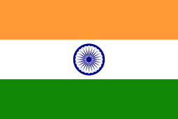 | India
India has emerged as one of the fastest growing major economies in the world. It has transformed itself into a provider of development aid with a global development cooperation approach.
Bilateral Relations
Diplomatic ties between India and Nepal were established on 13 June 1947 and subsequently, in December 1947 India established its Embassy in Nepal.
The 1950 India-Nepal Treaty of Peace and Friendship compels both nations to acknowledge and respect the complete sovereignty, territorial integrity and independence of each other.
India maintains its Embassy at Lainchour, Kathmandu and Nepal has its Embassy in New Delhi. At present Mr. Vinay Mohan Kwatra is the 25th Ambassador to Nepal (November 2021).
Development Cooperation
Since the 1950’s, India has been assisting Nepal in its quest for prosperity and economic development. India’s initial assistance was channeled through the India Aid Mission, which was established in 1954 to support development projects across Nepal.
The first highway to link the Kathmandu valley with the Terai region was constructed with Indian assistance in 1953. Also, Nepal’s first six airports — at Gaucher (1951), Simara (1964), Janakpur (1964), Bhairahawa (1964), Pokhara (1964) and Biratnagar (1968) — were major landmarks in the initial years.
Other large projects, such as Koshi Barrage (1963), Devighat Hydropower and Irrigation Project (1983), and Bir Hospital in Kathmandu (1984) were also the key part of Indian assistance to its neighbor.
India’s Major Support to Nepal by Sector
The followings are the top five sectors of the Indian support to Nepal during the last five year.
- Health
- Drinking Water
- Local Development
- Road Transportation
- Education

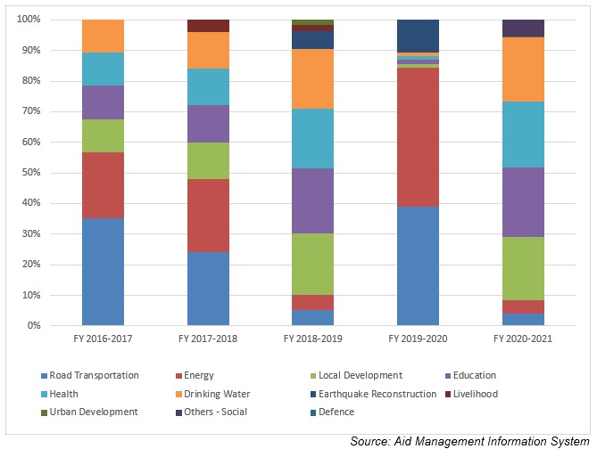
Indian Aid Disbursement during FYs 2016/17 – 2020/2021 (in US $)
Over the last five year period beginning from FY 2010/11 to FY2019/20, India disbursed a total of US$ 340.8 million of ODA to Nepal. The flow of Indian ODA to Nepal gets the highest level, US $ 93.6 million in FY 2019/20 whereas the lowest level of disbursement during the five year period was US $ 56.7 million, just below an average annual disbursement flow of US $ 68.0 million.
During the last five year period Indian committed to provide US $ 294.7 million through separate agreements. In this course, the highest level of aid commitment, US $ 78.3 million, was made in fiscal year 2017/18. There is not direct relationship between the year of the agreement amount and year and disbursed amount though disbursement are made out of agreed amount.
Fiscal Year | Agreement Amount | Disbursement
2016/17 | 51,118,616 | 59,259,430
2017/18 | 78,341,235 | 56,762,100
2018/19 | 77,131,230 | 58,944,224
2019/20 | 20,005,380 | 93,571,298
2020/21 | 68,157,689 | 72,320,905
Source: Aid Management Information System
Note: The Agreement Amount is not comparable with disbursement because disbursement here accounts for disbursement of each fiscal year only, whereas Agreement Amount refers to the project cost over the period (not only for single fiscal year but also beyond).
Development Cooperation Strategy
The Government of India has been supporting construction of Postal Highway, Optical Fibre Network, railway links, Integrated Check Posts and transmission lines at different locations near the border of the two countries.
Recognizing the historical and cultural relations between the two countries, India is supporting in the improvement of infrastructure and facilities at major pilgrimage and heritage sites such as Pashupatinath, Muktinath and Janakpur.
Government of India has been providing ambulances since 1994 to various districts of Nepal. In addition, it provides school buses to various health and educational institutions to facilitate the movement of teachers, students, doctors and nurses.
Updated
Social Sector/ IECCDJanuary 2022

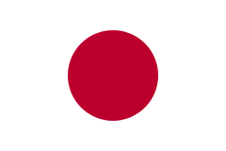 | Japan
According to the OECD, in 2020 Japan was one of the top 5 countries in the DAC in terms of provision of ODA (in absolute terms). It was ranked fourth and the volume was US$ 16.2 billion, 0.31 percent of Japanese GNI (OECD 2021).
Bilateral Relations
Nepal and Japan established diplomatic relations in 1956. In 1968, the Embassy of Japan was established and in 1978, the Japan International Cooperation Agency (JICA) office was opened in Nepal. Since 1969, Japan has been supporting Nepal for social and economic development activities.
Japan maintains an Embassy in Kathmandu. Mr. Masamichi Maigo is the Ambassador to Nepal at present (December 2021). Nepal has an embassy in Tokyo, Japan with two consulate offices in Fukuoka and Osaka.
Development Cooperation
Japan has been a development partner of Nepal since 1969. Beginning in 1975, Japan provided support to construct several economic infrastructural facilities including the Kulekhani Hydroelectric Power Plant, the Kaligandaki Hydroelectric Power Plant, the Udayapur Cement Plant and several bridges in Kathmandu.
During the period of 1980-1994, Japan also provided assistance to establish and expand the Tribhuvan University Teaching Hospital, the Water-Induced Disaster Prevention Technical Center and the Kanti Children’s Hospital.
Japan is the only bilateral development partner providing food grains (especially rice) and chemical fertilizers. Japan has been providing food grains since 1970 under the scheme popularly known as KR or KRI (Kennedy Round) and fertilizer assistance since 1977 under KRII.
Japan’s Major Support to Nepal by Sector
The followings are the major five sectors where Japan used to support over the last five year period.
- Education
- Road Transportation
- Earthquake Reconstruction
- Urban Development
- Agriculture
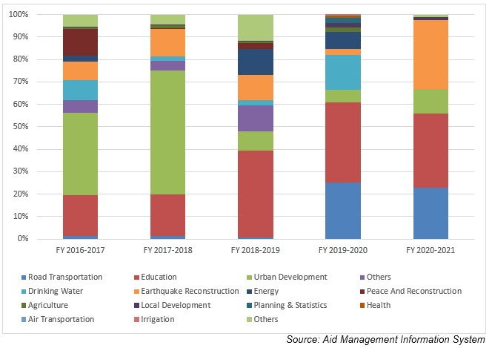
Japanese aid disbursement during FYs 2010/11-2019/20 (in US$)
Fiscal Year | Agreement Amount | Disbursement
2016/17 | 219,949,168 | 77,652,833
2017/18 | 16,538,604 | 106,207,039
2018/19 | 22,248,869 | 110,502,190
2019/20 | 20,683,396 | 72,612,032
2020/21 | 2,820,504 | 32,977,147
Source: Aid Management Information System
Note: The Agreement Amount is not comparable with disbursement because disbursement here accounts for disbursement of each fiscal year only, whereas Agreement Amount refers to the project cost over the period (not only for single fiscal year but also beyond).
Japanese Aid disbursement during FYs 2016/17-2020/21 (in US$)
Over the last five-year period beginning from FY 2010/11 to FY 2019/20, a total of US$ 399.9 million Japanese aid was disbursed to Nepal. The highest level of annual disbursement amounting to US $ 110.5 million took place in fiscal year 2018/19. Similarly, the lowest level of disbursement of an amount of US $ 32.9 million was realized in fiscal year 2020/21. The average annual disbursement during the five year period remained at us $ 80 million.
During this period Japan government agreed to provide a sum of US $ 282.5 million to Nepal. The highest level of aid commitment stands at US $ 219.9 million in fiscal year 2016/17. Likewise, the lowest level of aid agreement was made of an amount of US $ 2.8 million in 2020/21. Though the amount disbursed is solely out of the committed amount, there is no direct relationship between the year, agreed amount and the disbursed amount.
Development Cooperation Strategy
Japanese development cooperation strategy for Nepal rests on: Infrastructure and institutional development for sustainable economic growth, Consolidation of peace and steady transition to a democratic state and rural poverty reduction.
Development issues identified under the Japanese cooperation strategies are: Social and economic infrastructure development; private sector development; Public Administration Capacity Building; agriculture and rural development; Education health sector improvement.
Japan has an ODA policy entitled ‘Country Development Cooperation Policy’ to guide its cooperation to Nepal. The major objective is to provide assistance for balanced and sustainable economic growth, focusing on Nepal’s graduation from LDC status. The priority areas (medium-term targets) are: (1) Recovery work and disaster resilient nation-building in both structural and non-structural aspects, (2) Social and economic structure and mechanism development which directly lead to economic growth and the national livelihoods improvement, (3) Poverty reduction and quality of life improvement and (4) Governance enhancement and basic framework development for democracy.
Updated
Economic Sector/ IECCDJanuary 2022

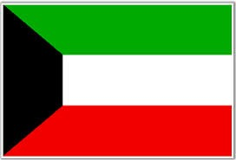 | Kuwait
KFAED is the first institution in the Middle East that took an active role in the international development efforts. Kuwait is one of the few countries in the world whose aid budget exceeds the UN target of 0.7% of GNI.
Bilateral Relations
Nepal and Kuwait established diplomatic relations on 25 February 1972. Nepal established its Embassy in Kuwait on 21 March 2010. The Embassy of Nepal in Kuwait facilitates aid and other matters with KFAED. There is no Embassy of the State of Kuwait in Nepal.
Development Cooperation
Economic cooperation between the two countries started in January 1976 with the signing of a loan agreement amounting US$ 18.5 million for the Kulekhani Hydro-Project. Further, in 1979, Kuwait provided a supplementary loan of US$ 7.4 million to meet the cost overrun of the same project.
On 25th January 1985, Kuwait provided KWD 6.0 million (approximately US$ 20 million) to the Marsyangdi Hydro Power Project through a separate loan agreement. Kuwait further provided an additional KWD 2.9 million (around US$ 9.5 million) for works related to the same Project.
A loan agreement of KWD 1.5 million (around US$ 5 million) was concluded on 26 October 1998 for the execution of the Praganna Kulo Irrigation Project in Dang district. In 2013, KFAED agreed to provide loan assistance of US$ 18 million for the Budhiganga Hydropower Project to be developed in Achham District.
Kuwait’s Major Support to Nepal by Sector
The followings are the major sector of Kuwait’s support in Nepal during the last five year period.
- Agriculture
- Irrigation
- Energy
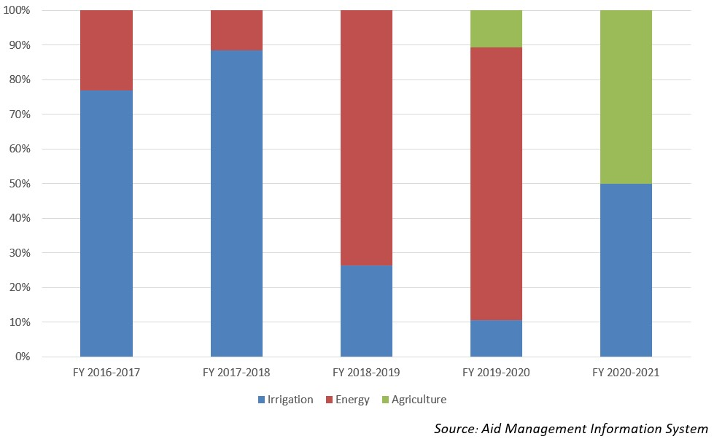
KFAED’s Disbursement during FYs 2016/17 and 2020/21 (in US $)
Over the last five year period beginning from FY 2016/17 to FY 2020/21, KFAED has disbursed a sum of US $ 7.6 million to Nepal. The highest level of disbursement of US $ 3.2 million took place in fiscal year whereas the lowest level of disbursement of US $ 0.26 million in fiscal year 2019/20. The average annual disbursement over the five year period is US $ 1.5 million. Kuwait and Nepal did not have any agreement of bilateral cooperation during the last five year period.
Fiscal Year | Agreement Amount | Disbursement
2016/17 |  | 649,148
2017/18 |  | 3,274,490
2018/19 |  | 2,652,546
2019/20 |  | 267,163
2020/21 |  | 797,826
Source: Aid Management Information System
Note: The Agreement Amount is not comparable with disbursement because disbursement here accounts for disbursement of each fiscal year only, whereas Agreement Amount refers to the project cost over the period (not only for single fiscal year but also beyond).
Development Cooperation Strategy
Kuwait has been supporting Nepal by providing soft loans for projects, especially in the areas of hydropower generation and irrigation.
Updated
Agriculture and Industry Sector/ IECCDJanuary 2022

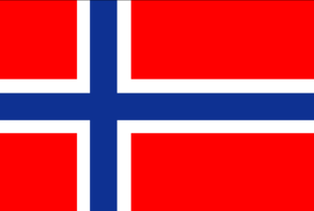 | Norway
Norway is the second largest Development Assistance Committee (DAC) provider in terms of ODA as a percentage of GNI. Norway is one of the very high Human Development Index countries with 0.957 index value, ranking the nation first, out of 189 nations (HDR, 2020).
Bilateral Relations
Norway and Nepal established diplomatic relations in 1973, although the ties between the two countries had started already in the early 1950’s. The Norwegian Embassy was opened in 2001 as the relations expanded, in particular through development cooperation.
Norway maintains its Embassy in Lalitpur, Nepal. Mr. Lasse Bjørn Johannessen is the Norwegian Ambassador to Nepal (August 2017 to date). The Nepali Ambassador in Copenhagen is concurrently accredited to Norway. Similarly, the Nepalese Honorary Consul General based in Oslo looks after the Nepalese interests in Norway.
Development Cooperation
The formal development cooperation between the Government of Norway and the Government of Nepal began in 1996 by signing a MOU. Norway’s contribution is based on a shared dedication to achieve the Sustainable Development Goals.
In 2017, Norway granted approximately 193 million NOK as the development aid to Nepal. Its priority areas are energy, education, good governance, human rights, environment and gender equality as cross-cutting issues.
Out of the total official development assistance to Nepal, approximately 75% is administered by the Norwegian Embassy in Kathmandu. The remaining 25% ODA is channeled directly from the Norwegian Ministry of Foreign Affairs and the Norwegian Agency for Development Cooperation (Norad).
Worth mentioning was also support to the Energize Nepal Project with a special link between Kathmandu University and Norwegian University of Science and Technology (NTNU), with a grant of NOK 25 million (over 5 years). Norway is supporting the regional intergovernmental learning and knowledge center- International Centre for Integrated Mountain Development (ICIMOD), with a budget of NOK 150 million over the 5 years.
Major Support of Norway to Nepal by Sector
The followings are the 5 major support sectors of the Norwegian cooperation during the last five – year period.
- Education
- Energy
- Environment, Science and Technology
- Women, Children and Social Welfare
- Policy and strategic
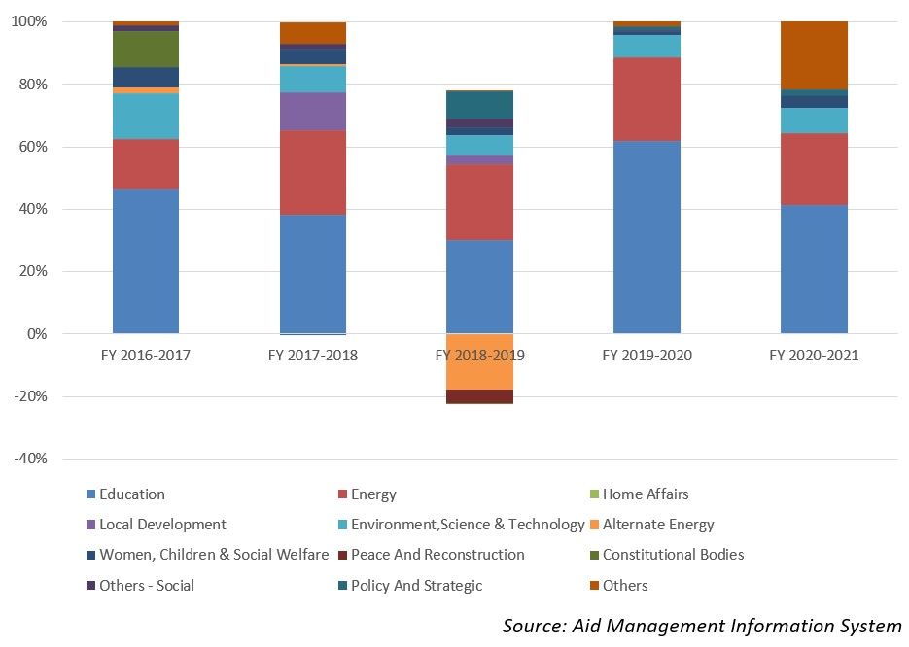
Norwegian aid disbursement during FYs 2016/17 - 2020/21 (in US$)
According to the data available in the AMIS Platform, over the last five-year beginning from FY 2010/11 to FY 2020/21, Norway disbursed a total of US$ 105.6 million to Nepal. During this period the highest level of disbursement amounting to US $ 23.9 million, took place in fiscal year 2017/18. Likewise, the lowest level of disbursement was US $ 15.8 million, just below the average annual disbursement over the five year period.
During the five-year period Norway agreed to provide US $ 364.5 million to Nepal through separate agreements. The highest level of bilateral cooperation agreement was concluded in fiscal year 2019/20, in an amount of US $231.5 million. However, there is not direct relationship between the year and agreement amount and the amount jof disbursement. But it is true that all the disbursement are the outcome of past aid commitment.
Fiscal Year | Agreement Amount | Disbursement
2016/17 | 33,723,101 | 20,318,915
2017/18 | 14,583,014 | 23,984,012
2018/19 | 44,518,827 | 23,584,627
2019/20 | 231,828,618 | 15,876,280
2020/21 | 39,891,129 | 21,868,100
Source: Aid Management Information System
Note: The Agreement Amount is not comparable with disbursement because disbursement here accounts for disbursement of each fiscal year only, whereas Agreement Amount refers to the project cost over the period (not only for single fiscal year but also beyond).
Development Cooperation Strategy
Norway has worked closely with other donors to reach the targets for the education program School Sector Reform Program (SSRP) since 2009, and is particularly committed to increasing access to education for girls and children with disabilities.
Norway is a long-time supporter for energy development in Nepal. The main energy support has to date been channeled through ADB, by a grant of NOK 330 million for the Electricity Transmission Expansion and Supply Improvement Project and the South Asia Sub-regional Economic Cooperation (SASEC) Power Expansion Project-Transmission Line in Nepal.
Khimti I Hydropower Plant is Norway’s largest private initiative in Nepal. The plant is built with private sector funding as a “BOOT” agreement (Build, Own, Operate, and Transfer) with GoN.
Updated
Social Sector/ IECCDJanuary 2022

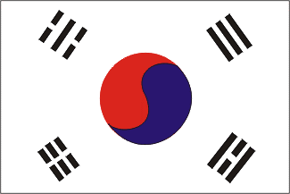 | Republic of Korea
Since 2020, the Republic of Korea (South Korea) became the 10th strongest economy in terms of GDP in the current price. Its journey from a poor to a developed country and from the recipient to donor country is seen as a successful development example.
Bilateral Relations
The Republic of Korea and Nepal established diplomatic relations on 15 May 1974. Agreements on Korean Youth Volunteers in January 1992 and the Economic Development Cooperation Fund (EDCF in September 1997 were the vital to enhance bilateral economic cooperation.
In 2007 the Nepalese and South Korean governments signed a MoU on the Employment Permit System (EPS) for recruiting Nepalese workers according to Korean labor laws. Korea has been maintaining the Embassy of the Republic of Korea in Kathmandu since 1974. Mr. Park Chong-Suk is the present Ambassador of the Republic of Korea to Nepal (November 2021)
Development Cooperation
From 1978 to 1995, KOICA focused on developing sericulture in Nepal by implementing the Sericulture Development Project and constructing a Khopasi Sericulture Center. The Government of Korea conducted a feasibility study for the Modi Khola Hydroelectric Project (1993-1994), eventually provided a soft loan to the project in 1997.
In 1999, with the financial and technical support from KOICA, the Korea-Nepal Friendship Hospital was established in Bhaktapur to provide access to quality health services to the people of Bhaktapur and adjoining districts.
The Agreements on the Avoidance of Double Taxation and the Prevention of Fiscal Evasion in October 2001, the Air Services Agreement in March 2005, and the Culture Agreement in April 2005 are remarkable.
Each year KOICA invites more than 100 government officials from Nepal to Korea in order to improve their capacities in a number of fields.
Korea’s Major Support to Nepal by Sector
The following are the top five major sectors that received Korean support during the last five-year period.
- Education
- Health
- Planning and statistics
- Agriculture
- Earthquake Reconstruction
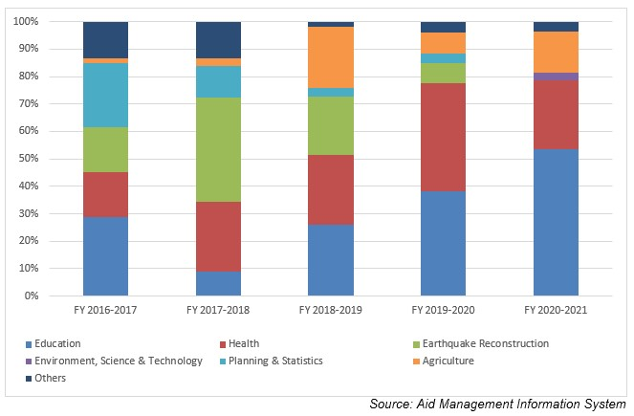
Korean aid disbursement during FYs 2016/17 to 2020/21 (in US $)
Over the last five-year period beginning from FY 2016/17 to FY 2020/21, Korean government disbursed a total of US$ 38 million of ODA to Nepal. The disbursement was the highest, at a level of US $ 8.4 million in FY 2020/21. The average annual disbursement in the five-year period stands at US $ 7.6 million.
During the last five-year period the Korean Government has agreed to provide a total of US $ 46.4 million through separate agreements. The highest level of aid commitment was of US $ 19 million signed in fiscal year 2016/17.
Fiscal Year | Agreement Amount | Disbursement
2016/17 | 19,010,000 | 7,638,528
2017/18 | 7,470,422 | 6,874,412
2018/19 | 5,000,000 | 7,652,068
2019/20 | 857,360 | 7,425,546
2020/21 | 14,125,500 | 8,124,983
Source: Aid Management Information System

Note: The Agreement Amount is not comparable with disbursement because disbursement here accounts for disbursement of each fiscal year only, whereas Agreement Amount refers to the project cost over the period (not only for single fiscal year but also beyond).
Development Cooperation Strategy
KOICA’s Country Partnership Strategy for Nepal 2020-2024 states that the Government of Korea aims to contribute to poverty reduction and economic growth. It also advocates for Nepal’s graduation from Least Developed Country (LDC) status to Middle Income Country status by creating a foundation for fostering competitive future generations that can create social values.
KOICA is implementing Integrated Rural Development of Nepal through Strengthening Research and Development Capacity of Kathmandu University (2017-2023), Empowering Rural Communities In Nepal through an Integrated Approach to Health and Income Growth (2020-2025), Capacity Building for TVET Model Institute in Province 2 Leading to Cultivate Skilled Workforce in Construction Sector (2021-2026), Establishment of Cyber Bureau with Capacity Building for Nepal Police Establishment of Cyber Bureau with Capacity Building for Nepal Police (2021- 2026) and Project for Strengthening Stage-Wise Support System for The Stable Reintegration of Korea Returnee Migrants in Nepal (2022-2028). Similarly Dispatch of Korean Volunteer and Capacity Building Program are other two prominent technical assistance to Nepal which KOICA has been implementing since a long time. More than 400 Korean Nationals has worked in Nepal as a volunteer, transferring knowledge, exchanging culture and Korean know how various development sectors. At the same time more than 1900 government officials have participated in various capacity building program in Korea.

Updated
Infrastructure Sector/ IECCDJanuary 2022

Saudi Arabia
Saudi Arabia possesses 25% of the world’s proven petroleum reserves. It ranks as the largest exporter of petroleum and plays a leading role in OPEC. The petroleum sector accounts for roughly 75% of budget revenues, 45% of GDP, and 90% of export earnings.
Bilateral Relations
Nepal and the Kingdom of Saudi Arabia established their diplomatic relations on 15 March 1977. Nepal’s then-Prince Gyanendra visited Saudi Arabia on an official visit in 1983. Similarly, Prince Alwaleed Bin Talal Bin Abdulaziz Alsaud visited Nepal in November 2010.
Saudi Arabia maintains its Embassy at Maharajgunj, in Kathmandu. Mr. Abdulnaser bin Husien Al-Harthi is the present (December 2021) Saudi Arabian Ambassador to Nepal.
Development Cooperation
Economic cooperation between the two countries began in 1978 when Nepal opened its Embassy in Jeddah, Saudi Arabia. The economic cooperation extended by the Saudi Arabian Government in Nepal initially focused on uplifting the Muslim community, agricultural development and emergency assistance.
The assistance to Nepal from Saudi Arabia is currently being provided through the Saudi Fund for Development (SFD). The SFD is an official agency for development cooperation established by Royal Decree in 1974.
SFD commenced operations in 1975 with the objective of participating in the financing of development projects in developing countries through the granting of loans and encouraging national non-crude-oil exports. SFD operates from a capital base provided by the Government of Saudi Arabia.
Saudi Arabia provided emergency food assistance during FY 1982/83. For the rehabilitation of the earthquake victims, the SFD provided 1,380 units of tents and over 3,000 packages of foods, as well as a cash grant of US$ 1 million for the procurement of equipment.
Saudi Arabia’s Major Support to Nepal by Sector
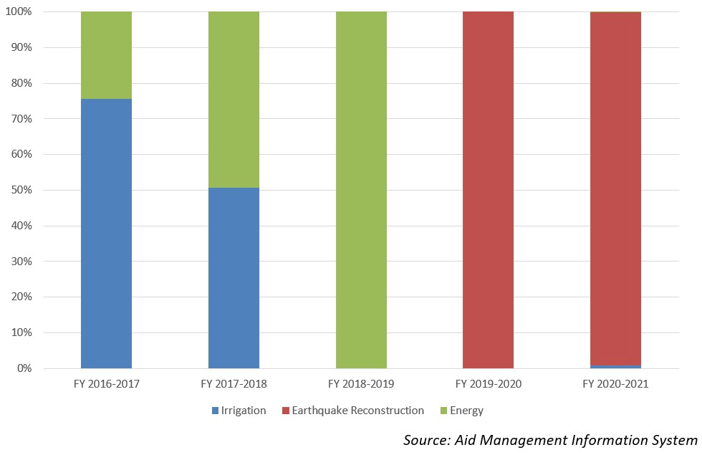
Disbursement from SFD during FYs 2016/17 to 2020/21 (in US$)
Over the last five-year period beginning from FY 2016/17 to FY 2020/21, SFD has disbursed a total of US $ 23 million. In terms of the volume of the disbursement the highest disbursement was of US $ 16.7 million in fiscal year 2020/21 whereas the lowest disbursement was limited to US $ 0.16 million in fiscal year 2017/18 which is less than the average annual disbursement of US $ 4.6 million during the five-year period.
Over the five-year period, SFD and GoN had an agreement of financial cooperation of US $ 29.1 million once in fiscal year 2020/21. There is no direct relationship between financial agreement amount and the disbursed amount though all the disbursed amount are based on agreed commitment.
Fiscal Year | Agreement Amount | Disbursement
2016/17 |  | 2,382,612
2017/18 |  | 168,108
2018/19 |  | 568,013
2019/20 |  | 3,110,778
2020/21 | 29,163,542 | 16,768,405
Source: Aid Management Information System

Note: The Agreement Amount is not comparable with disbursement because disbursement here accounts for disbursement of each fiscal year only, whereas Agreement Amount refers to the project cost over the period (not only for single fiscal year but also beyond).
Development Cooperation Strategy
SFD provides untied concessional loan which has no specific geographical or sectoral limitations. Nepal has been utilized SFD loan for the development of infrastructure such as power generation, road construction and irrigation development.
Loans extended by SFD carry a 15-25 year repayment period and a loan charge of 2-5% interest, depending upon the nature of the loan. The Saudi Charter allows the SFD to finance up to 50% of the project costs.
Updated
Agriculture and Industry Sector/ IECCDJanuary 2022

Switzerland
Switzerland has one of the most competitive economies with one of the highest gross domestic product (GDP) per capita in the world. It has also a long tradition of international assistance, especially in humanitarian aid.
Bilateral Relations
Switzerland and Nepal established diplomatic relations in 1956. On the occasion of 50 years of development cooperation between the countries, the Government of Switzerland opened its Embassy in Nepal in 2009. Similarly, Nepal also opened its residential Embassy in Geneva, Switzerland. At present, Ms Elisabeth von Capeller is Swiss Ambassador to Nepal (November 2021).
Development Cooperation
The first cooperation initiative was in the field of cheese and diary development from 1956-1964. The construction of the Lamosanghu-Jiri Road, during 1974-1985 facilitated the transfer of knowledge of mountain road construction acquired over long experience in the Swiss Alps.
Since 1963 Nepal has been a priority country for Swiss development cooperation. Switzerland works closely with local authorities, other donors, and international organizations in Nepal. Its key partners include Helvetas Swiss Inter-cooperation, AF-ITECO AG, Swiss Contact.
Switzerland also works with multilateral organizations such as the World Bank, the Asian Development Bank and the International Centre for Integrated Mountain Development (ICIMOD). In the aftermath of catastrophic earthquake of 2015, the Swiss Humanitarian Aid in coordination with development cooperation actively supported the Government of Nepal
Swiss Major Support to Nepal by Sector
The followings are the top five sectors of Swill development cooperation in Nepal during the last five-year period.
- Agriculture
- Local Development
- Education
- Labor
- Road Construction
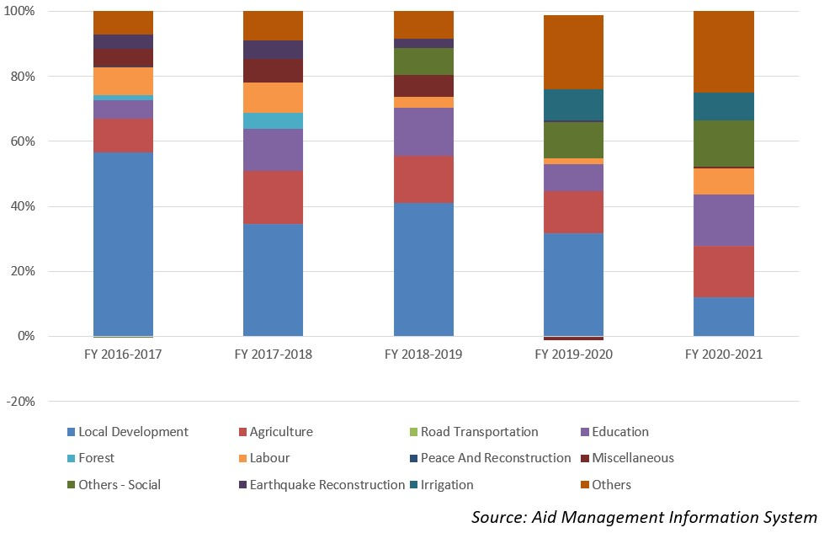
Swiss Aid Disbursement during FYs 2016/17-2020/21 (in US$)
During the last five-year period beginning from FY 2016/17 to FY 2020/21, the total Swiss aid disbursement stands at US $ 147.3 million. The highest level of disbursement, with a total amount of US$ 36.7 million took place in FY 2019/20.The average annual disbursement of the Swiss aid stands at US $ 29.4 million, during the last five year.
Regarding the financial cooperation agreement between the two countries, a sum of US $ 128.5 million aid was committed by the Switzerland Government in the last five-year period. In fiscal year 2017/18, both the nations did not conclude any financial cooperation agreement.
Fiscal Year | Agreement Amount | Disbursement
2016/17 | 24,713,653 | 34,941,429
2017/18 |  | 26,412,734
2018/19 | 24,648,289 | 25,880,596
2019/20 | 76,266,402 | 36,734,500
2020/21 | 27,667,089 | 24,397,709
Source: Aid Management Information System
Note: The Agreement Amount is not comparable with disbursement because disbursement here accounts for disbursement of each fiscal year only, whereas Agreement Amount refers to the project cost over the period (not only for single fiscal year but also beyond).
Development Cooperation Strategy
The Swiss cooperation strategy Nepal (2018-2021) has stipulated the objectives that women and men benefit from equitable socio-economic development and exercise their rights and responsibilities in an inclusive federal state. The Swiss government has earmarked CHF 130 million (equivalent to Rs. 14.7 billion) of disbursement during the four year period.
The areas of Swill involvement to achieve the overall goals are: i) all people at subnational level build an inclusive and accountable federal state, ii) the women and men, especially from disadvantaged groups, find employment and increase their income and iii) the migrants and their families are better protected by democratic institutions in Nepal and benefit from decent work conditions abroad.
Updated
Social Sector/ IECCDJanuary 2022

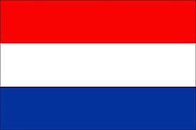 | The Netherlands
The Netherlands is committed at European level to collectively achieve a 0.7% ODA/GNI ratio by 2030. Geographically, Dutch development assistance is concentrated on sub-Saharan Africa and low-income countries.
Bilateral Relations
Nepal and the Netherlands established diplomatic relations in April 1960. The Netherlands Consulate in Nepal is located in Jawalakhel, Lalitpur. The Embassy of Nepal in Belgium is concurrently accredited to the Netherlands and the Netherlands Embassy in New Delhi is accredited to Nepal.
Development Cooperation
The Government of the Netherlands provides ODA to Nepal including other developing countries through SNV Netherlands Development Organization which opened its first Asia office in Nepal in 1980.
Economic cooperation between the two countries started earlier, in 1976, with the involvement of Dutch volunteers (technicians/engineers) to assist in various development sectors.
In 1983, Nepal and the Dutch government signed an agreement on the employment of Dutch volunteers for economic development and cooperation. The Biodiversity Sector Support Program (BSSP) was one of the major projects funded by SNV Nepal.
Major Support of the Netherlands to Nepal by Sector
The followings are the major sectors of Dutch support to Nepal during the last five-year period.
- Drinking water
- Energy
- Environment, Science and Technology
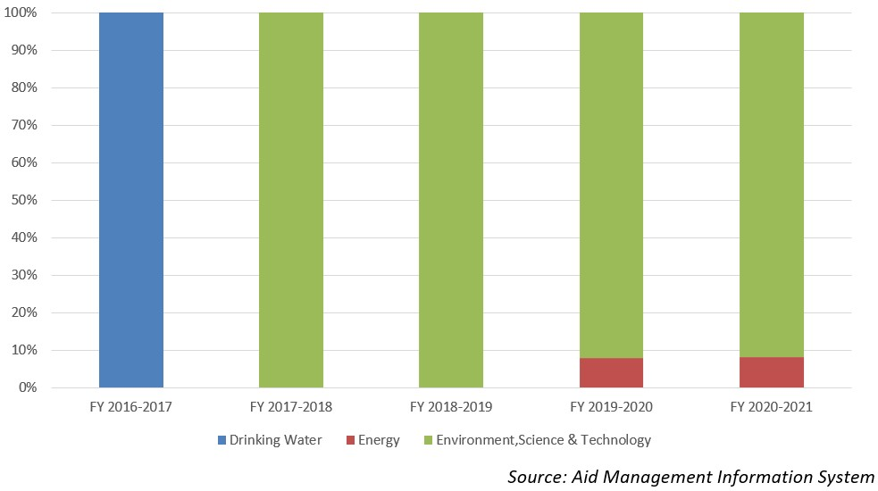
The Netherlands’ aid disbursement during FYs 2016/17-2020/21 (in US$)
Over the last five-year period beginning from FY 2016/17 to FY 2020/21, the Netherlands has disbursed US$ 3.77 million aid to Nepal. The highest annual disbursement was of US $ 1.4 million disbursed in fiscal year 2018/19. The average annual disbursement over the last five-year was US $ 0.75 million.
During the said five year period the Netherlands has agreed to provide financial support of US $ 3.15 million through five separate agreements. The highest level of annual commitment was made of US $ 1.2 million in 2020/21. There is not direct relationship between the commitment and the disbursed amount though amount disbursed are solely based on commitment.
Fiscal Year | Agreement Amount | Disbursement
2016/17 | 303795 | 303,795
2017/18 | 42,141 | 42,141
2018/19 | 679,125 | 1,478,866
2019/20 | 919,355 | 623,176
2020/21 | 1,215,501 | 1,322,302
Source: Aid Management Information System
Note: The Agreement Amount is not comparable with disbursement because disbursement here accounts for disbursement of each fiscal year only, whereas Agreement Amount refers to the project cost over the period (not only for single fiscal year but also beyond).
Development Cooperation Strategy
SNV Nepal programs are aligned with the development priorities of the Government of Nepal. In collaboration with the Government of Nepal and the International Fund for Agriculture Development, the Government of the Netherlands has also supported the High Value Agriculture Project (2010-2017).
In addition to domestic biogas, SNV, together with the Bank of Kathmandu, launched Biogas for Business (B4B) in 2012. It targeted support for the installation of medium to large scale biogas plants for waste management, energy production and production of organic fertilizer.
Updated
Social Sector/ IECCDJanuary 2022

United Kingdom
The UK Government is legally required to spend 0.7% of Gross National Income (GNI) on ODA. In 2020, the UK is the third largest donor in ODA behind the USA and Germany according to the Organization for Economic Co-operation and Development (OECD).
Bilateral Relations
The history of official relations between the UK and of Nepal dates back to 1816. Relations between the two countries grew with a Treaty of Perpetual Peace and Friendship which was signed in 1950.
The UK was the first country in the world with which Nepal established diplomatic relations and was also the first country to establish an Embassy in Kathmandu. Nepal had established its legation in London in 1934, which was elevated to the Ambassador level in 1947.
The UK has been offering fellowships to the Government of Nepal since the 1950’s, and British volunteers have been engaged in Nepal since 1964. The UK has been maintaining the British Embassy in Lainchaur, Kathmandu. Ms. Nicola Pollitt is serving as the British Ambassador to Nepal at present (November 2021) .
Development Cooperation
To support the development endeavor of Nepal, in April 1999 DFID established an in-country office staffed by a multi-disciplinary team of both UK nationals and staff appointed in country.
During FY 2015/16, foreign direct investment commitment from the UK stood at US$ 128.3 million, according to Nepal’s Department of Industry. An agreement for the promotion and protection of investment between Nepal and the UK was signed in March 1993.
Nepal has received generous support and assistance from the UK, especially in the aftermath of the devastating earthquakes of 2015 that claimed over 9,000 lives. The UK Government responded to the Nepal earthquakes immediately with the deployment of eight disaster response specialists under the Rapid Response Facility releasing US$ 6.55 million. It later pledged an additional US$ 110 million for the reconstruction and rebuilding of Nepal.
UK Government’s Major Support to Nepal by Sector
Over the last five-year period the UK Government has supported Nepal mainly in the following 5 sectors.
- Education
- Earthquake Reconstruction
- Economic Reform
- Health
- Home Affairs
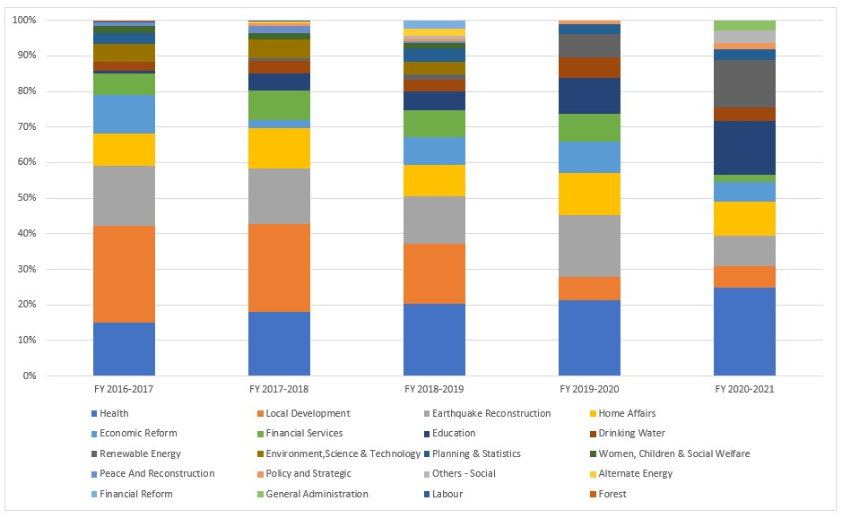
UK ODA disbursement during FYs 2016/17-2020/21 (in US$)
Over the last five-year period beginning from FY 2016/17 to FY 2019/20, the UK Government has disbursed US$ 548.6 million of ODA to Nepal. The highest level of annual disbursement of ODA took place in fiscal year 2016/17 with an amount of US $ 128 million. Likewise, in fiscal year 2020/21, ODA disbursement of US $ 83.9 million took place which is less than the annual average disbursement of UK ODA of US$ 109.7 million.
During the last five-year period the government of UK has agreed to provide assistance of US $ 473 million through different agreements. The highest level of support agreement was concluded in fiscal year 2016/17.
Fiscal Year | Agreement Amount | Disbursement
2016/17 | 371,023,684 | 128,313,164
2017/18 | 8,843,418 | 123,870,280
2018/19 | 19,693,407 | 117,238,011
2019/20 | 44,875,034 | 95,227,536
2020/21 | 28,742,392 | 83,974,701
Source: Aid Management Information System
Note: The Agreement Amount is not comparable with disbursement because disbursement here accounts for disbursement of each fiscal year only, whereas Agreement Amount refers to the project cost over the period (not only for single fiscal year but also beyond).
Development Cooperation Strategy
UK intends to support Nepal’s economic growth and economic inclusion so as to help increase incomes and access to finance for 650,000 rural poor people by 2021. The UK’s technical assistance is helping to harness FDI for large industrial projects such as hydro power generation to create an environment that is conducive to business and investments.
The UK supported the Strengthening Disaster Resilience and Responding to Humanitarian Emergencies in Nepal (US$ 60.2 million) and Climate Smart Development Program (US$ 59.6 million).
UK-support strategies include Accelerating Investment and Infrastructure in Nepal (AIIN) (US$ 9.7 million), UK/Nepal-Support to Nepal Health Sector Program III (NHSP) (US$ 8.6 million), Nepal Market Development Program (US$ 6.4 million) and Access to Finance for the Poor Program (US$ 6.1 million).
Updated
Social Sector/ IECCDJanuary 2022

United States
The United States is the largest ODA donor in terms of dollar contribution in the world. The Point IV agreement of 1951 with the USA introduced Nepal in the era of international development cooperation. Strengthening democratization process and human resources development are the key areas of US aid mobilization in Nepal.
Bilateral Relations
Bilateral diplomatic relations between Nepal and the U.S. was officially started in 1947 during the democratic movement of Nepal, which had culminated a new era for opening the country for outward oriented foreign policy.
The U.S. is the second country, after the United Kingdom, with which Nepal entered into official diplomatic relations in April 25, 1947. Following the establishment of bilateral relations, the relations between the two countries were upgraded to the Ambassadorial level in 1953.
Nepal established its Embassy in Washington, DC on February 3, 1958. Similarly, the United States opened its Embassy in Kathmandu on August 6, 1959. A number of Nepal’s honorary consuls have been appointed in various US cities. At present, the U.S. Ambassador to Nepal is Mr. Randy Berry (December 2021).
Development Cooperation
The history of official development cooperation had been initiated in early 1950s as the United States is the first country to provide the bilateral development cooperation in 1951 under its point four program.
United States is consistently extending various development and technical cooperation to Nepal including Peace Corps volunteers initiated in 1961 and much more emergency assistance.
Various sectors such as transport, communication, public health, family planning, malaria eradication, agriculture, forestry, energy, etc., have been benefitted greatly. USAID/Nepal is the primary development assistance arm of the US government to Nepal.
The MCC has chosen Nepal to mobilize US assistance though compact program. For this to happen, Nepal and MCC has entered into a bilateral compact (agreement) in September 2017
Major Support of the USA to Nepal by Sector
The followings are the top five sectors of bilateral cooperation between Nepal and the USA during the last five-year period.
- Health
- Agriculture
- Education
- Local Development
- Energy

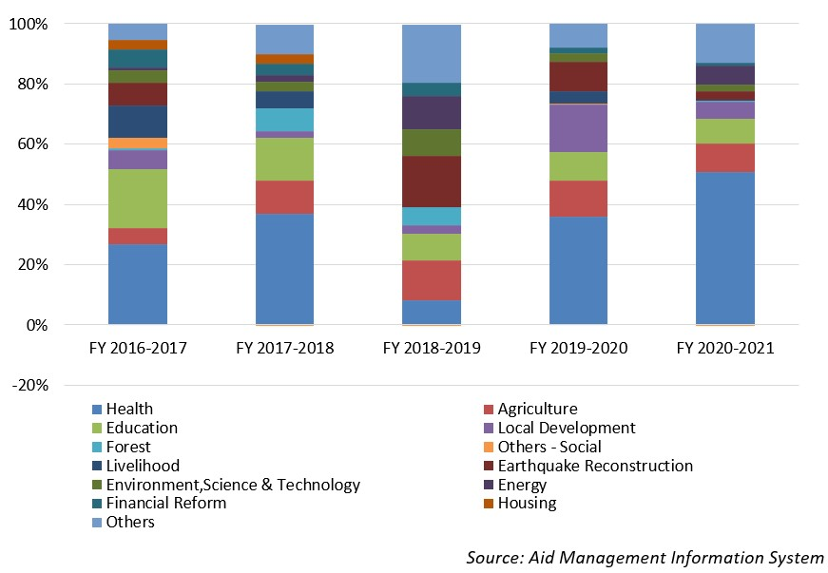
USAID’s Aid disbursement during FYs 2016/17-2020/2021 (in US$)
Over the last five-year period beginning from fiscal year 2016/17 to fiscal year 2020/21 the total disbursement from the USAID to Nepal was US $ 558.9 million. The highest level of disbursement took place in fiscal year 2016/17 amounting to US $ 134 million. Likewise, the lowest level of disbursement was made in fiscal year 2018/19 amounting to US $ 77 million, less than the average annual disbursement during the last five-year.
During the last five year period, the USA has agreed to provide Nepal with a sum of US $ 904 million through separate agreements. The highest level of commitment of support was made of US $ 558.5 million in fiscal year 2017/18. However, there is no direct relationship between the amount committed to support and the amount disbursed in years.
Development Cooperation Strategy
USAID/Nepal has recently rolled out Country Development Cooperation Strategy (CDCS), which is normally prepared for five years period outlining the broader parameters of USAID’s strategic priorities and areas of Nepal’s development need for mobilizing the development cooperation in Nepal.
This strategy for the period of 2021 to 2025 which envisions creating a more self-reliant, prosperous and inclusive Nepal that could deliver improved democratic governance and health and education outcomes.
Major highlights of Country Development Cooperation Strategy (CDCS):
i) More Effective, Participatory, and Equitable Democratic Ecosystem
ii) Broad-Based and Inclusive Economic Growth Fostered
iii) Inclusive Health and Education Systems Strengthened and
(iv) More Equitable and Improved Natural Resources and Disaster Risk.
Updated Economic Sector /IECCDJanuary 2022

