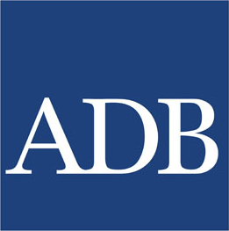 | Asian Development Bank
Partnership of Nepal with ADB began in 1966 as its founding member. ADB is committed to achieving a prosperous, inclusive, resilient and sustainable Asia and the Pacific. ADB, based on Country Partnership Strategy (2020–2024), supports environmentally sustainable and private sector led growth in Nepal.
Organization
The Asian Development Bank (ADB), a multilateral development bank, was established in 1966. It is owned by 67 members, 48 of which are regional members from Asia and the Pacific providing 63.5% of its capital, and 19 non-regional members providing 36.5% of its capital. The headquarters of the Bank is in Manila, the Philippines.
The main instruments of ADB assistances are loans, technical assistance (TA), grants, guarantees, and equity investments. These instruments are financed through Ordinary Capital Resources (OCR), special funds, and trust funds.
ADB provides loan assistance through two windows, namely the OCR and Asian Development Fund (ADF). OCR is a commercial window for loans with market-based interest rates. To finance its OCR lending operations, ADB issues debt securities in the international and domestic capital markets.
Development Cooperation
The development partnership between Nepal and ADB began in 1966 when Nepal joined ADB as a founding member. ADB provides assistance to Nepal according to the provisions of its Charter, regulations and operational policies for ordinary operation, special operation and co-financing.
In addition, ADB has also approved assistance to Nepalese private sector undertakings under its non-sovereign operations. Non-sovereign operations comprise the provision of any loan, guarantee, equity investment, or other financing arrangement to privately held, state-owned, or sub-sovereign entities. Assistance is mostly in the form of loans, grants and technical assistance.
ADB actively undertakes annual country programming review exercises to promote policy dialogue and discuss sector development priorities; as well as project implementation challenges with the Government of Nepal and other development partners.
ADB is also a key contributor to the Nepal Portfolio Performance Review, organized between the Government and 13 development partners, to enhance the efficiency and effectiveness of the country’s development projects, and to move toward the adoption of the principles of the Paris Declaration for making aid more effective.
Major Support by Sector
The Top five sectors of ADB assistance are:
- Education
- Energy
- Urban development
- Drinking water
- Road Transportation
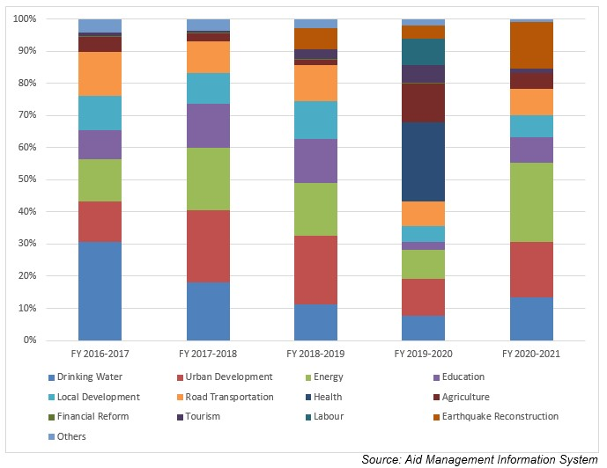
Large Projects
The followings are the five largest ADB funded projects selected from among the several ongoing projects:
- Power Transmission and Distribution Efficiency Enhancement Project;
- South Asia Sub Regional Economic Cooperation Power System Expansion Project (SASEC
- Disaster Risk Resilience for Public School Infrastructure and Communities Project;
- Second Kathmandu Valley Water Supply Improvement Project.
- Mugling - Pokhara Highway Improvement Project
Disbursement during FYs 2016/17 to 2020/21 (in US$)
Over a period of 5 years beginning from FY 2016/17 to FY 2020/21, ADB has disbursed a total of US $ 1810.8 million to Nepal. In terms of actual disbursement, it is the second highest-disbursing partner among multilateral DPs. The highest level of disbursement from ADB took place in fiscal year 2019/20, with an amount of US $ 611.4 million. The average annual disbursement over the five year from ADB is US $ 362.1 million.
In the last five-year period ADB has committed to provide US $ 3636.8 million to Nepal through separate agreements. The highest level of ADB commitment was made of an amount of US $ 1830.7 million in fiscal year 2018/19.
Fiscal Year | Agreement Amount | Disbursement
2016/17 | 151,931,165 | 253,898,091
2017/18 | 437,225,000 | 291,693,735
2018/19 | 1,830,725,000 | 292,484,030
2019/20 | 661,000,000 | 611,453,523
2020/21 | 556,000,000 | 251,055,059
Source: Aid Management Information System
Note: The Agreement Amount is not comparable with disbursement because disbursement here accounts for disbursement of each fiscal year only, whereas Agreement Amount refers to the project cost over the period (not only for single fiscal year but also beyond).
Country Partnership Strategy (CPS)
ADB implements its development partnership through its ongoing Country Partnership Strategy (CPS). In September 2019 a five year country partnership strategy was agreed. As stated in the CPS, 2020–2024, the Asian Development Bank (ADB) has declared three objectives of its involvement:
- improved infrastructure for private sector-led growth,
- improved access to devolved services, and
- Environmental sustainability and resilience.
Updated
Agriculture and Industry Sector / iECCD
January 2022
References
- Asian Development Bank: https://www.adb.org/

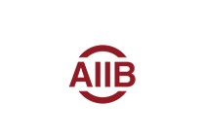 | Asian Infrastructure Investment Bank (AIIB)
Nepal is a founder member of AIIB and has signed Articles of Agreement in June 2015. AIIB is a multilateral development bank with a mission to improve social and economic outcomes in Asia and beyond. The Upper Trishuli-1 Hydropower Project is the first project of Nepal financed from AIIB.
Organization
The Asian Infrastructure Investment Bank (AIIB) is an international financial institution established in January 2016 to provide financing for infrastructure projects in Asia. It is a multilateral development bank with a mission to improve social and economic outcomes in Asia and beyond. AIIB headquarter is located in Beijing, China. AIIB commenced operations in January 2016 and its membership has grown to 105 from around the world.
Overview and Approach to Development Cooperation
According to the Articles of Agreement (AOA) of AIIB, the Bank will “provide or facilitate financing to any member, or any agency, instrumentality or political subdivision thereof, or any entity or enterprise operating in the territory of a member, as well as to international or regional agencies or entities concerned with the economic development of the Asia region”.
AIIB provides financing in a variety of ways, including making loans, investing in the equity capital of an enterprise, and guaranteeing, whether as primary or secondary obligor, in whole or in part, loans for economic development. In addition, the AIIB may underwrite, or participate in the underwriting of, securities issued by any entity or enterprise for purposes consistent with its purpose.
Development Cooperation
Nepal is a regional founder member of AIIB and has signed the Articles of Agreement on 29 June 2015. Nepal has received project preparatory grant as well as project financing from AIIB.
I. Project Preparatory Grant
The Asian Infrastructure Investment Bank (AIIB) has approved Project preparatory grants for the following three projects in Nepal;
- Nepal: Urban Infrastructure Investment Project: Project Preparatory Grant of US $ 1 million
- Nepal: Power Distribution System Upgrade and Expansion Project: Project Preparatory Grant of US $ 1 million
- Nepal: Tamakoshi V Hydroelectricity Project (TV-HEP): Project Preparatory Grant of US$ 900 thousand.
II. Project Financing
The AIIB has approved a sovereign loan on December 12, 2019 for the following project with an objective to increase and improve the quality and efficiency of the electricity supply areas of Western Nepal which aligns with the sector strategy of AIIB, "The Sustainable Energy for Asia Strategy".
- Nepal: Power Distribution System Upgrade and Expansion project: Sovereign loan of US $112.3 million. This loan is approved by the Government of Nepal blending with
Updated
Governance Sector/ IECCDMarch 2022

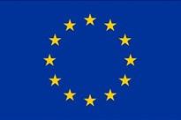 | European Union
European Commission with a diplomatic status has been providing development aid to Nepal since 1992. EU unites 27 European countries and has successfully ensured lasting peace, stability and economic prosperity within Europe. EU today is the big provider of grant aid in Nepal.
Organization
The European Union (EU) is a unique economic and political union that was formed on the European continent in the aftermath of the Second World War some six decades ago. The European Union’s Member States are Austria, Belgium, Bulgaria, Croatia, Cyprus, the Czech Republic, Denmark, Estonia, Finland, France, Germany, Greece, Hungary, Ireland, Italy, Latvia, Lithuania, Luxembourg, Malta, the Netherlands, Poland, Portugal, Romania, Slovakia, Slovenia, Spain and Sweden. UK the founder member of EU left the Union in 2020.
The principles that inspired EU’s own creation, development and enlargement are: democracy, the rule of law, the universality and indivisibility of human rights and fundamental freedoms, respect for human dignity, the principles of equality and solidarity, and respect for the principles of the United Nations Charter and international law; and are seen as an integral part of the European way of life.
The Commission’s Directorate-General for International Cooperation and Development (DG DEVCO) is responsible for designing European international cooperation and development policy and delivering aid throughout the world. DG DEVCO is in charge of development cooperation policy in a wider framework of international cooperation, and adapting to the evolving needs of partner countries.
As per the Multiannual financing Framework 2021-2027, the planned expenditure of EU over the said period is estimated to be Euro 1824.3 billion. The preliminary data shows that the EU institutions provided USD 19.4 billion in ODA during 2020.
Development Cooperation
The European Commission, which has been present in Nepal since 1992 for technical cooperation, was upgraded in 2002 to a delegation with a diplomatic status similar to that of other diplomatic missions in Nepal. It underwent a name change and became the Delegation of the European Union to Nepal after the formation of European External Action Service on 26 July 2010. The EU Delegation does not deal with tasks of a consular nature, which are dealt with by the EU Member State Embassies in Nepal, and instead functions as an official channel of bilateral relations, be it political, development, economic or cultural. The Nepal Delegation is a fully-fledged diplomatic mission and officially represents the EU in Nepal.
The EU’s assistance to Nepal is given in the form of project grants, service contracts and budget support. The largest area of support of the EU has been its budget support to the Education sector.EU continues to support the school sector through budget support to the School Sector Development Plan (SSDP). The total amount allocated for 2014-2020 is 61.4 million Euros.
The EU also supports Technical Education and Vocational Training with an allocation of 20 million Euros. The EU-TVET Program invests in human capital by creating better employment opportunities. Its specific objectives are to strengthen and implement more effectively a TVET policy responsive to labour market needs.
Major Support by Sector
The followings are the top five sectors of EU support during the last five year period in Nepal:
- Education
- Agriculture
- Energy
- General Administration
- Local Development
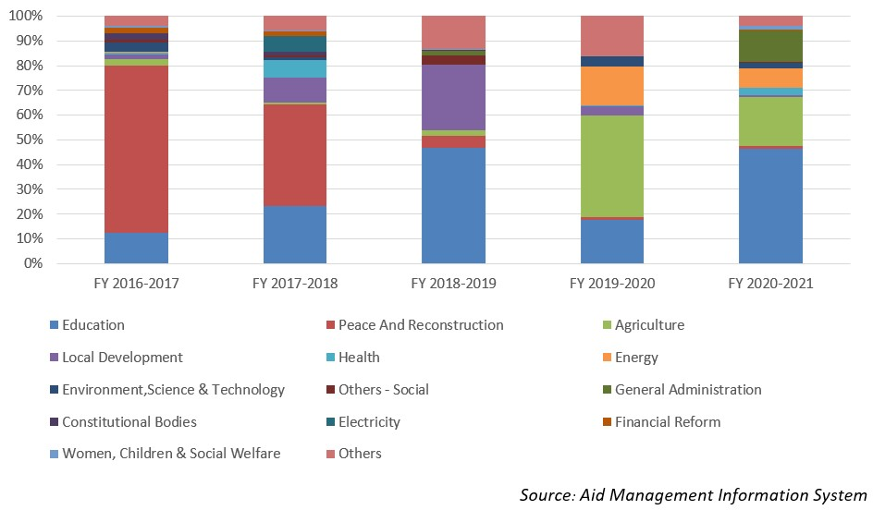
Large Projects
- EU-Nepal Practical Partnership for Technical Vocational Education and Training Reform (EU-TVET)
- Nepal - EU Action for Recovery and Reconstruction -NEARR- (State Building Contract) - CTR 383496
- Nutrition Budget Support
- The School Sector Development Program(SSDP)
- Support for stability and peace building

Disbursement during FYs 2016/17 to 2020/21 (in US$)
Over period of last five-year beginning from FY 2016/17 to 2020/21, EU has disbursed a total of US $ 379.1 million of ODA. During this period the highest level of disbursement amounting to US $ 116.1 million, took place during fiscal year 2017/18. Likewise, the lowest amount of disbursement of US $ 26.1 million was made in fiscal year 2018/19, which is below the annual average disbursement of US $ 75.8 million.
During the said five-year period, EU has committed to provide an assistance of US $ 425.9 million to Nepal through separate agreements. The highest level of commitment of aid was made of US $ 171.1 million in fiscal year 2017/18.
Fiscal Year | Agreement Amount | Disbursement
2016/17 | 49,053,159 | 83,885,219
2017/18 | 171,144,837 | 116,178,534
2018/19 | 7,706,713 | 26,177,011
2019/20 | 56,970,557 | 49,845,027
2020/21 | 141,065,831 | 105,444,147
Source: Aid Management Information System
Note: The Agreement Amount is not comparable with disbursement because disbursement here accounts for disbursement of each fiscal year only, whereas Agreement Amount refers to the project cost over the period (not only for single fiscal year but also beyond).
Country Partnership Strategy
In an effort to support Nepal, and as set out in the Multiannual Indicative Programme (MIP) 2014-2020, the EU has chosen, together with the Government of Nepal, to focus its activities on three major focal areas: (1) sustainable rural development; (2) education; and (3) strengthening democracy and decentralization.
Following the 2015 earthquakes, reconstruction also became an important focus of EU assistance to Nepal. The financial envelope for this period was 360 million Euro, which is the triple of the previous period’s financial envelope.
In the area of sustainable rural development, the EU is providing support to the National Multi-Sector Nutrition Plan (MSNP) with an envelope of 22.65 million Euros, jointly with UNICEF.
Updated
Social Sector/ IECCDJanuary 2022
References
- https://ec.europa.eu/info/strategy/eu-budget/long-term-eu-budget/2021-2027/
- http://www.oecd.org/dac/development-assistance-committee/ DAC-Joint-Statement-COVID-19.pdf

Global Fund to Fight AIDS, Tuberculosis and Malaria
The GFATM was established in 2002 with the aim of rapidly ending AIDS, tuberculosis and malaria as epidemics. Towards this end, the Global Fund has provided US $ 19.2 million to Nepal during the last five-year. Nepal is a Delegate Member of the Global Fund since its establishment.
Organization
The Global Fund to Fight AIDS, Tuberculosis and Malaria (also referred to as the Global Fund, or GFATM) is an international financing institution founded in 2002. It is a public–private partnership organization based in Geneva, Switzerland. The Bill & Melinda Gates Foundation is one of the first private foundations among many donors to provide seed money for the project. The idea of establishing the Global Fund was discussed at a G8 summit in Okinawa, Japan, in 2000. In January 2002, Global Fund came into effect with the aim of accelerating the end of AIDS, tuberculosis and malaria as epidemics.
The Board of the Global Fund meets twice a year on average and makes decisions which are binding to the Board, the Secretariat and in-country partners. In addition, the Board sets strategy, governs the institution and approves all funding decisions. The Board includes members from donor and implementer governments, non-governmental organizations, the private sector, private foundations and affected communities.
The Global Fund is a financing mechanism rather than an implementing agency. This means that the monitoring of programs is supported by a Secretariat of approximately 700 staff in Geneva. Implementation is overseen by Country Coordinating Mechanisms, committees consisting of in-country stakeholders that need to include, according to Global Fund requirements, a broad spectrum of government, NGOs, United Nations, faith-based, private sector and people living with the diseases.
Development Cooperation
Nepal has been a Delegate Member of the Global Fund since its establishment in 2002. In 2006 it was decided that the South East Asian Constituency (comprised of 11 countries of the region) would serve as a single voting member constituency of the Global Fund Executive Board. Since 2009, Nepal has been serving as a Board Member of the Global Fund, with the Minister for Health and Population of Nepal acting as a member with equal rights, and representing the South East Asian Constituency Delegation.
The organization releases funds upon the request of recipient countries through Country Coordinating Mechanisms (CCMs), which are the national committees in each country that submit funding applications to the Global Fund on behalf of the entire country. The CCM does not handle Global Fund financing itself, but is responsible for submitting proposals to the Global Fund.
The Global Fund disburses primarily through the following principal recipients: (1) Family Planning Association of Nepal (FPAN); (2) National Centre for AIDS and STD Control (NCASC); (3) National TB Centre (NTC); (4) Epidemiology & Disease Control Division; (5) Save the Children, an international non-government organization; and (6) United Nations Development Programme, along with the Government of Nepal.
Major Support by Sector
The Following major 3 sectors are the areas of GFATM
- HIV Aids
- Tuberculosis
- Malaria
Disbursement during FYs 2016/17-2020/21 (in US$)
Over the last five-year period beginning from FY 2016/17 to FY 2020/21 period, the Global Fund has disbursed a sum of US $ 19.2 million. The disbursement was at the highest level in FY 2017/18, at US$ 11.8 million. However, the level of flow declined to US $ 0.9 million in 2019/20, less than the annual average disbursement of US $ 3.8 million over the said period.
During the five-year period, the Global Fund had agreed to provide support of US $ 12.5 million to Nepal through separate agreements. The highest level of commitment was made of an amount of US $ 6.7 million in fiscal year 2016.17 whereas the lowest level of commitment was made of US $ 0.05 million in following year 2017/18.
Fiscal Year | Agreement Amount | Disbursement
2016/17 | 6,789,051 | 1,720,536
2017/18 | 50,451 | 11,867,980
2018/19 | 1,724,464 | 1,724,464
2019/20 | 940,327 | 940,327
2020/21 | 3,015,332 | 3,015,332
Source: Aid Management Information System
Note: The Agreement Amount is not comparable with disbursement because disbursement here accounts for disbursement of each fiscal year only, whereas Agreement Amount refers to the project cost over the period (not only for single fiscal year but also beyond).
Country Partnership Strategy
As the Global Fund does not have country offices around the globe, there is no specific framework agreement for Nepal. However, the recipient countries have to address the three diseases of HIV/AIDS, tuberculosis and malaria with collective efforts to end the epidemics, and this applies to Nepal as well.
As per current global strategy, the Global Fund Strategy 2017-2022, which is based on an ambitious vision to end the epidemics, as a recipient nation we have been applying for funding.
Updated
Social Sector/ IECCDJanuary 2022
References
- Global Fund: https://www.theglobalfund.org/en/
- Country Coordinating Mechanisms, Nepal: http://ccmnp.org/

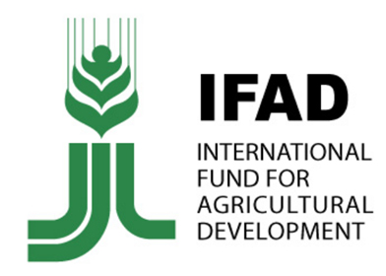 | International Fund for Agricultural Development
Nepal became a member of The International Fund for Agricultural Development in 1977. IFAD works in the most remote regions of developing countries where poverty and hunger are deepest. Nepal country strategic plan (2019–2023) of IFAD reflects the zero hunger strategic review to achieve zero hunger by 2030.
Organization
The International Fund for Agricultural Development (IFAD), a specialized agency of the United Nations, was established as an international financial institution in 1977 as one of the major outcomes of the 1974 World Food Conference. The conference was organized in response to the food crises of the early 1970’s that primarily affected the Sahelian countries of Africa.
The governance structure of IFAD is led by the Governing Council, its highest decision-making authority. Each Member State is represented in the Governing Council by Governors, Alternate Governors and any other designated advisers. The Executive Board is responsible for overseeing the general operations of IFAD and for approving its program of work.
IFAD’s Highly concessional loans carry no interest charge, have a service charge of 0.75% and are repaid over 40 years. Loans on hardened terms have the same interest and service terms, but are repaid over 20 years. IFAD is a financial institution, and this distinguishes it from its partner food and agriculture organizations, Food and Agricultural Organization (FAO) and WFP (World Food Programme).
The Annual Report 2019 of IFAD published in July 2020 shows that in Asia and the Paci­fic region there are 59 ongoing projects in 20 countries. As of 31 December 2019, 94 countries had pledged a total of US$1,008.7 million, against the IFAD11 target of US $ 1.2 billion.
Development Cooperation
Nepal became a member of IFAD on 13 December 1977. Nepal’s membership was ratified by the Governing Council on 5 May 1978, making Nepal among the first countries to benefit from IFAD funds.
IFAD’s investments reinforce the issues of poverty, inequality and social marginalization that have been at the heart of conflict in the country. Since 1977, IFAD has provided with low-interest (highly concessional) loans and grants for different socio-economic projects, directly benefitting rural households. In addition, IFAD also provides a range of regional grants, technical support and assistance across the region.
IFAD’s first project in Nepal was the Integrated Rural Development Project (Sagarmatha Zone), which was launched in November 1979 with a loan amount of US$ 11.5 million. Subsequently, on 5 December 1980, IFAD started another credit and financial services related project, the Small Farmer Development Project, with total costs of US$ 16.1 million. The Second Small Farmer Development Project (US$ 24.5 million) was initiated in 1985 after the irrigation project Command Area Development Project (US$ 30.2 million) launched in 1981. The already completed Leasehold Forestry and Livestock Programme (US$ 15.8 million) was started in 2004.
Major Support by Sector
The five major sectors of IFAD support during the last five-year period:
- Agriculture
- Forests
- Livelihood
- Labor
- Economic Reform
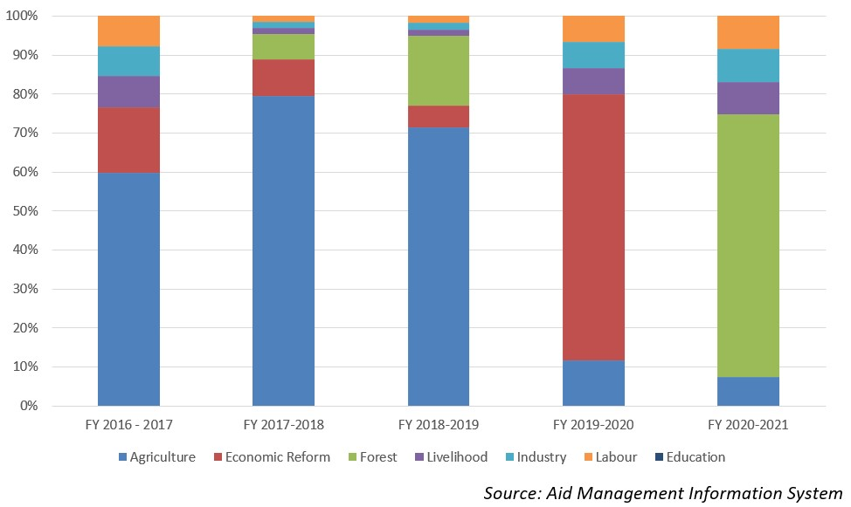
Disbursement during FYs 2016/17-2020/21 (in US$)
Over the period of last five-year beginning from fiscal year 2016/17 to fiscal year 2020/21, IFAD has disbursed a sum of US $ 56.1 million to carry out different projects of joint priorities. The highest level of disbursement was of an amount of US $ 15.8 million, which took place in fiscal year 2017/18. Likewise, the lowest level of disbursement amounting to US $ 6.4 million was made in 2020/21, which is less than the annual average disbursement during the last five year period.
In the last five year IFAD was committed to provide Nepal a sum of US $ 44.8 million to c carry out different socio-economic development projects. However, IFAD did not entered into any agreement financial support with the government during fiscal year 2016/17, 2018/19 and fiscal year 2019/20.
Country Partnership Strategy
Nepal country strategic plan (2019–2023) was approved with the total WFP cost of US $ 126 million. The plan reflects the zero hunger strategic review recommendations to achieve zero hunger by 2030. It is designed to align with the new federal structure and the constitutional right to food. The plan has five related strategic outcomes addressing Strategic Development Goals 2 and 17.
The five outcomes are: i) Affected populations will have timely access to adequate food and nutrition ii) People in food deficit targeted areas have improved nutrition throughout the key stages of their lives by 2025. Iii) Poor communities in remote food-insecure areas have improved food security and resilience to climate and other shocks by 2030 iv) Strengthened public sector capabilities to provide essential food security and nutrition by 2023, and v) Achieving zero hunger by 2030.
Updated
Agriculture and Industry Sector/ IECCDJanuary 2022
References
- IFAD: https://www.ifad.org/
- IFAD, Nepal: https://operations.ifad.org/web/ifad/operations/country/ home/tags/nepal
- IFAD Annual Report, 2019

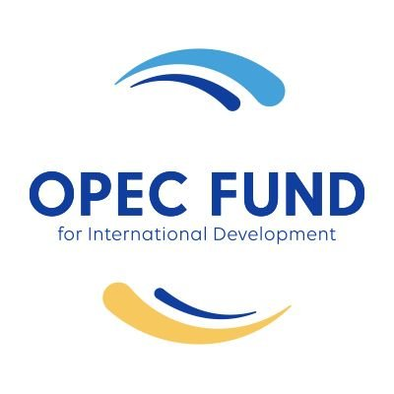 | OPEC Fund for International Development
Development cooperation between Nepal and OFID started from 1976. OFID aims to develop South-South Cooperation and help the poorer, low-income countries in pursuit of their social and economic advancement. Over the last five-year OFID has disbursed US$ 20.85 million for tourism, drinking water, urban development and agriculture projects.
Organization
The OPEC Fund for International Development (OFID), an intergovernmental development finance institution was established in January 1976 by the 13 Member Countries of the Organization of the Petroleum Exporting Countries (OPEC) following the decision made at the Conference of Sovereigns and Heads of State of the OPEC Member Countries, held in Algiers, Algeria in March 1975. Initially, it was called the OPEC Special Fund.
It provides grants in support of technical assistance, food aid, research, and humanitarian emergency relief. OFID also serves as an agent of OPEC Member Countries in the international financial arena whenever collective action is deemed appropriate.
OFID is led by its supreme authority, the Ministerial Council, composed of finance ministers of the Member Countries. The Council issues policy guidelines, approves the replenishment of OFID’s resources, authorizes the administration of special funds and makes major policy decisions. It meets once a year.
OFID provides its assistance to all developing countries with the exception of OPEC Member Countries. The least developed countries, however, are accorded higher priority. A total of 134 countries including 53 from Africa, 43 Asia, 31 Latin America and the Caribbean, and 7 Europe have been benefited from OFID’s financial assistance to date.
In 2020 the OPEC fund had committed US $ 1.59 billion. The Fund has allocated US $ 1 billion to help Covid-19 affected communities across the world and joined in multinational efforts to help developing nations to mitigate the effects of pandemic.
Development Cooperation
Development cooperation between the Government of Nepal and OFID was initiated following the establishment of the OPEC Fund by the oil-rich countries in 1976. Since then, OFID has been assisting Nepal for development projects, especially in the water and sanitation sector. OFID loans to Nepal bear a 1.5% interest charge and a 1% service charge, but carry no commitment charge.
OFID has made contributions to better the lives of poor people with proper and clean water supply. Indeed, one of OFID’s objectives in Nepal is to support a wide range of operations, ranging from large-scale water storage, treatment and distribution projects to village pumps and school latrines, as well as schemes for the efficient utilization of water in arid regions.
As of December 2021, OFID has approved loans for various sectors in Nepal for a total amount of US$ 313.40 million. The loans include one BOP support loan in the amount of US$ 4.15 million; one program loan worth US$ 5.00 million; and rest project loans. Projects supported by the loans have been mainly in the agriculture, education, telecommunications, transport, water supply and sewerage, energy and infrastructure sectors.
The OPEC Fund for International Development (the OPEC Fund) has signed a US$15 million loan in favor of NMB Bank Limited in Nepal for the purpose of financing micro-, small- and medium-sized enterprises (MSMEs) and renewable energy projects in 2019. The loan represents the OPEC Fund’s first financial institution transaction in the country.
Major Support by Sector
The followings are the major support sectors of OFID:
- Drinking Water
- Tourism
- Urban Development
- Irrigation
- Agriculture
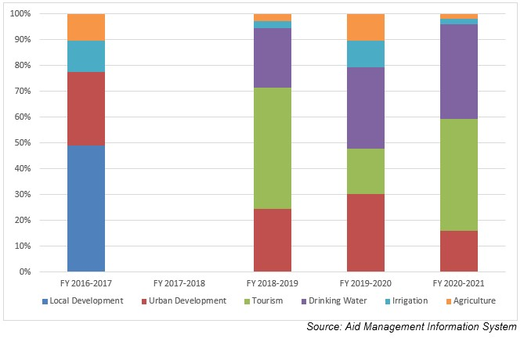
Disbursement from OFID during FYs 2016/17 to 2020/21 (in US$)
Over the last five-year period beginning from FY 2016/17 to FY 2020/21, the total disbursement amount from the OPEC Fund for International Development to Nepal is US$ 20.85 million. During the said period the level of disbursement was highest in fiscal year 2018/19 amounting to US $ 11.5 million. However, no disbursement took place in fiscal year 2017/18. The average annual disbursement over the period was US$ 4.1 million.
During the last five year period, OFID has agreed to provide US $ 3.2 million through separate agreements concluded with the government of Nepal. The highest level of support agreement was of US $ 3.4 million in fiscal year 2016/17. However, no commitment of support was made during fiscal years 2017/18 and 2020/21.
Fiscal Year | Agreement Amount | Disbursement
2016/17 | 3,455,202 | 11,377,029
2017/18 | - | -
2018/19 | 2,844,623 | 11,583,420
2019/20 | 419,289 | 4,993,013
2020/21 | - | 4,277,126
Source: Aid Management Information System
Note: The Agreement Amount is not comparable with disbursement because disbursement here accounts for disbursement of each fiscal year only, whereas Agreement Amount refers to the project cost over the period (not only for single fiscal year but also beyond).
Updated
Agriculture and Industry Sector/ IECCDJanuary 2022
References
- OPEC Fund for International Development: http://www.ofid.org/
- https://opecfund.org/operations/countries-a-z/asia/nepal

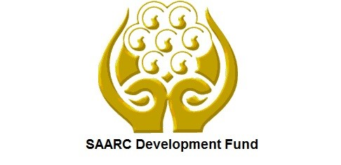 | SAARC Development Fund
Nepal - SDF cooperation is based broadly on SAARC’s overall development strategy. SDF was established in 2008 aiming at alleviating poverty and promoting the welfare of the people of the SAARC region. SDF has concentrated in areas of women, children and social welfare, agriculture and health sectors in Nepal.
Organization
A Charter of the SAARC Development Fund (SDF) was signed by the SAARC leaders on 3 August2008 at the Fifteenth SAARC Summit (Colombo, 2–3 August 2008). The SAARC[1] Development Fund (SDF) Secretariat was formed by the Heads of State/Governments of SAARC Member States in April 2010 during the 16th SAARC Summit in Thimphu, Bhutan.
SADF objectives were to support industrial development, poverty alleviation, protection of environment, institutional/human resource development and promotion of social and infrastructure development projects in the SAARC region.
The Governing Council is the apex policy making and management body of the SDF. The Member States are represented in the Governing Council by their respective Honorable Finance Ministers. The GC meets once a year for operational matters. The Fund is guided by a Board of Directors which comprises eight representatives from the Ministries of Finance of the respective Member States.
SDF is an umbrella financial institution for SAARC projects and programs which are in fulfillment of the objectives of the SAARC Charter. SDF has three funding windows: Social, Economic and Infrastructure Windows. Infrastructure Window is mainly used to fund projects in areas of energy, power, transportation, telecommunications, environment, tourism and other infrastructure areas.
As of July 2020 there are 12 un-going projects under social window. Currently SDF’s Fund commitment under Social Window totals around US $ 90.02 million, of which around US $ 48.86 million has already been disbursed. The fund (loan) commitments under Economic and Infrastructure Windows total to an amount of around US $73 million. The 33rd Meeting (virtual, 28-29 July 2020), of SDF Board, approved US $ 7.7 million for seven COVID-19 projects of the Seven Member States, to respond to the COVID-19 pandemic.
Development Cooperation
Nepal has been a member of SDF since its establishment and has a representative on the SDF Board. The development cooperation between Nepal and SDF is based broadly on SAARC’s overall strategy with its member nations because SDF is a fund under the SAARC mechanism. SDF mainly focuses on the welfare of the people of Nepal as a country in the SAARC region so that their quality of life can be improved.
The current projects under implementation through SDF support in Nepal include Networking and Capacity Building of Women Entrepreneurs (SMEs) from SAARC Countries; Bamboo Based Enterprise Development; and SAARC Regional Inter-Professional Master’s Program in Rehabilitation Science.
Major Support by Sector
The following 4 sectors are the major support sectors of SDF:
- Women, Children and Social Welfare
- Agriculture
- Communications
- Health

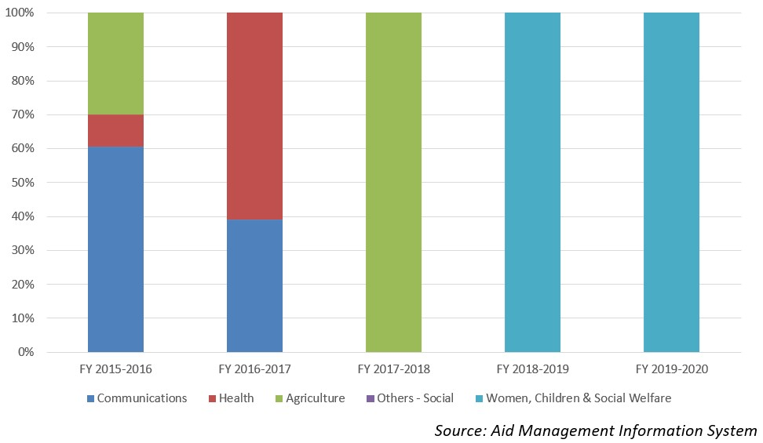
Disbursement during FYs 2016/17 - 2020/21 (in US$)
During the last five-year period beginning from fiscal year 2016/17 to fiscal year 2020/21, SDF has disbursed a total of US$ 0.82 million to Nepal. The highest level of disbursement of US $ 0.31 million took place in fiscal year 2015/16. Likewise, the lowest amount of disbursement of US $ 0.06 million took place in 2017/18, less than the average annual disbursement of US $ 0.16 million.
SDF commitment during the last five-year period was 0.57 million. The highest level of commitment agreement was made of US $ 0.15 million in fiscal year 2018/19 whereas the lowest level of commitment of US $ 0.068 was made in fiscal year 2017/18.
Fiscal Year | Agreement Amount | Disbursement
2015/16 | 126,014 | 319,319
2016/17 | 87,270 | 143,500
2017/18 | 68,843 | 68,843
2018/19 | 150,249 | 150,249
2019/20 | 138,792 | 138,792
Source: Aid Management Information System
Note: The Agreement Amount is not comparable with disbursement because disbursement here accounts for disbursement of each fiscal year only, whereas Agreement Amount refers to the project cost over the period (not only for single fiscal year but also beyond).
Country Partnership Strategy
The partnership strategies of SDF are aimed to identify, study prospects and approve projects; leverage funding i.e. arranging and mobilizing financing and/or co-financing for projects; provide grants for projects of strategic importance to SAARC, provide financial and technical assistance, and manage the fund.
The 13 stated areas of cooperation are as follows: agriculture, education, culture and sports, health, population, child welfare, the environment and meteorology, rural development (including the SAARC Youth Volunteers Program), tourism, transport, science and technology, and communications. Nepal is implementing several projects under SDF.
Updated
Social Sector/ IECCDJanuary 2022
References
- SAARC Development Fund: http://www.sdfsec.org/
- SAARC Headquarters, Nepal: http://saarc-sec.org/

[1] SAARC (South Asian Association for Regional Cooperation) is a regional intergovernmental organization and geopolitical union of nations in South Asia founded in Dhaka on 8 December 1985.

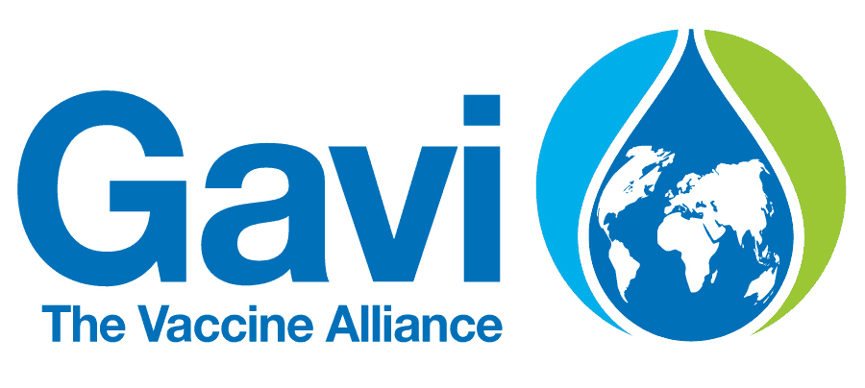 | The Global Alliance for Vaccines and Immunization
Gavi has been assisting Nepal since 2000 as a part of its global campaign of improving access for immunization in the world’s poorest countries. Its goal is creating equal access to new and underused vaccines for children living in the world’s poorest countries since its establishment in 2000.
Bilateral Relations
Gavi, The Global Alliance for Vaccines and Immunizations previously the GAVI Alliance— is a public–private partnership which is committed to increasing access to immunization in poor countries. The Geneva, Switzerland based organization was created in January 2000 with the help of a US$ 750 million five-year pledge from the Bill & Melinda Gates Foundation aiming to bring together the public and private sectors with the shared goal of creating equal access to new and underused vaccines for children living in the third world.
Gavi’s mission is to save children’s lives and protect people’s health by increasing equitable use of vaccines in lower-income countries. In June 2014, the Gavi Board approved a new five-year strategy to ensure its overall mission for 2016–2020. The mission is guided by four strategic goals: (1) Vaccine Goal (accelerate equitable uptake and coverage of vaccines), (2) Health Systems Goal (3) Sustainability Goal (improving sustainability of national immunization programs), and (4) Market Shaping Goal (shape markets for vaccines and other immunization products).
Gavi is governed by a Board with membership drawn from a range of partner organizations, as well as experts from the private sector. The Board is comprised of 18 “representative” seats, 9 seats for independent or “unaffiliated” individuals and one seat for Gavi’s CEO. Board members are appointed by the existing Board members subject to and in accordance with the statutes and by-laws.
COVAX is known as the vaccines pillar of the Access to COVID-19 Tools (ACT) Accelerator which is co-led by Gavi, the Coalition for Epidemic Preparedness Innovations (CEPI) and WHO. In 2020, the Bill & Melinda Gates Foundation has announced a five-year, US$1.6 billion commitment to Gavi, the Vaccine Alliance, to deliver lifesaving vaccines to the world’s poorest countries.
Development Cooperation
Gavi has been assisting Nepal since 2000 as a part of its global campaign of improving access for immunization in the world’s poorest countries. To date Gavi has supported Nepal with cash support (CASHSUPP), health system strengthening (HSS), new vaccine support (NVS) for the introduction of HepB mono, HPV demonstration, immunization services support (ISS), injection safety devices, injection safety support, and vaccine introduction grants (VIG).
Nepal’s first application was accepted and awarded with ISS funds of US$ 704,600 in 2001 in two equal allotments over a 2-year period. Since then, Nepal has been benefiting from Gavi’s support for new vaccine introductions and immunization campaigns. The targeted country assistance plan for 2021 of GAVI shows that Nepal will be receiving a sum of US $ 627,837 during that period.
Gavi, in collaboration with UNICEF and WHO, is supporting to national communication and social mobilization strategy for routine immunization program and providing TA to use geospatial data and for new vaccine introduction as well strengthening new vaccine introduction and routine immunization at national and sub-national levels.
Currently, at Patan hospital, Gavi is funding impact studies on two vaccines that protect children against the main causes of deadly pneumonia: Haemophilus influenzae type b (Hib) and pneumococcal disease. Three doctors— Dr Andrew J Pollard, Professor of Pediatric Infection and Immunity, University of Oxford; Professor Shrijana Shrestha, Dean of the Academy of Health Science at Patan hospital; and Dr Imran Ansari, Chief Pediatrician of Patan Hospital are leading these studies.

Disbursement during FYs 2016/17 to 2020/21 (in US$)
Over the last five-year period beginning from FY 2016/17 to 2020/21, GAVI has disbursed a sum of US$ 22.4 million of ODA was to Nepal. The highest volume of annual disbursement from GAVI was US $ 11.7 million in fiscal year 2019/20. Likewise, the lowest volume of ODA disbursement was US $ 0.02 million in fiscal year 2018/19. The average annual disbursement over the period stands at US $ 4.4 million.
During the last five-year period GAVI has agreed to provide the support of US $ 22.4 million through separate agreements. The trend of agreement and disbursement shows a direct relationship between the agreement amount and the disbursement.
Fiscal Year | Agreement Amount | Disbursement
2016/17 | 244,614 | 244,614
2017/18 | 1,173,541 | 1,173,541
2018/19 | 22,783 | 22,783
2019/20 | 11,693,153 | 11,693,153
2020/21 | 9,329,736 | 9,329,736
Source:Aid Management Information System

Note: The Agreement Amount is not comparable with disbursement because disbursement here accounts for disbursement of each fiscal year only, whereas Agreement Amount refers to the project cost over the period (not only for single fiscal year but also beyond).
Country Partnership Strategy
Gavi’s development cooperation strategy with Nepal is based on its portfolio of country support - health system strengthening (HSS) support; vaccine support; cold chain equipment optimization platform (CCEOP) support; and targeted country assistance (TCA). Gavi’s support aims to assist Nepal in advancing its national immunization plans and improving immunization coverage and equity in a sustainable way.
Apart from the studies, Gavi is assisting in other vaccine-related programs to strengthen the capacity of integrated health systems of Nepal to deliver immunization.
Updated
Social Sector/ IECCDJanuary 2022
References
- GAVI, the Vaccine Alliance: http://www.gavi.org/
- https://www.gavi.org/programmes-impact/country-hub/south-east-asia/nepal(retrieved in December 3, 2021)

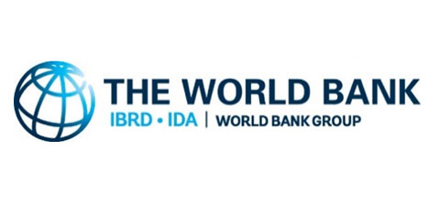 | The World Bank
IDA (WB) provided first credit to Nepal in 1969 for a telecommunication project. The World Bank Group is the world’s largest sources of funding and knowledge for developing countries. The CPF (2019-2023) and SCD prioritize public institution strengthening, private sector investment, human capital development and natural resources management.
Organization
The World Bank Group is a multilateral financial organization established in July 1945. It was founded as the International Bank for Reconstruction and Development (IBRD) in 1944 at the Bretton Woods Conference to provide loans to rebuild countries devastated by World War II. The World Bank comprises two institutions: the International Bank for Reconstruction and Development (IBRD), and the International Development Association (IDA).
The World Bank is a component of the World Bank Group, which consists of five organizations: IBRD, IDA, the International Finance Corporation (IFC), the International Centre for Settlement of Investment Disputes (ICSID), and the Multilateral Investment Guarantee Agency (MIGA).
IFC was founded in 1956 to lend to private companies and financial institutions in developing countries. IDA was established in 1960 to complement the existing IBRD by lending to developing countries which suffer from the lowest gross national income or from the lowest per capita income. ICSID was established in 1965 for legal dispute resolution and conciliation between international investors, and MIGA was founded in 1988 to offer political risk insurance and credit enhancement guarantees.
The World Bank Group, thus, is a global partnership of five institutions working for sustainable solutions that reduce poverty and build shared prosperity in developing countries. The World Bank has 189 member countries. These member countries, or shareholders, are represented by a Board of Governors, the ultimate policymakers at the World Bank. They meet once a year at the Annual Meetings of the Boards of Governors of the World Bank Group and the International Monetary Fund (IMF).
The headquarters of the Bank is in Washington, DC. The World Bank Group works in more than 130 locations across six regions - Africa, East Asia and Pacific, Europe and Central Asia, Latin America and the Caribbean, the Middle East and North Africa, and South Asia. The World Bank Group is one of the world’s largest sources of financial and technical assistance to developing countries around the world. It provides low-interest loans, zero to low-interest credits, and grants to developing countries.
These support a wide array of investments to a range of sectors and projects. Some of the projects are co-financed with governments, other multilateral institutions, commercial banks, export credit agencies, and private sector investors. The World Bank Group works with country governments, the private sector, civil society organizations, regional development banks, think tanks, and other international institutions on issues ranging from climate change, conflict, and food security to education, agriculture, finance and trade.
The World Bank Group has set two goals for the world to achieve by 2030: reducing extreme poverty to 3%, and promoting shared prosperity by increasing the incomes of the poorest 40% of people in every country. All support to a member country is guided by a single strategy that the country itself designs with support from the World Bank and others development partners.
The World Bank made four loans totaling US$ 497 million in 1947; In fiscal 2021, the number of countries eligible for IDA assistance are 74. New IDA lending commitments amounted to US $36.0 billion for 297 operations, of which seven were IBRD and IDA blended operations in this year. These commitments included $23.9 billion in credits and $12.1 billion in grants. The total disbursement during 2021 is estimated to be US $ 12.9 billion.
Development Cooperation
In 1963, the World Bank Group fielded its first economic mission to Nepal to assess the country’s development prospects and challenges. It approved its first credit in 1969 for a telecommunications project, from the International Development Association (IDA), the World Bank’s concessionary lending affiliate. The World Bank country office in Nepal was established in 1971. The World Bank (IDA) is working closely with the IFC in Nepal.
The two institutions, the World Bank and IFC, coordinate closely in the energy and financial sectors. In addition to the Systematic Country Diagnostic (SCD), multiple joint analytical works are underway. These include the Country Private Sector Diagnostic (CPSD) and the Infrastructure Sector Assessment Program (InfraSAP). IFC investment is being continued since 1956. BY June 2020, IFC’s committed portfolio is more than US$ 484 million. In 2020, IFC has financed in the 216 MW Upper Trishuli-1 Hydropower project.
Nepal is eligible for concessional financing support from the IDA. During the IDA17 period (17th replenishment (2015-2017), the World Bank committed US$ 1.2 billion. This amount included additional financing of US$ 300 million from the IDA Crisis Response Window to respond to the emergency needs after the 2015 earthquake. During the IDA18 period (FYs 2018-2020), Nepal had access to approximately US$ 1.3 billion in IDA financing.
As of December 2021 the World Bank portfolio in Nepal comprised of 43 active projects. Across its projects, the World Bank considers gender, citizen engagement and climate change as cross cutting issues. In addition to own sources, the World Bank also administered a multi-donor trust fund that pools resources from Japan, European Union, Canada, the UK’s Department for International Development (DFID), Switzerland, and USAID.
Major Support Sectors
The followings are the five top focused sectors of the World Bank group during the last five year period:
- Education
- Policy and Strategic
- Health
- Energy
- Road Transportation

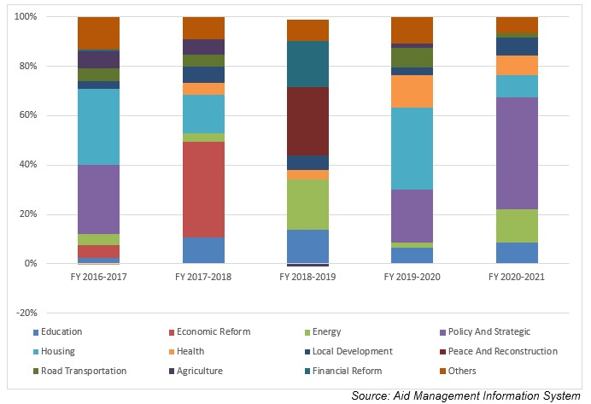
Large Projects
The following are the top five largest projects of the World Bank Group support in terms of volume of financing:
- Earthquake Housing Reconstruction Project (EHRP) - IDA
- The School Sector Development Program(SSDP)
- Strategic Road Connectivity and Trade Improvement Project
- Finance for Growth Development Policy Credit
- Forests for Prosperity

Disbursement during FYs 2016/17 to 2020/21 (in US$)
Over the last five- year period beginning from FY 2016/17 to FY 2020/21, the World Bank Group has disbursed a total of US$ 2675.5 million of aid to Nepal. In terms of volume of both commitments and disbursement, the World Bank Group has been the largest Development Partners working in Nepal. The volume of WB annual disbursement was the highest in FY 2020/21 with an amount of US$ 807.4 million. Likewise, the lowest level of annual disbursement amounting to US $ 345.9 million took place in fiscal year 2016/2017. The average annual disbursement of the World Bank group remains US $ 535.3 million, over the last five-year period. In general, resource flow from the World Bank Group during the last 5 year period remained in an increasing trend.
The World Bank Group has agreed to provide financial support of US $ 4247.5 million in the last five-year period through different agreement with the government of Nepal. The highest level of annual aid commitment was made of US $ 1270. 4 million in 2020/21 whereas the lowest level of such commitment took place in fiscal year 2018/19 at a level of US $ 629.6 million.
Fiscal Year | Agreement Amount | Disbursement
2016/17 | 645,450,000 | 345,968,357
2017/18 | 970,000,000 | 533,515,228
2018/19 | 629,610,000 | 528,313,473
2019/20 | 731,958,000 | 461,311,832
2020/21 | 1,270,491,141 | 794,605,737
Source: Aid Management Information System
Note: The Agreement Amount is not comparable with disbursement because disbursement here accounts for disbursement of each fiscal year only, whereas Agreement Amount refers to the project cost over the period (not only for single fiscal year but also beyond).

Country Partnership Strategy
The World Bank and Nepal agreed on a Country Partnership Framework (CPF) covering the five-year period of FY2019-2023 in 2018. The SCD carried by the World Bank suggested that strengthening public institutions is the top priority, followed by private sector investment, human capital development, natural resources management, strengthened resilience and unlocking the benefits of migration. Based on the stated SCD and nations development agenda the CPF has focused on three transformative engagement areas: (i) public institutions, (ii) private-sector led jobs and growth, and (iii) inclusion and resilience.
In line with the CPF, IFC’s program in Nepal is addressing the key development gaps and creating markets by focusing on financial inclusion, sustainable infrastructure, including power and connectivity, and sectors that contribute to growth, increased competitiveness and better employment opportunities.
Updated
Infrastructure Sector/ IECCD
January 2022

References
- The World Bank: http://www.worldbank.org/
- The World Bank in Nepal: http://www.worldbank.org/en/country/nepal

