|  |  |
| --- | --- |
|  | **Food and Agriculture Organization** |

**Nepal and FAO have been cooperating to improve agricultural, forestry and rural development since 1951 when Nepal became a member of FAO. FAO works to defeat hunger in over 130 countries worldwide. It is cooperating to formulate an Agriculture Development Strategy and Food and Nutrition Security Plan for Nepal.**

**Organization**

The Food and Agriculture Organization (FAO) is a specialized UN agency established in Quebec City, Canada in 1945. Washington DC was designated as a temporary FAO headquarters, which later shifted to Rome, Italy in 1951. Its major objectives are to achieve food security for all and make sure that people have regular access to enough high-quality food to lead active, healthy lives. FAO works to defeat hunger in over 130 countries worldwide.

FAO has a total of 197 Members, 194 Member Nations, one Member Organization (European Union) and two Associate Members (Faroe Islands and Tokelau), since its establishment.  FAO’s activities comprise four main areas: (1) putting information within reach; (2) sharing policy expertise; (3) providing a meeting place for nations; and (4) bringing knowledge to the field.

As with other UN agencies, FAO is directed by the Conference of Member Nations, which meets every two years to review the work carried out by the organization and to work and budget for the next two-year period. The Conference elects a council of 49 Member States (serving three-year rotating terms) that acts as an interim governing body, and the Director-General, who heads the agency.

**Development Cooperation**

Nepal and FAO have been cooperating to improve agricultural, forestry and rural development in the country over the last 64 years. Nepal became a member of FAO on 21 November 1951 and FAO established its Nepal Country Office in 1977. FAO was the first among the different UN agencies to open an office and begin field level work in Nepal.

Since its establishment, FAO in Nepal has made great strides in vital areas of agriculture and rural development by providing advice on policy matters and technical support in relevant sub sectors. Upon the request of the government, FAO mobilizes its own internal resources in the form of Technical Cooperation Programme (TCP) or solicits support for funds from potential donors in the form of Government Cooperation Programme (GCP) or Unilateral Trust Fund (UTF).

FAO works in cooperation with the Government of Nepal and other Development Partners in Nepal. To date, the organization has supported the implementation of over 350 projects in the fields of agriculture, livestock, and forestry development, food security, nutrition, rural income generation, agricultural value chains, and adaptation to the effects of climate change across the country.

In support of post-earthquake recovery, FAO developed the project Emergency Response to Restore the Rural Livelihoods of Earthquake-affected Farmers, and helped around 6,000 households.

**Major Support by Sector**

FAO support sectors during the last five year are:

1. Agriculture
2. Forests
3. Livelihood

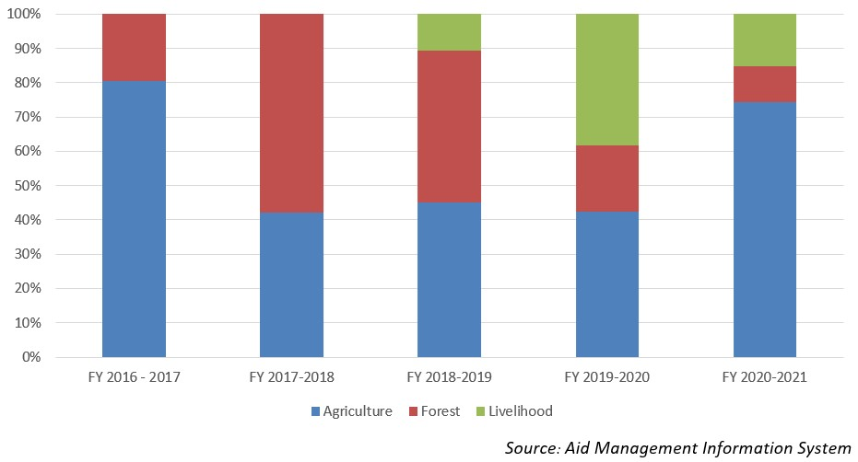

**Disbursement during FYs 2016/17 to 2020/21 (in US$)**

Over the last five-year beginning from FY 2016/17 to 2020/21, FAO has disbursed US$ 3.85 million of ODA to Nepal. The disbursement was the highest annual disbursement standing at US $ 1.53 million in fiscal year 2016/17 whereas it was the lowest amounting to US $ 0.27 million. The average annual disbursement during the said period is US $ 0.77 million.

FAO had agreed to provide US $ 3.87 million during the last fiave-year period through separate agreements. The highest level of commitment of US $ 1.6 million was made in fiscal year 2018/19 whereas the lowest level was US $ 0.13 million in fiscal year 2017/18.

|  |  |  |
| --- | --- | --- |
| **Fiscal Year** | **Agreement Amount** | **Disbursement** |
| **2016/17** | 767,000 | 1,531,432 |
| **2017/18** | 132,059 | 379,126 |
| **2018/19** | 1,608,771 | 272,209 |
| **2019/20** | 629,912 | 1,013,199 |
| **2020/21** | 737,000 | 658,175 |

*Source: Aid Management Information System*

**Note: The Agreement Amount is not comparable with disbursement because disbursement here accounts for disbursement of each fiscal year only, whereas Agreement Amount refers to the project cost over the period (not only for single fiscal year but also beyond).**

**Country Partnership Strategy**

FAO’s assistance in Nepal focuses on four priority areas for technical cooperation: (1) food and nutrition security and safety; (2) institutional and policy support, strengthening analytical and technical capacities from policy and program formulation to implementation and monitoring; (3) market orientation and competitiveness, promoting market-oriented production and value addition through enhanced technical and institutional capacities; and (4) natural resource conservation and use, including adaptation to climate change.

FAO is also collaborating with other Development Partners in supporting the Government of Nepal in formulating an Agriculture Development Strategy and a National Food and Nutrition Security Plan, both of which have a vision for 20 years. In addition, the Country Programming Framework (CPF) 2013-2017 for Nepal outlines the joint GoN and FAO medium‐term priorities for FAO’s technical assistance over the five‐year period.

**Updated**

Forest and Environment Sector/ IECCD  
January 2022

**References**

*- FAO: http://www.fao.org/home/en/*

|  |  |
| --- | --- |
|  | **Global Environment Facility** |

**Global Environment Facility (GEF) provides funding to assist developing countries in meeting the objectives of international environmental conventions. GEF has been supporting Nepal primarily in three focal areas - climate change, biodiversity, and land degradation. GEF is not a project financier but a project co-financier.**

**Organization**

The Global Environment Facility (GEF) was established in October 1991, and restructured on the eve of the 1992 Rio Earth Summit to forge international cooperation and finance actions to address critical threats to the global environment. The global environmental focal areas of GEF are biodiversity, climate change, international waters, ozone depletion, and other cross-cutting issues such as land degradation.

GEF provides funding to assist developing countries in meeting the objectives of international environmental conventions. It serves as a financial mechanism to five such conventions: Convention on Biological Diversity, United Nations Framework Convention on Climate Change (UNFCCC), Stockholm Convention on Persistent Organic Pollutants, UN Convention to Combat Desertification, and Minamata Convention on Mercury. In November 2021, GEF has 184 member countries (participants). The GEF Secretariat is located in Washington, DC.

Both developed and developing countries are donors to the GEF Trust Fund. The World Bank, since 1994, has been serving as GEF Trustee and administering the GEF Trust Fund. GEF receives contributions from 40 donor countries. At the last replenishment, 30 countries pledged a record US$ 4.43 billion for the GEF-6 period 2014 to 2018.

GEF has developed the “GEF2020: Strategy for GEF”. According to the strategy, GEF will pursue five strategic priorities: address the drivers of environmental degradation; deliver integrated solutions; enhance resilience and adaptation; ensure complementarily and synergies, especially in climate finance; and focus on choosing the right influencing model.

**Development Cooperation**

Nepal is a member of the GEF constituency comprised of Bangladesh, Bhutan, India, the Maldives, Nepal, and Sri Lanka. Nepal has nominated the Finance Secretary as Political Focal Point, and the Joint Secretary of the Ministry of Finance’s International Economic Cooperation Coordination Division as Operational Focal Point.

GEF has been supporting Nepal primarily in three focal areas - climate change, biodiversity, and land degradation. GEF’s Small Grants Programme (SGP) is implemented by the United Nations Development Programme (which hosts SGP on behalf of the GEF Implementing Agencies, namely UNEP, the World Bank and UNDP) and executed by the United Nations Office for Project Services (UNOPS).

**Major Support by Sector**

The major sectors of GEF during the five-year period are:

1. Agriculture
2. Alternative Energy
3. Forests
4. Energy
5. Environment, Science and Technology

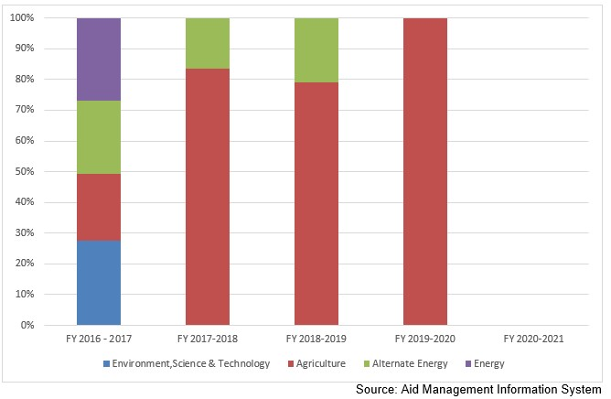

**Disbursement during FYs 2016/17 to 2020/21 (in US$)**

Over the last five-year period, beginning from FY 2016/17 to FY 2020/21, GEF disbursed a total of US$ 4 million to Nepal. During the period, the volume of disbursement was the highest in FY 2020/21, at US$ 1.8 million. Likewise no disbursement took place in fiscal year 2020/21. The annual average disbursement from GEF stands at US $ 0.8 million.

During the last five year period GEF has agreed to provide Nepal US $ 13.9 million. However, no commitment of GEF support took place in fiscal year 2017/18 and fiscal year 2019/20. Exceptionally a negative resource flow commitment of US $ 0.67 million.

|  |  |  |
| --- | --- | --- |
| **Fiscal Year** | **Agreement Amount** | **Disbursement** |
| **2016/17** | -676,516 | 1,879,163 |
| **2017/18** |  | 1,422,362 |
| **2018/19** | 28,000 | 687,022 |
| **2019/20** |  | 108,925 |
| **2020/21** | 14,597,248 |  |

*Source: Aid Management Information System*

**Note: The Agreement Amount is not comparable with disbursement because disbursement here accounts for disbursement of each fiscal year only, whereas Agreement Amount refers to the project cost over the period (not only for single fiscal year but also beyond).**

**Country Partnership Strategy**

The Country Programme Strategy (CPS) 2015-2018 includes four main strategic initiatives: community landscape conservation; reclamation of degraded public and community lands through community based innovative activities; conservation of biodiversity and ecosystems; and climate change mitigation and adaptation, including the promotion of innovative climate-smart agriculture, and low carbon energy access co-benefits. The CPS specifically identifies the goals, strategic objectives and outcomes that GEF-SGP Nepal proposes to achieve over this operational phase.

**Updated**

Forest and Environment Sector/ IECCD  
January 2022

**References**

*-*   The Global Environment Facility *(*GEF*): https://www.thegef.org*

*-*   GEF in Nepal*: https://www.thegef.org/country/nepal*

|  |  |
| --- | --- |
|  | **Green Climate Fund** |

**The Green Climate Fund (GCF) is a global fund set up by 194 countries to support the efforts of developing countries to respond to the challenges of climate change. Mitigating GhG emission, improving climate resilience of vulnerable communities and building resilience Churia Region are the Nepalese projects approved by GCF.**

**Organization**

The Green Climate Fund (GCF) is a global fund created to support the efforts of developing countries to respond to the challenge of climate change. It was set up by 194 countries who were parties to the United Nations Framework Convention on Climate Change (UNFCCC) in 2010, as part of the Convention’s financial mechanism. These funds come mainly from developed countries and also from developing countries, regions, and one city (Paris).

Developing countries appoint a National Designated Authority (NDA) that acts as the interface between their government and GCF, and must approve all GCF project activities within the country.

The Fund also pays particular attention to the needs of societies that are highly vulnerable to the effects of climate change. GCF focuses on the use of public investment to stimulate private finance, for climate-friendly investment for low emission, climate resilient development. GCF’s investments can be in the form of grants, loans, equity or guarantees.

The 29th meetings of the Board (July 2021) decided to allocate an additional amount of up to USD 12.4 million under the Readiness and Preparatory Support Programme as a new dedicated support component. International Center for Integrated Mountain Development, Nepal was accredited by AF since 31 January 2021 as the eligible entity for fast-track accreditation to GCF.  The 29th meeting of the Board approved USD 501.1 million of GCF funding, supporting projects and programmes with a total value of USD 2,948.8 million.

**Development Cooperation**

Ministry of Finance (MoF) is designated as the NDA and serves as the contact for GCF in Nepal. As preparatory support, MoF’s International Economic Cooperation Coordination Division, in collaboration with the United Nations Development Programme (UNDP) and the United Nations Environment Programme (UNEP) is implementing the Green Climate Fund Readiness Program in Nepal (GCF-RP), with financial support from the German Federal Ministry for the Environment, Nature Conservation, Building and Nuclear Safety (BMUB).

Although Nepal is yet to access funds directly from GCF, the GCF Board has approved US$ 3 million for development of the National Adaptation Plan for Nepal through UNEP. Similarly, the NDA has nominated two national institutions i.e. Alternative Energy Promotion Center (AEPC) and National Trust for Nature Conservation (NTNC) for their accreditation as Direct Access Entities to access resources from GCF more directly.

The 3 projects, mitigating GhG emission, improving climate resilience of vulnerable communities, and building a resilience Churia Region are submitted and approved by GCF for financing of an amount of US $ 87.8 million. Likewise, for 3 readiness activities are ongoing at the cost of US $ 4.5 million approved from GCF.

**Updated**

Forest and Environment Sector/ IECCD  
January 2022

**References**

*-*   *GCF: https://www.greenclimate.fund/home*

*-*   *https://www.greenclimate.fund/sites/default/files/document/gcf-b29-02-rev02.pdf*

|  |  |
| --- | --- |
|  | **International Labour Organization** |

**Nepal joined International Labour Organization in 1966.  ILO brings together governments, employers and workers to set labor standards and promote decent work for all women and men. Enabling decent work for all ensuring fundamental principles and rights at work are the ILO priorities for 2018-2022 in Nepal.**

**Organization**

ILO was founded in 1919 and became the first specialized agency of the UN in 1946. The ILO is the only tripartite UN agency based in Geneva, Switzerland. It has 187 Member States — 186 of the 193 UN Member States and the Cook Islands. The ILO was founded as a part of the Treaty of Versailles that ended World War I, to reflect the belief that universal and lasting peace can be accomplished only if it is based on social justice.

The Governing Body is the executive body of the ILO. The ILO secretariat (staff) is referred to as the International Labour Office. The Governing Body meets three times a year, in March, June and November. It takes decisions on ILO policy, decides the agenda of the International Labour Conference, adopts the draft program and budget for submission to the Conference, and elects the Director-General.

The ILO aims to ensure that it serves the needs of working women and men by bringing together governments, employers and workers to set labor standards, develop policies and devise programs. The ILO encourages this tripartism within its constituents- employers, workers and Member States- by promoting social dialogue between trade unions and employers in formulating, and where appropriate, implementing national policy on social, economic, and many other issues.

The Organization is devoted to promoting social justice and internationally recognized human and labor rights, pursuing its founding mission that social justice is essential to universal and lasting peace.  To address the issues such as forced labor, minimum wage laws, HIV/AIDS, migrant workers, domestic workers and globalization, the ILO has been investing millions of dollars every year. In FY 2018/19, it had allocated US$ 784.1 million for global aid and had proposed US$ 790.6 million worth of support for fiscal year 2020/21.

**Development Cooperation**

Nepal joined the ILO in 1966. Later, in January 1994, the Office of the Senior ILO Adviser was established in Nepal in view of the increasing need for support in the country and scope for expansion of ILO programs. The Kathmandu office transitioned to a full-fledged Country Office in 2000. The ILO program in Nepal is aligned with the ILO work worldwide, the Government’s Development Plan and the United Nations Development Assistance Framework (UNDAF).

 From Protocol to Practice: A BRIDGE to Global Action on Forced Labour (2015-2019) aimed at  effectively eliminating  traditional and modern slavery/forced labor systems often linked to human trafficking. Apart from Government other project partners were Rastriya Mukta Haliya Samaj Federation (RMHSF), as well as workers’ and employers’ organizations.

 The ILO-DFID Partnership Programme on Fair Recruitment and Decent Work for Women Migrant Workers in South Asia and the Middle East “Work in Freedom” was implemented to reduce the incidence of trafficking of women and girls from India, Bangladesh and Nepal through economic, social and legal empowerment. The ILO provided technical assistance to the Nepal Labor Force Survey-III Project (2017-2018), in partnership with CBS.

**Disbursement during FYs 2016/17 to 2020/21 (in US$)**

Over the last five-year period beginning from FY 2016/17 to FY 2020/21, the ILO has disbursed US$ 4.48 million of ODA to Nepal. The disbursement was US$ 1.4 million in FY 2020/21, highest in terms of volume during the 5-year period. There was no disbursement at all in fiscal year 2019/20, while the annual average disbursement during this 5 year period was 0.89 million.

The ILO has agreed to provide a total support of US $ 5.2 million in the last five year period. However there was no any commitment at all in three different fiscal years- 2016/16, 2018/19 and 2020/21.

|  |  |  |
| --- | --- | --- |
| **Fiscal Year** | **Agreement Amount** | **Disbursement** |
| **2016/17** |  | 800,000 |
| **2017/18** | 2,200,000 | 1,200,000 |
| **2018/19** |  | 1,000,000 |
| **2019/20** | 3,000,000 |  |
| **2020/21** |  | 1,485,000 |

*Source: Aid Management Information System*

**Note: The Agreement Amount is not comparable with disbursement because disbursement here accounts for disbursement of each fiscal year only, whereas Agreement Amount refers to the project cost over the period (not only for single fiscal year but also beyond).**

**Country Partnership Strategy**

The ILO Nepal Decent Work Country Programme (DWCP) 2013-2017 focused on three fundamental areas: (i) Promotion of employment-centric and inclusive growth; (ii) Improved labor market governance and industrial relations; and (iii) Promotion of fundamental principles and rights at work.

The ILO Office in Nepal has formulated its next phase of Decent Work Country Programme, 2018 to 2022. There are two priorities: (1) Enabling decent work for all through sustainable and inclusive growth; and (2) Ensuring fundamental principles and rights at work.

**Updated**

Social Sector/ IECCD  
January 2022

**References**

*-*   ILO*:* http*://*www*.*ilo*.*org*/*global*/*lang*--*en*/*index*.*htm

*-*   ILO Country Office, Nepal*:* http*://*www*.*ilo*.*org*/*kathmandu*/*lang*--*en*/*index*.*htm

|  |  |
| --- | --- |
|  | **United Nations Children's Fund** |

**UNICEF began its work in Nepal from 1964 though its liaison Office established in 1968. UNICEF was awarded Nobel Peace Prize in 1965 for its assistance to children and mothers in developing countries. The agreed CPAP (2018-2022) with UNICEF emphasizes health, nutrition, education, WASH and child protection.**

**Organization**

The United Nations Children’s Fund (UNICEF) is a United Nations (UN) agency created by the General Assembly on 11 December 1946. At the time of establishment, its name was the United Nations International Children’s Emergency Fund and the objective was to provide emergency food and healthcare to children in countries that had been devastated by World War II.

UNICEF works with about 13,000 staff in over 190 countries and territories. Its headquarters is in New York. More than 200 country offices carry out UNICEF’s mission through programs developed with host governments. Seven regional offices provide technical assistance to country offices as needed. UNICEF’s office for the South Asian Region is based in Kathmandu. UNICEF works with national governments, non-governmental organizations, other UN agencies and private sector partners, to protect children and their rights.

UNICEF is dependent on contributions from governments and private donors. Governments contribute two-thirds of the organization’s resources. Most of the fundraising is done by UNICEF’s 36 National Committees, which are independent non-governmental organizations. The UNICEF Executive Board approves a total commitment for Regular Resources to support the program activities described in the Country Plan of Action (CPAP).

Direct programme expenses of UNICEF was US $ 5.7 billion as per the UNICEF Annual Report 2020. In 2020, in the face of the pandemic, UNICEF adapted its health programming to support the global COVID-19 response and to ensure continuation of essential lifesaving services. The areas of assistance were health, education, water, sanitation and hygiene (WASH), child protection, nutrition, social inclusion and HIV/AIDS.

**Development Cooperation**

UNICEF began its work in Nepal in 1964 under the administrative supervision of the United Nations Development Programme (UNDP) from its New Delhi office. UNICEF’s Liaison Office in Nepal was established in 1968, and an Office was opened in 1972 to support the Government’s efforts to provide basic services to Nepali children. The Basic Cooperation Agreement (BCA) was agreed on 21 February 1996.

Nepal served on UNICEF’s Executive Board during 1982–1985, 1992–1994, 2002–2004 and 2016-2018.  Election of Nepal in the Board was the opportunity to contribute to the work of the United Nations at the global level. Likewise, Ambassador and Permanent Representative of Nepal to the United Nations Mr Durga Prasad Bhattarai was unanimously elected as Vice-President to the Bureau of the Executive Board of UNICEF for 2016.

UNICEF has contributed to logistic support and immunization in the 1960’s and 1970’s and early childhood rights, education and protection in the 1980’s. UNICEF will support SSDP as a joint financing partner.

**Major Support by Sector**

The following are the top five sectors of UNICEF cooperation:

1. Education
2. Health
3. Drinking water
4. Local Development
5. Women, Children and Social Welfare

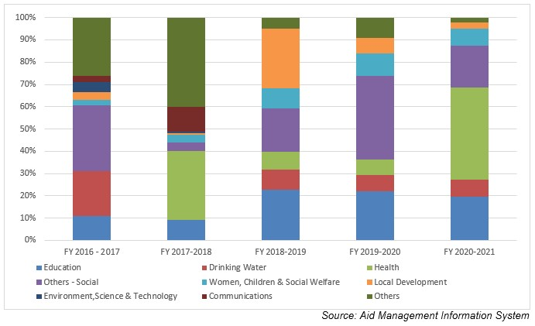

**Disbursement during FYs 2016/17 to 2020/21 (in US$)**

Over the last five-year period beginning from FY 2016/17 to FY 2020/21, UNICEF has disbursed a total of US$ 155.6  million to Nepal. The volume of disbursement was the highest, at US$ 66 million, in FY 2019/20. Likewise, the lowest level of UNICEF support was disbursed amounting to US $ 13 million in fiscal year 2019/20. The average annual disbursement was US $ 31.1 million in the said period.

UNICEF has committed to provide a sum of US $ 136.4 million to Nepal during the last five year period. The highest level of annual aid commitment of US $ 68.4 million was made in fiscal year 2017/18. Such commitment was made at the lowest level of US $ 3.9 million in fiscal year 2019/20.

|  |  |  |
| --- | --- | --- |
| **Fiscal Year** | **Agreement Amount** | **Disbursement** |
| **2016/17** | 38,523,755 | 66,016,245 |
| **2017/18** | 68,483,941 | 31,429,240 |
| **2018/19** | 14,770,549 | 24,551,955 |
| **2019/20** | 3,981,628 | 13,096,020 |
| **2020/21** | 10,692,608 | 20,555,700 |

*Source: Aid Management Information System*

**Note: The Agreement Amount is not comparable with disbursement because disbursement here accounts for disbursement of each fiscal year only, whereas Agreement Amount refers to the project cost over the period (not only for single fiscal year but also beyond).**

In 2017 UNICEF underwent a participatory exercise involving stakeholders at all levels to design a new country program, and in response to the new federal structure in the country. UNICEF’s programs for 2018-2022 have focused the areas of cooperation as per the particular exercise.

**Country Partnership Strategy**

The ongoing CPAP (2018-2022) agreed between Nepal and UNICEF is fully aligned with United Nations Development Assistance Framework (UNDAF 2018-2022) contributing directly to three of the UNDAF’s four outcomes: (1) social development; (2) disaster risk reduction, disaster preparedness and resilience; and (3) human rights, rule of law and governance. The CPAP (2018-2022) is structured by six components: Health, Nutrition, Education, Wash, Child protection and Social policy, evidence and evaluation.

A budget of US $ 150 million is estimated as a requirement to carry out the Action Plan that covers all the components. UNICEF’s Executive Board has approved the total commitment for regular resources and has also authorized the executive director to seek additional funding to support the implementation of programmes specified in the CPAP.

**Updated**

Forest and Environment Sector/ IECCD  
January 2022

**References**

*-*   UNICEF*:* https*://*www*.*unicef*.*org*/*

*-*   UNICEF in Nepal*:* http*://*www*.*unicef*.*org*.*np

|  |  |
| --- | --- |
|  | **United Nations Development Programme** |

**UNDP has been working in Nepal from its in-country office since 1963 though the Standard Basic Assistance Agreement was signed in 1984. UNDP’s Strategic Plan (2022-2025) envisages helping 100 million people to escape from multidimensional poverty. The CPD (2018-2022) emphasizes skill building, climate change and sustainable natural resource management.**

**Organization**

The United Nations Development Programme (UNDP) is the United Nations’ global development network founded on 22 November 1965. UNDP headquarter is in New York, the USA. UNDP works in over 170 countries and territories of the globe and has five regional bureaus worldwide with regional hubs in each regional bureau. The UNDP Administrator is the third highest-ranking official of the United Nations after the United Nations Secretary-General and Deputy Secretary-General.

UNDP’s Strategic Plan 2018-2021 had focused on supporting countries to end extreme poverty, reduce inequality, and achieve the goals of the 2030 Agenda for Sustainable Development. The Plan intends to guide nations to be driven by their own choice of development and poverty eradication.

UNDP supports nations to pursue i) structural transformation including green, inclusive and digital transitions; ii), leaving no-one behind: a rights-based approach centered on empowerment, inclusion, equity, human agency and human development; iii) Building resilience: strengthening countries and institutions to prevent, mitigate and respond to crisis, conflict, natural disasters, climate and social and economic shocks.

The Strategic Plan has stipulated 6 different signature solutions in realizing the SDGs, namely poverty and inequality, gender equality, energy, environment, resilience and governance. Likewise, 3 enablers are devised by the plan to scale up development impact for partner nations. They are: Digitalization, Strategic innovation and development financing.

The UNDP Executive Board is made up of representatives from 36 countries around the world who serve on a rotating basis. The Board oversees and supports the activities of UNDP, ensuring that the organization remains responsive to the evolving needs of program countries. UNDP is funded entirely by voluntary contributions from UN Member States, multilateral organizations, private sector and other sources.

**Development Cooperation**

UNDP has been working in Nepal since it opened an in-country office in 1963, just a few years before UNDP’s official establishment. The Government of Nepal and UNDP entered into a formal agreement, the Standard Basic Assistance Agreement, on 23 February 1984 to govern UNDP’s assistance to Nepal. Since then, UNDP’s support has helped government agencies, civil society and community groups to improve the lives of the Nepalese people.

UNDP Nepal’s work is closely linked with the priorities of both the Government and the United Nations system in Nepal. Much of the support has gone to building up the capacity of government agencies, civil society, and community groups to fight poverty and to bringing these groups and Nepal’s donors together to design and implement successful poverty alleviation projects.

In 2017, UNDP was able to train and orient 600 masons and carpenters and 25,000 people (about 40% women) on resilient and affordable housing models. Similarly, in 2016, UNDP successfully completed a climate adaptation project at one of the world’s highest places, in the Everest region. The project involved draining the Imja glacial lake, which was at the risk of bursting, by three meters through a sluice, making the lives of over 80,000 people downstream safer.

**Major Support by Sector**

The followings are the top five sectors out of dozens of  UNDP support areas:

1. Livelihood
2. Policy and Strategic
3. Peace and reconstruction
4. Alternative Energy
5. Education

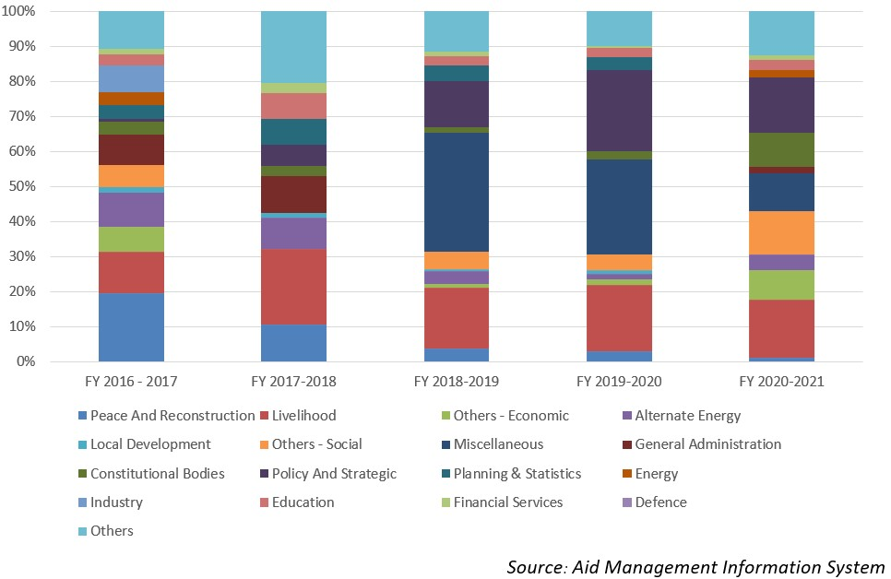

**Disbursement during FYs 2016/17 to 2020/21 (in US$)**

Over the last five-year beginning from fiscal year 2016/17 to fiscal year 2020/21, UNDP has disbursed a total of US $ 29.59 million to Nepal. The volume of disbursement was the highest, at US$ 7.9 million, in FY 2018/19 and the lowest was at a level of US $ 3.3 million in 2017/18. The average annual disbursement from UNDP over the five-year period remained US $ 5.9 million.

UNDP has made commitment through different agreements of providing US $ 50.3 million in the last five-year period. The highest level of annual commitment was of US $ 17.8 million, committed in fiscal year 2018/19. Likewise, the lowest level of annual support commitment was of US $ 1.7 million, which was made in fiscal year 2016/17.

|  |  |  |
| --- | --- | --- |
| **Fiscal Year** | **Agreement Amount** | **Disbursement** |
| **2016/17** | 1,728,744 | 6,412,697 |
| **2017/18** | 9,607,628 | 3,362,985 |
| **2018/19** | 17,822,502 | 7,910,600 |
| **2019/20** | 10,104,499 | 7,336,956 |
| **2020/21** | 11,064,025 | 4,569,762 |

*Source: Aid Management Information System*

**Note: The Agreement Amount is not comparable with disbursement because disbursement here accounts for disbursement of each fiscal year only, whereas Agreement Amount refers to the project cost over the period (not only for single fiscal year but also beyond).**

**Country Partnership Strategy**

The present UNDP’s strategic engagement in Nepal is stated in its Country Programme Document (CPD), which covers the period 2018-2022. The CPD is aligned not only with the 2018-2022 UNDAF, but also with the SDGs and Nepal’s Fourteenth Development Plan. Three outcomes have been identified in the CPD.

1. Increased access to employment and livelihoods: UNDP will contribute through the mutually reinforcing strategies of skills building. Ii. Strengthened democratic institutions andBuilding resilience to natural hazards and climate change, and strengthening sustainable environmental and natural resources management.

**Updated**

Forest and Environment Sector/ IECCD  
January 2022

**References**

*-   UNDP: http://www.undp.org/*

*-   UNDP in Nepal: http://www.np.undp.org*

|  |  |
| --- | --- |
|  | **United Nations Educational, Scientific and Cultural Organization** |

**Nepal became the member of UNESCO in 1953 although its country office in Kathmandu was established in 1998. UNESCO aims to contribute to peace and security by promoting international collaboration through educational, scientific, and cultural reforms.  UNESCO advocates for education, building peace and fostering intercultural dialogue in Nepal.**

**Organization**

United Nations Educational, Scientific and Cultural Organization (UNESCO) is a specialized agency of the United Nations formed on 16 November 1945. Its headquarters is in Paris, France. It is the successor of the League of Nations’ International Committee on Intellectual Cooperation (ICIC).[1]

In general UNESCO pursues peace and security objectives through five major program areas: education, natural sciences, social/human sciences, culture and communication/information.

UNESCO’s governance structure is led by two phases, the General Conference and the Executive Board. The General Conference consists of the representatives of UNESCO’s Member States. It meets every two years, and is attended by Member States and Associate Members, together with observers for non-Member States, intergovernmental organizations and non-governmental organizations. It also elects the Members of the Executive Board and appoints the Director-General for a 4 year term.

UNESCO has a global network of national cooperating bodies known as National Commissions for UNESCO. Presently, there are 199 National Commissions for UNESCO across the world.

The  Programme  and  Budget  for  2018-2021  (39  C/5  Approved)  covers  the  last  quadrennium  of  the  Medium-Term Strategy for 2014-2021 (37 C/4) which focuses on UNESCO’s contribution for the implementation of Sustainable  Development agenda  and  the  Paris  Agreement  on  Climate  Change.

**Development Cooperation**

Nepal became a member of the UNESCO in 1953. In 1998 UNESCO established its country office for Nepal in Kathmandu. Since then, UNESCO Nepal has been supporting the Government of Nepal to attain quality education for all, mobilize scientific knowledge and science policy for sustainable development, preserve Nepal’s rich cultural heritage and promote cultural diversity.

Development cooperation ties between Nepal and UNESCO started in the 1950’s, though official assistance only began in 1979 with the project Financing Assistance for the Consolidation of Swoyambhu Temple in Kathmandu Valley with a cost of US$ 30,000. The most recent contribution from UNESCO was in Post-Earthquake Assistance for Emergency Operations and to Re-build the Capacity of Management Authorities for the Safeguarding of the Kathmandu Valley World Heritage Property.

There are projects being executed under the Participatory Programme (PP) via Nepal National Commission for UNESCO (NatCom), which is under the Ministry of Education. UNESCO Nepal works closely with the NatCom as a main counterpart. NatCom’s main function is to be involved in UNESCO’s activities in various ministerial departments, agencies, institutions, organizations and with individuals working for the advancement of education, sciences, culture, and communication and information in Nepal.

**Major Support by Sector**

The followings are top five sectors of UNESCO Support during the last five year period:

1. Tourism
2. Earthquake Reconstruction
3. Education
4. Women, Children and Social Welfare
5. Youth Sports and Culture

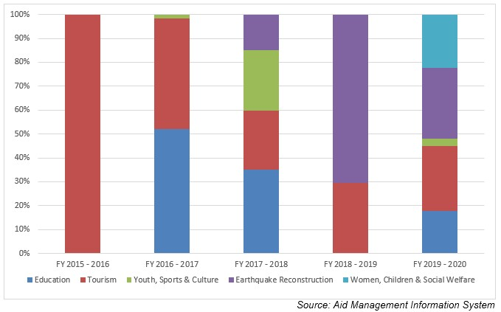

**Disbursement during FYs 2016/17-2020/21 (in US$)**

Over the last five-year beginning from FY 2016/17 to FY 2020/21, a total of US$ 2.6 million of support was disbursed to Nepal from UNESCO. The highest amount of annual support was disbursed in FY 2016/17, in the amount of US$ 1.5 million. Likewise, the lowest level of disbursement took place in fiscal year 2018/19 in the amount of US $ 0.19 million which is lower than the average annual disbursement of US $ 0.5 million.

UNESCO, over the last five-year period has agreed to provide a sum of US $ 3.2 million through 5 separate agreements. Its annual commitment was the highest in fiscal year 2015/16 with an amount of US $ 1.99 million whereas the lowest level of annual commitment of UNESCO support was US $ 0.09 million in fiscal year 2016/17.

|  |  |  |
| --- | --- | --- |
| **Fiscal Year** | **Agreement Amount** | **Disbursement** |
| **2015/16** | 1,990,798 | 201,675 |
| **2016/17** | 533,005 | 1,592,269 |
| **2017/18** | 377,595 | 350,405 |
| **2018/19** | 98,501 | 192,327 |
| **2019/20** | 205,134 | 305,961 |

*Source: Aid Management Information System*

**Note: The Agreement Amount is not comparable with disbursement because disbursement here accounts for disbursement of each fiscal year only, whereas Agreement Amount refers to the project cost over the period (not only for single fiscal year but also beyond).**

**Country Partnership Strategy**

UNESCO advocates for education, building peace, alleviating poverty, and fostering sustainable development and intercultural dialogue in Nepal.

It works to attain quality education for all, focusing on women empowerment and literacy, to rehabilitate cultural heritage after the earthquake, promote cultural diversity and intercultural dialogue, to mobilize scientific knowledge, to promote press freedom, freedom of expression.

**Updated**

Forest and Environment Sector/ IECCD  
January 2022

**References**

*-*   UNESCO*:* https*://*en*.*unesco*.*org*/*

*-*   UNESCO Office, Nepal*:* http*://*www*.*unesco*.*org*/*new*/*en*/*kathmandu*/*

[1] An advisory organization for the League of Nations which had aimed to promote international exchange between scientists, researchers, teachers, artists and intellectuals; established in 1922.

|  |  |
| --- | --- |
|  | **United Nations Entity for Gender Equality and the Empowerment of Women** |

**The UN Women Nepal Country Office was established in 2012. UN Women is mandated to be a lead driver and lead voice advocating for gender equality and women’s empowerment globally. UN Women in Nepal focuses on violence against women, leadership and participation and economic empowerment of women.**

**Organization**

The United Nations Entity for Gender Equality and the Empowerment of Women, UN Women is a New York based UN organization established in July 2010 which became operational in January 2011. It works globally to make the vision of the Agenda 2030 and its Sustainable Development Goals (SDGs)[1]a reality for women and girls, standing behind women’s equal participation in all aspects of life.

Five key priority areas of UN Women are: expanding women’s leadership and political participation; ending violence against women; engaging women in all aspects of peace and security processes; enhancing women’s economic empowerment; and making gender equality central to national development planning and budgeting.[2]

UN Women is governed by a multi-tiered intergovernmental governance structure in charge of providing normative and operational policy guidance. The organization is led by an Under Secretary-General appointed by the Secretary-General in consultation with Member States, for a term of four years, with the possibility of renewal for one term.

UN Women implements programs in more than 90 countries in the world. Its funding comes from different donors either through governmental, organizational or individual contributions. In 2020, UNWOMEN received a total of US $ 548.6 million. This contribution consists of the contribution from Member States, business partners, philanthropists and individual donors.

**Development Cooperation**

The UN Women Nepal Country Office was established in April 2012 in Kathmandu, and received full Delegation of Authority in July 2013. The Country Office’s Strategic Note for 2018-2022 builds on lessons learned from past programming and adopts a holistic and integrated approach across its two thematic priorities, inclusive governance and leadership and women’s economic empowerment. Moreover, the Country Office explicitly pursues the objective of transforming discriminatory social norms and harmful practices.

The Strategic Note is guided by Nepal’s stated priorities, as described in Nepal’s Fourteenth Three-year Periodic Plan, and its commitments to relevant normative frameworks, the country’s United Nations Development Assistance Framework (UNDAF) for Nepal 2018-2022; the CEDAW[3] Concluding Observations 2011; as well as Agenda 2030 for Sustainable Development and UN Women’s Corporate Strategic Plan 2018-2021. The Country Office promotes national ownership, capacity development and institutionalization.

The Country Office seeks to advance women’s economic empowerment by promoting increased income security, better jobs and economic independence of vulnerable women. The Country Office is adopting a Communications for Development (C4D) approach to further mobilize awareness and action on transforming discriminatory social norms and harmful practices.

**Major Support Sectors**

The followings are the major support sectors of UN Women:

1. Women, Children and Social Welfare
2. Policy and Strategic
3. Agriculture
4. Home Affaires
5. Education

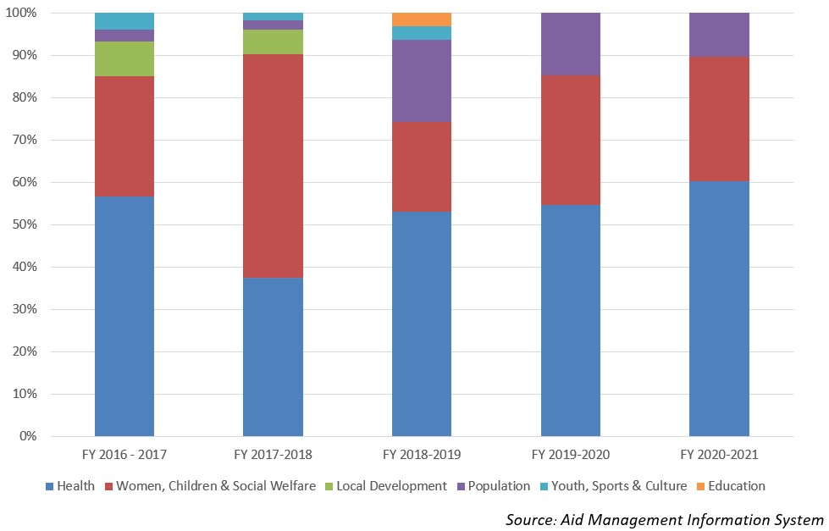

**Disbursement during FYs 2016/17 to 2020/21 (in US$)**

Over the period of five-year beginning from FY 2016/17 to FY 2020/21, UN Women’s Country Office in Nepal has disbursed US$ 5.2 million of ODA. The disbursement volume was highest with US$ 1.8 million in FY 2018/19. And the level of annual disbursement touched the lowest level in fiscal year 2017/18 with an amount of US$ 0.16 million. The average annual disbursement over the period stands at US $ 1 million during the last five year period.

The UN Women had agreed to provide a sum of US $ 7.5 million during the five year period through separate agreements with the government of Nepal. The highest level of annual commitment was made of US $ 2.2 million in fiscal year 2016/17 and the lowest level of commitment took place in 2019/20 at a level of US $ 0.33 million.

|  |  |  |
| --- | --- | --- |
| **Fiscal Year** | **Agreement Amount** | **Disbursement** |
| **2015/16** | 1,710,858 | 1,108,091 |
| **2016/17** | 2,251,655 | 1,635,873 |
| **2017/18** | 2,187,659 | 164,984 |
| **2018/19** | 1,055,025 | 1,884,590 |
| **2019/20** | 333,472 | 413,472 |

*Source: Aid Management Information System*

*Source: Aid Management Information System*

**Note: The Agreement Amount is not comparable with disbursement because disbursement here accounts for disbursement of each fiscal year only, whereas Agreement Amount refers to the project cost over the period (not only for single fiscal year but also beyond).**

**Country Partnership Strategy**

Guided by UN Charter, the UN Women country office, Nepal works for the elimination of discrimination against women and girls; empowerment of women; achievement of equality between women and men as partners and beneficiaries of development, human rights, humanitarian action and peace and security.

The UN Women office in Nepal will provide substantive support to UN bodies working in Nepal on all aspects of gender equality issues. It is guided by CEDAW, BPfA and MDGs. UN Women in Nepal, will focus on the following key areas: i) Violence against women ii) Peace and security iii) Leadership and Participation iv) Economic Empowerment and v) National planning and budget.

**Updated**

Forest and Environment Sector/ IECCD  
January 2022

**References**

*-   UN Women, headquarters, New York, USA: http://www.unwomen.org/en*

*-   https://un.org.np/agency/un-women*

[1] A set of 17 Sustainable Development Goals —as part of UN General Assembly Resolution A/RES/70/1 'Transforming our World: the 2030 Agenda for Sustainable Development' — were adopted in September 2015.

[2]More information about UN Women Strategic Plan priority areas is available at UN Women corporate website, <http://www.unwomen.org/en/executive-board/documents/strategic-plan-2018-2021>

[[3] The Convention on the Elimination of all Forms of Discrimination against Women (CEDAW) is an international treaty adopted in 1979 by the UN General Assembly. Described as an international bill of rights for women, it was instituted on 3 September 1981 and has been ratified by 189 states.](http://www.unwomen.org/en/executive-board/documents/strategic-plan-2018-2021)

|  |  |
| --- | --- |
|  | **United Nations Population Fund** |

**In Nepal, UNFPA has been focusing on reproductive rights, maternal health and family planning since 1971. It envisages every pregnancy is wanted, every child birth is safe and every young person’s potential is fulfilled. UNFPA’s strategic plan (2018-2022), aims at ending preventable maternal deaths and unmet need for family planning.**

**Organization**

The United Nations Population Fund (UNFPA), formerly the United Nations Fund for Population Activities is a UN organization. The United Nations Fund for Population Activities was established as a trust fund in 1967 and began operations in 1969. In 1987, it was officially renamed the United Nations Population Fund, reflecting its lead role in the UN system in the area of population. The original abbreviation, UNFPA, is retained.

UNFPA supports programs in more than 150 countries and areas spread across four geographic regions: Arab States and Europe, Asia and the Pacific, Latin America and the Caribbean, and sub-Saharan Africa. It is a member of the United Nations Development Fund and part of its Executive Committee.  The Executive Board ensures that the UNDP, UNFPA and the United Nations Office for Project Services (UNOPS) remain responsive to the evolving needs of program countries, and support the work of UNFPA.

Contributions to UNFPA totaled US$ 979 million in 2015. In 2020 the core and co-financing contribution to UNFPA constituted a total of US $ 1,268 million. Of the total contribution US$ 417 million was core contribution and the remaining US$ 851 million was from co-financing contributions which constitutes 66% of the total contributions.

**Development Cooperation**

UNFPA cooperation in Nepal began in 1971, and has evolved in response to the changing national context. Since the beginning, UNFPA has been working in close collaboration with the Government of Nepal in the areas of population dynamics, gender equality, reproductive rights, maternal health, and family planning.

UNFPA’s major goal is to achieve universal access to Sexual and Reproductive Health (SRH) services including family planning and to realize reproductive rights and reduce maternal mortality. Its mandate is guided by the Program of Action adopted at the International Conference on Population and Development.

With funding made available through the Australian Government’s Gender Equality Fund, the Department of Foreign Affair and Trade (DFAT) and UNFPA signed an agreement on 23 March 2016 providing US$ 385,000 grant for empowering girls in Nepal through life skills and comprehensive sexuality education. The beneficiaries are school age children, aged 5 to 16, attending public schools, as well as some participating in non-formal education.

**Major Sectors of Support**

The followings are the  top five sectors of UNFPA support:

1. Health
2. Women, Children and Social Welfare
3. Population
4. Education
5. Local Development

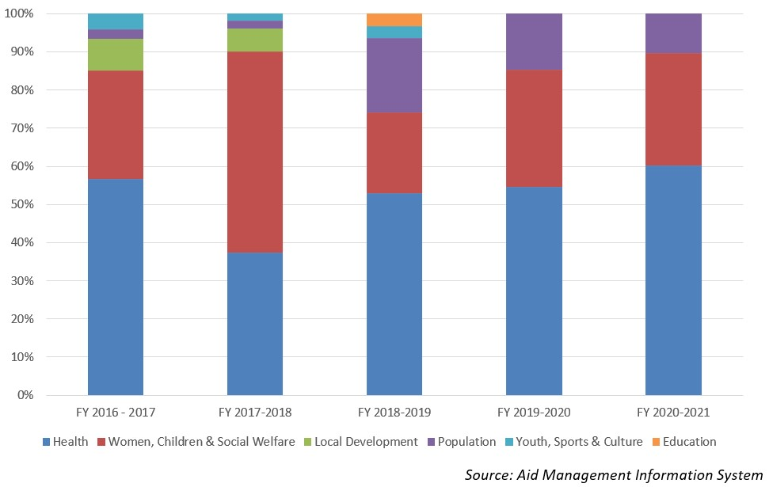

**Disbursement during FYs 2016/17 to 2020/21 (in US$)**

Over a period of five-year beginning from FY 2016/17 to FY 2020/21, Nepal has received total ODA disbursement of US$ 23.9 million from UNFPA. In FY 2020/21 the disbursement volume was recorded highest at US$ 6.6 million. Likewise, the lowest volume of disbursements took place in fiscal year 2017/18 at the level of US $ 3.0 million. The average annual disbursement during the five-year period stands at US $ 4.7 million.

UNFPA has agreed to provide US $ 26.6 million ODA support during the last five-year period through separate agreements with the government. The highest level of commitment was made in fiscal year 2019/20. However, there was no any agreement of support in fiscal year 2016/17.

|  |  |  |
| --- | --- | --- |
| **Fiscal Year** | **Agreement Amount** | **Disbursement** |
| **2016/17** | **0** | 4,745,440 |
| **2017/18** | 6,081,714 | 3,040,651 |
| **2018/19** | 5,746,056 | 5,611,005 |
| **2019/20** | 8,409,747 | 3,878,748 |
| **2020/21** | 6,384,462 | 6,672,101 |

*Source: Aid Management Information System*

**Note: The Agreement Amount is not comparable with disbursement because disbursement here accounts for disbursement of each fiscal year only, whereas Agreement Amount refers to the project cost over the period (not only for single fiscal year but also beyond).**

**Country Partnership Strategy**

UNFPA’s Country Programme is aligned with the Government’s national health sector strategies and plans, as well as with the UN Development Assistance Framework. UNFPA’s major contribution has been in the strengthening of national systems through, among others, development of policies, strategies, guidelines and protocols; equipment and supplies; capacity building and quality improvement in the health sector.

UNFPA’s new strategic plan (2018-2022), has focused on three transformative results: first, to end preventable maternal deaths, second to end unmet need for family planning and the third to end gender-based violence and harmful practices. The fourth outcomes areas stipulated in the Plan are: a. Sexual and reproductive health; b. Adolescents and youth c. Gender equality and women’s empowerment and d. Population dynamics. Altogether US $ 30.8 million is proposed as an indicative UNFPA assistance for this period.

**Updated**

Forest and Environment Sector/ IECCD  
January 2022

**References**

*-   UNFPA: http://www.unfpa.org/*

*-   UNFPA in Nepal: http://nepal.unfpa.org/*

|  |  |
| --- | --- |
|  | **World Food Programme** |

**WFP has been supporting Nepal since 1963, to develop greater food security. WFP is a humanitarian agency fighting against hunger, delivering food assistance in emergencies and working with communities. In view of Nepal's vulnerability to natural disasters, country strategic plan (2019-2023) focuses on emergency preparedness and response.**

**Organization**

WFP was established in 1961 following the 1960 Food and Agricultural Organization (FAO) Conference, when George McGovern, director of the United States Food for Peace Programs, proposed establishing a multilateral food aid program. On average, WFP reaches more than 80 million people with food assistance in over 80 countries every year, addressing hunger and promoting food security.

The Strategic Plan (2022- 2026) is guided by the Sustainable Development Goals (SDGs) set forth in the 2030 Agenda, in particular Goal 2 on ending hunger and Goal 17 on revitalizing global partnerships for implementation of the SDGs.  The six enablers of the five year strategic plans of WFP are: partnership, workforce, finance, technology, evidence and innovation.

WFP is governed by its Executive Board, which consists of 36 Member States and provides intergovernmental support, direction and supervision of WFP’s activities. The organization is headed by an Executive Director, who is appointed jointly by the UN Secretary-General and the Director-General of the Food and Agriculture Organization of the United Nations.

WFP relies entirely on voluntary contributions to finance its humanitarian and development projects. Donations are made either as cash, food in-kind or the basic items necessary to grow, store and cook food — kitchen utensils, agricultural tools, and warehouses. Governments are the principal source of funding for WFP. In 2020, WFP raised US$ 8.4 billion from voluntary contributions.

**Development Cooperation**

WFP has been working in Nepal since 1963, supporting the Government to develop greater food security among vulnerable communities and build resilience to disasters. The WFP Country Office for Nepal was established in 1967. Its work in Nepal primarily targets the most food insecure and those in the hard-to-reach districts of the mid- and far-western hills and mountains.

WFP’s main priority areas in Nepal include: resilience building, nutrition, risk reduction and capacity development, earthquake recovery activities and food assistance to refugees in Nepal. WFP also works to prevent chronic malnutrition and provides school meals to 270,000 children. To support education, WFP supplies non-food items such as school furniture and constructs toilets.

**Major Sectors of Support**

The followings are the top sectors of the WFP support during the last five-year period:

1. Home Affairs
2. Education
3. Health
4. Agriculture
5. Livelihood

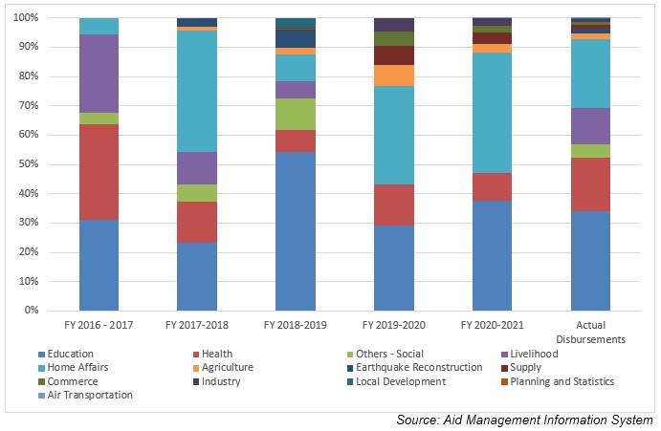

**Disbursement during FYs 2016/17 to 2020/21 (in US$)**

Over the period of the last fove-year beginning from FY 2016/17 to FY 2020/21, US$ 104.7million of ODA was disbursed to Nepal by WFP. The disbursement hit its highest level in FY 2016/17, at US$ 35.1 million. Likewise, the disbursement touched the lowest level amounting to US $ 9.2 million in 2019/20.  The average annual disbursement was US $ 20.9 million during the five-year period.

WFP had committed to provide assistance of US $ 78.9 million in the last five-year period through separate agreements with the government. The highest amount of support committed was US $ 34.8 million in the agreement concluded in fiscal year 2019/20. Likewise, the lowest amount of support of US $ 3.8 million was committed in fiscal year 2016/17.

|  |  |  |
| --- | --- | --- |
| **Fiscal Year** | **Agreement Amount** | **Disbursement** |
| **2016/17** | 3,849,290 | 35,187,558 |
| **2017/18** | 29,514,966 | 23,722,014 |
| **2018/19** | 13,356,238 | 16,881,065 |
| **2019/20** | 34,887,387 | 9,290,079 |
| **2020/21** | 32,198,678 | 19,732,900 |

*Source: Aid Management Information System*

**Note: The Agreement Amount is not comparable with disbursement because disbursement here accounts for disbursement of each fiscal year only, whereas Agreement Amount refers to the project cost over the period (not only for single fiscal year but also beyond).**

**Country Partnership Strategy**

This country strategic plan (2019-2023) provides support for the Government in its work to achieve the Strategic Development Goals. WFP expects to shift from direct implementation of food security and nutrition programmes to more specialized technical assistance to the Government and for national programmes. In view of Nepal's vulnerability to natural disasters, emergency preparedness and response will be a WFP focus.

WFP has earmarked support of US $ 126 million for  the said plan period. WFP is also supporting the Government of Nepal to conduct a strategic review of SDG 2 (end hunger, achieve food security and improve nutrition, and promote sustainable agriculture).

**Updated**

Forest and Environment Sector/ IECCD  
January 2022

**References**

*-   WFP: http://www1.wfp.org/*

*-   WFP Country Office, Nepal: http://www1.wfp.org/countries/nepal*

*-   https://docs.wfp.org/api/documents/9e280ff2cc1846ba85108050995de293/*

|  |  |
| --- | --- |
|  | **World Health Organization** |

**Nepal became a member of WHO and joined South East Asia Region by becoming a party to the Constitution in 1953. WHO is concerned with international public health and provides leadership on health issues. WHO Cooperation Strategies (2018-2022) focuses to reduce mortality and morbidity from communicable diseases in Nepal.**

**Organization**

The World Health Organization (WHO) is a specialized agency of the United Nations that is concerned with international public health. It was established on 22 July 1946 by the representatives of 61 States and entered into force on 7 April 1948 after the first meeting of the World Health Assembly. The WHO is a member of the UN Development Group and its predecessor, the Health Organization, was an agency of the League of Nations.

WHO helps people around the globe by providing leadership on matters critical to health and engaging in partnerships where joint action is needed; setting norms/standards and promoting their implementation; articulating ethical and evidence-based policy options; providing technical support, and building sustainable institutional capacity; and monitoring the health situation and assessing health trends.

The World Health Assembly is the supreme decision-making body for WHO. It generally meets in Geneva in May each year to determine the policies of the organization and is attended by delegations from all 194 Member States. The three strategic priorities of the Program of work 13th are achieving universal health coverage, addressing health emergencies and promoting healthier population. The total programme budget 2020–2021 amounts to US$ 4.84 billion.

**Development Cooperation**

Nepal became a member of WHO in September 1953 by becoming a party to the Constitution, joining the South East Asia Region (SEAR).[1]  Later, in 1954, WHO established its Country Office in Kathmandu. Since then it has been working in collaboration with the Government of Nepal for developing health systems and improving health outcomes for the population.

A recent major contribution of WHO in Nepal was the handing over of the Regional Health Emergency Operation Centre (RHEOC) in Doti to the Far-Western Regional Health Directorate on 24 November 2017. Other key areas of focus include the decentralized district health system as well as support to improve epidemiological surveillance with regard to malaria, Japanese encephalitis, HIV/AIDS, polio eradication and leprosy elimination.

**Disbursement during FYs 2016/17 to 2020/21 (in US$)**

Over the last five-year period beginning from FY 2016/17 to FY 2020/21, US$ 19.9 million of ODA was disbursed to Nepal from WHO. The highest level of disbursement took place in FY 2020/21, at US$ 8.1 million. Likewise, the lowest level of disbursement, US $ 2.3 was made in fiscal year 2016/17. The annual average disbursement in the five-year period is US $ 3.99 million.

WHO had committed to make available of US $ 25.9 million to the government of Nepal through five separate agreements in over last five-year. Highest level of commitment of annual support was of US $ 11.3 million in fiscal year 2020/21, whereas the lowest level of aid commitment was of US $ 3.0 million in fiscal year 2017/18. But there is no direct year to year relationship between the amount of commitment and of disbursement.

|  |  |  |
| --- | --- | --- |
| **Fiscal Year** | **Agreement Amount** | **Disbursement** |
| **2015/16** | 5,106,635 | 2,395,241 |
| **2016/17** | 3,099,335 | 3,099,335 |
| **2017/18** | 3285473 | 3,285,473 |
| **2018/19** | 3,108,016 | 3,108,016 |
| **2019/20** | 11,305,859 | 8,097,568 |

*Source:Aid Management Information System*

**Note: The Agreement Amount is not comparable with disbursement because disbursement here accounts for disbursement of each fiscal year only, whereas Agreement Amount refers to the project cost over the period (not only for single fiscal year but also beyond).**

**Country Partnership Strategy**

Nepal and WHO have developed a Country Cooperation Strategies (2018-2022) which has outlined four different strategic priorities - a. Advancing universal health coverage in a federalized governance structure, b. Effective delivery of priority public health programmes, c. Enhance health security and disaster preparedness and response, d. Multi-sectoral engagement and partnerships for improved health outcomes.

In addition, the WHO’s main focus areas for cooperation with Nepal are to reduce mortality and morbidity from communicable diseases including vaccine-preventable diseases, and to achieve disease eradication, elimination and control targets of communicable diseases; to support prevention and control of major non-communicable diseases through the primary health care approach.

**Updated**

Forest and Environment Sector/ IECCD  
January 2022

**References**

*-   WHO: http://www.who.int/en/*

*-   WHO Country Office, Nepal: http://www.searo.who.int/nepal/about/history/en/*

*- https://apps.who.int/iris/bitstream/handle/10665/272476/9789290226413-pdf*

[1] WHO’s South East Asia Regioncomprises a group of 11 states/countries including Bangladesh, India, Indonesia, Nepal, Sri Lanka, Thailand, Bhutan, DPR Korea, Myanmar, Maldives and Timor-Leste.