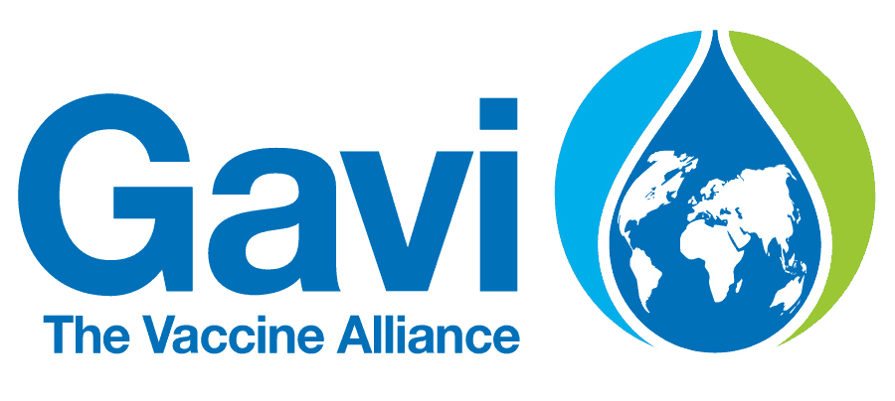 | The Global Alliance for Vaccines and Immunization
Gavi has been assisting Nepal since 2000 as a part of its global campaign of improving access for immunization in the world’s poorest countries. Its goal is creating equal access to new and underused vaccines for children living in the world’s poorest countries since its establishment in 2000.
Bilateral Relations
Gavi, The Global Alliance for Vaccines and Immunizations previously the GAVI Alliance— is a public–private partnership which is committed to increasing access to immunization in poor countries. The Geneva, Switzerland based organization was created in January 2000 with the help of a US$ 750 million five-year pledge from the Bill & Melinda Gates Foundation aiming to bring together the public and private sectors with the shared goal of creating equal access to new and underused vaccines for children living in the third world.
Gavi’s mission is to save children’s lives and protect people’s health by increasing equitable use of vaccines in lower-income countries. In June 2014, the Gavi Board approved a new five-year strategy to ensure its overall mission for 2016–2020. The mission is guided by four strategic goals: (1) Vaccine Goal (accelerate equitable uptake and coverage of vaccines), (2) Health Systems Goal (3) Sustainability Goal (improving sustainability of national immunization programs), and (4) Market Shaping Goal (shape markets for vaccines and other immunization products).
Gavi is governed by a Board with membership drawn from a range of partner organizations, as well as experts from the private sector. The Board is comprised of 18 “representative” seats, 9 seats for independent or “unaffiliated” individuals and one seat for Gavi’s CEO. Board members are appointed by the existing Board members subject to and in accordance with the statutes and by-laws.
COVAX is known as the vaccines pillar of the Access to COVID-19 Tools (ACT) Accelerator which is co-led by Gavi, the Coalition for Epidemic Preparedness Innovations (CEPI) and WHO. In 2020, the Bill & Melinda Gates Foundation has announced a five-year, US$1.6 billion commitment to Gavi, the Vaccine Alliance, to deliver lifesaving vaccines to the world’s poorest countries.
Development Cooperation
Gavi has been assisting Nepal since 2000 as a part of its global campaign of improving access for immunization in the world’s poorest countries. To date Gavi has supported Nepal with cash support (CASHSUPP), health system strengthening (HSS), new vaccine support (NVS) for the introduction of HepB mono, HPV demonstration, immunization services support (ISS), injection safety devices, injection safety support, and vaccine introduction grants (VIG).
Nepal’s first application was accepted and awarded with ISS funds of US$ 704,600 in 2001 in two equal allotments over a 2-year period. Since then, Nepal has been benefiting from Gavi’s support for new vaccine introductions and immunization campaigns. The targeted country assistance plan for 2021 of GAVI shows that Nepal will be receiving a sum of US $ 627,837 during that period.
Gavi, in collaboration with UNICEF and WHO, is supporting to national communication and social mobilization strategy for routine immunization program and providing TA to use geospatial data and for new vaccine introduction as well strengthening new vaccine introduction and routine immunization at national and sub-national levels.
Currently, at Patan hospital, Gavi is funding impact studies on two vaccines that protect children against the main causes of deadly pneumonia: Haemophilus influenzae type b (Hib) and pneumococcal disease. Three doctors— Dr Andrew J Pollard, Professor of Pediatric Infection and Immunity, University of Oxford; Professor Shrijana Shrestha, Dean of the Academy of Health Science at Patan hospital; and Dr Imran Ansari, Chief Pediatrician of Patan Hospital are leading these studies.

Disbursement during FYs 2016/17 to 2020/21 (in US$)
Over the last five-year period beginning from FY 2016/17 to 2020/21, GAVI has disbursed a sum of US$ 22.4 million of ODA was to Nepal. The highest volume of annual disbursement from GAVI was US $ 11.7 million in fiscal year 2019/20. Likewise, the lowest volume of ODA disbursement was US $ 0.02 million in fiscal year 2018/19. The average annual disbursement over the period stands at US $ 4.4 million.
During the last five-year period GAVI has agreed to provide the support of US $ 22.4 million through separate agreements. The trend of agreement and disbursement shows a direct relationship between the agreement amount and the disbursement.
Fiscal Year | Agreement Amount | Disbursement
2016/17 | 244,614 | 244,614
2017/18 | 1,173,541 | 1,173,541
2018/19 | 22,783 | 22,783
2019/20 | 11,693,153 | 11,693,153
2020/21 | 9,329,736 | 9,329,736
Source:Aid Management Information System

Note: The Agreement Amount is not comparable with disbursement because disbursement here accounts for disbursement of each fiscal year only, whereas Agreement Amount refers to the project cost over the period (not only for single fiscal year but also beyond).
Country Partnership Strategy
Gavi’s development cooperation strategy with Nepal is based on its portfolio of country support - health system strengthening (HSS) support; vaccine support; cold chain equipment optimization platform (CCEOP) support; and targeted country assistance (TCA). Gavi’s support aims to assist Nepal in advancing its national immunization plans and improving immunization coverage and equity in a sustainable way.
Apart from the studies, Gavi is assisting in other vaccine-related programs to strengthen the capacity of integrated health systems of Nepal to deliver immunization.
Updated
Social Sector/ IECCDJanuary 2022
References
- GAVI, the Vaccine Alliance: http://www.gavi.org/
- https://www.gavi.org/programmes-impact/country-hub/south-east-asia/nepal(retrieved in December 3, 2021)

