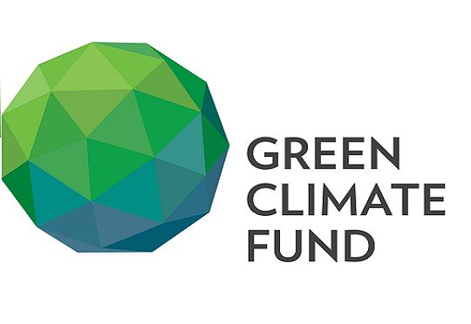 | Green Climate Fund
The Green Climate Fund (GCF) is a global fund set up by 194 countries to support the efforts of developing countries to respond to the challenges of climate change. Mitigating GhG emission, improving climate resilience of vulnerable communities and building resilience Churia Region are the Nepalese projects approved by GCF.
Organization
The Green Climate Fund (GCF) is a global fund created to support the efforts of developing countries to respond to the challenge of climate change. It was set up by 194 countries who were parties to the United Nations Framework Convention on Climate Change (UNFCCC) in 2010, as part of the Convention’s financial mechanism. These funds come mainly from developed countries and also from developing countries, regions, and one city (Paris).
Developing countries appoint a National Designated Authority (NDA) that acts as the interface between their government and GCF, and must approve all GCF project activities within the country.
The Fund also pays particular attention to the needs of societies that are highly vulnerable to the effects of climate change. GCF focuses on the use of public investment to stimulate private finance, for climate-friendly investment for low emission, climate resilient development. GCF’s investments can be in the form of grants, loans, equity or guarantees.
The 29th meetings of the Board (July 2021) decided to allocate an additional amount of up to USD 12.4 million under the Readiness and Preparatory Support Programme as a new dedicated support component. International Center for Integrated Mountain Development, Nepal was accredited by AF since 31 January 2021 as the eligible entity for fast-track accreditation to GCF. The 29th meeting of the Board approved USD 501.1 million of GCF funding, supporting projects and programmes with a total value of USD 2,948.8 million.
Development Cooperation
Ministry of Finance (MoF) is designated as the NDA and serves as the contact for GCF in Nepal. As preparatory support, MoF’s International Economic Cooperation Coordination Division, in collaboration with the United Nations Development Programme (UNDP) and the United Nations Environment Programme (UNEP) is implementing the Green Climate Fund Readiness Program in Nepal (GCF-RP), with financial support from the German Federal Ministry for the Environment, Nature Conservation, Building and Nuclear Safety (BMUB).
Although Nepal is yet to access funds directly from GCF, the GCF Board has approved US$ 3 million for development of the National Adaptation Plan for Nepal through UNEP. Similarly, the NDA has nominated two national institutions i.e. Alternative Energy Promotion Center (AEPC) and National Trust for Nature Conservation (NTNC) for their accreditation as Direct Access Entities to access resources from GCF more directly.
The 3 projects, mitigating GhG emission, improving climate resilience of vulnerable communities, and building a resilience Churia Region are submitted and approved by GCF for financing of an amount of US $ 87.8 million. Likewise, for 3 readiness activities are ongoing at the cost of US $ 4.5 million approved from GCF.

Updated
Forest and Environment Sector/ IECCDJanuary 2022
References
- GCF: https://www.greenclimate.fund/home
- https://www.greenclimate.fund/sites/default/files/document/gcf-b29-02-rev02.pdf

