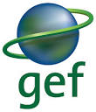 | Global Environment Facility
Global Environment Facility (GEF) provides funding to assist developing countries in meeting the objectives of international environmental conventions. GEF has been supporting Nepal primarily in three focal areas - climate change, biodiversity, and land degradation. GEF is not a project financier but a project co-financier.
Organization
The Global Environment Facility (GEF) was established in October 1991, and restructured on the eve of the 1992 Rio Earth Summit to forge international cooperation and finance actions to address critical threats to the global environment. The global environmental focal areas of GEF are biodiversity, climate change, international waters, ozone depletion, and other cross-cutting issues such as land degradation.
GEF provides funding to assist developing countries in meeting the objectives of international environmental conventions. It serves as a financial mechanism to five such conventions: Convention on Biological Diversity, United Nations Framework Convention on Climate Change (UNFCCC), Stockholm Convention on Persistent Organic Pollutants, UN Convention to Combat Desertification, and Minamata Convention on Mercury. In November 2021, GEF has 184 member countries (participants). The GEF Secretariat is located in Washington, DC.
Both developed and developing countries are donors to the GEF Trust Fund. The World Bank, since 1994, has been serving as GEF Trustee and administering the GEF Trust Fund. GEF receives contributions from 40 donor countries. At the last replenishment, 30 countries pledged a record US$ 4.43 billion for the GEF-6 period 2014 to 2018.
GEF has developed the “GEF2020: Strategy for GEF”. According to the strategy, GEF will pursue five strategic priorities: address the drivers of environmental degradation; deliver integrated solutions; enhance resilience and adaptation; ensure complementarily and synergies, especially in climate finance; and focus on choosing the right influencing model.
Development Cooperation
Nepal is a member of the GEF constituency comprised of Bangladesh, Bhutan, India, the Maldives, Nepal, and Sri Lanka. Nepal has nominated the Finance Secretary as Political Focal Point, and the Joint Secretary of the Ministry of Finance’s International Economic Cooperation Coordination Division as Operational Focal Point.
GEF has been supporting Nepal primarily in three focal areas - climate change, biodiversity, and land degradation. GEF’s Small Grants Programme (SGP) is implemented by the United Nations Development Programme (which hosts SGP on behalf of the GEF Implementing Agencies, namely UNEP, the World Bank and UNDP) and executed by the United Nations Office for Project Services (UNOPS).
Major Support by Sector
The major sectors of GEF during the five-year period are:
- Agriculture
- Alternative Energy
- Forests
- Energy
- Environment, Science and Technology
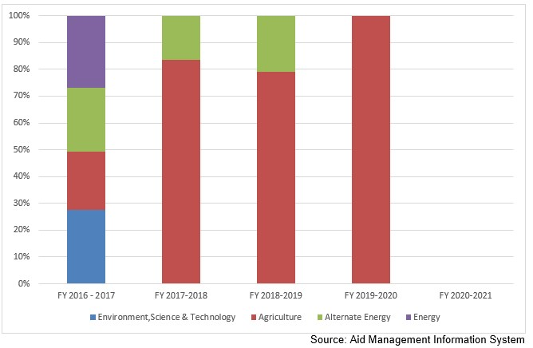
Disbursement during FYs 2016/17 to 2020/21 (in US$)
Over the last five-year period, beginning from FY 2016/17 to FY 2020/21, GEF disbursed a total of US$ 4 million to Nepal. During the period, the volume of disbursement was the highest in FY 2020/21, at US$ 1.8 million. Likewise no disbursement took place in fiscal year 2020/21. The annual average disbursement from GEF stands at US $ 0.8 million.
During the last five year period GEF has agreed to provide Nepal US $ 13.9 million. However, no commitment of GEF support took place in fiscal year 2017/18 and fiscal year 2019/20. Exceptionally a negative resource flow commitment of US $ 0.67 million.
Fiscal Year | Agreement Amount | Disbursement
2016/17 | -676,516 | 1,879,163
2017/18 |  | 1,422,362
2018/19 | 28,000 | 687,022
2019/20 |  | 108,925
2020/21 | 14,597,248
Source: Aid Management Information System
Note: The Agreement Amount is not comparable with disbursement because disbursement here accounts for disbursement of each fiscal year only, whereas Agreement Amount refers to the project cost over the period (not only for single fiscal year but also beyond).
Country Partnership Strategy
The Country Programme Strategy (CPS) 2015-2018 includes four main strategic initiatives: community landscape conservation; reclamation of degraded public and community lands through community based innovative activities; conservation of biodiversity and ecosystems; and climate change mitigation and adaptation, including the promotion of innovative climate-smart agriculture, and low carbon energy access co-benefits. The CPS specifically identifies the goals, strategic objectives and outcomes that GEF-SGP Nepal proposes to achieve over this operational phase.
Updated
Forest and Environment Sector/ IECCDJanuary 2022
References
- The Global Environment Facility (GEF): https://www.thegef.org
- GEF in Nepal: https://www.thegef.org/country/nepal

