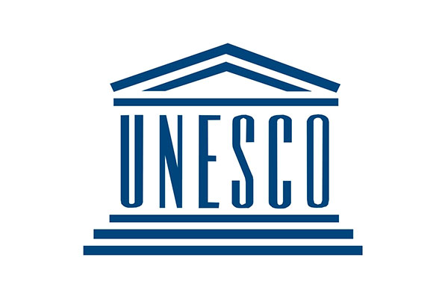 | United Nations Educational, Scientific and Cultural Organization
Nepal became the member of UNESCO in 1953 although its country office in Kathmandu was established in 1998. UNESCO aims to contribute to peace and security by promoting international collaboration through educational, scientific, and cultural reforms. UNESCO advocates for education, building peace and fostering intercultural dialogue in Nepal.
Organization
United Nations Educational, Scientific and Cultural Organization (UNESCO) is a specialized agency of the United Nations formed on 16 November 1945. Its headquarters is in Paris, France. It is the successor of the League of Nations’ International Committee on Intellectual Cooperation (ICIC).[1]
In general UNESCO pursues peace and security objectives through five major program areas: education, natural sciences, social/human sciences, culture and communication/information.
UNESCO’s governance structure is led by two phases, the General Conference and the Executive Board. The General Conference consists of the representatives of UNESCO’s Member States. It meets every two years, and is attended by Member States and Associate Members, together with observers for non-Member States, intergovernmental organizations and non-governmental organizations. It also elects the Members of the Executive Board and appoints the Director-General for a 4 year term.
UNESCO has a global network of national cooperating bodies known as National Commissions for UNESCO. Presently, there are 199 National Commissions for UNESCO across the world.
The Programme and Budget for 2018-2021 (39 C/5 Approved) covers the last quadrennium of the Medium-Term Strategy for 2014-2021 (37 C/4) which focuses on UNESCO’s contribution for the implementation of Sustainable Development agenda and the Paris Agreement on Climate Change.
Development Cooperation
Nepal became a member of the UNESCO in 1953. In 1998 UNESCO established its country office for Nepal in Kathmandu. Since then, UNESCO Nepal has been supporting the Government of Nepal to attain quality education for all, mobilize scientific knowledge and science policy for sustainable development, preserve Nepal’s rich cultural heritage and promote cultural diversity.
Development cooperation ties between Nepal and UNESCO started in the 1950’s, though official assistance only began in 1979 with the project Financing Assistance for the Consolidation of Swoyambhu Temple in Kathmandu Valley with a cost of US$ 30,000. The most recent contribution from UNESCO was in Post-Earthquake Assistance for Emergency Operations and to Re-build the Capacity of Management Authorities for the Safeguarding of the Kathmandu Valley World Heritage Property.
There are projects being executed under the Participatory Programme (PP) via Nepal National Commission for UNESCO (NatCom), which is under the Ministry of Education. UNESCO Nepal works closely with the NatCom as a main counterpart. NatCom’s main function is to be involved in UNESCO’s activities in various ministerial departments, agencies, institutions, organizations and with individuals working for the advancement of education, sciences, culture, and communication and information in Nepal.
Major Support by Sector
The followings are top five sectors of UNESCO Support during the last five year period:
- Tourism
- Earthquake Reconstruction
- Education
- Women, Children and Social Welfare
- Youth Sports and Culture

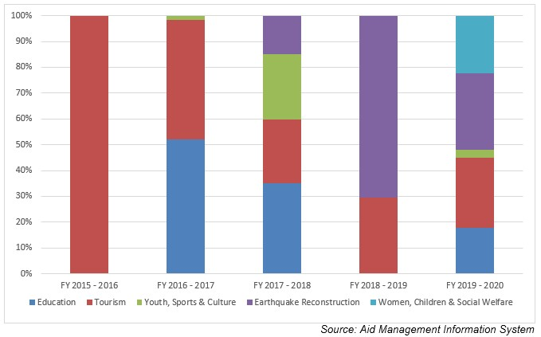
Disbursement during FYs 2016/17-2020/21 (in US$)
Over the last five-year beginning from FY 2016/17 to FY 2020/21, a total of US$ 2.6 million of support was disbursed to Nepal from UNESCO. The highest amount of annual support was disbursed in FY 2016/17, in the amount of US$ 1.5 million. Likewise, the lowest level of disbursement took place in fiscal year 2018/19 in the amount of US $ 0.19 million which is lower than the average annual disbursement of US $ 0.5 million.
UNESCO, over the last five-year period has agreed to provide a sum of US $ 3.2 million through 5 separate agreements. Its annual commitment was the highest in fiscal year 2015/16 with an amount of US $ 1.99 million whereas the lowest level of annual commitment of UNESCO support was US $ 0.09 million in fiscal year 2016/17.
Fiscal Year | Agreement Amount | Disbursement
2015/16 | 1,990,798 | 201,675
2016/17 | 533,005 | 1,592,269
2017/18 | 377,595 | 350,405
2018/19 | 98,501 | 192,327
2019/20 | 205,134 | 305,961
Source: Aid Management Information System
Note: The Agreement Amount is not comparable with disbursement because disbursement here accounts for disbursement of each fiscal year only, whereas Agreement Amount refers to the project cost over the period (not only for single fiscal year but also beyond).
Country Partnership Strategy
UNESCO advocates for education, building peace, alleviating poverty, and fostering sustainable development and intercultural dialogue in Nepal.
It works to attain quality education for all, focusing on women empowerment and literacy, to rehabilitate cultural heritage after the earthquake, promote cultural diversity and intercultural dialogue, to mobilize scientific knowledge, to promote press freedom, freedom of expression.
Updated
Forest and Environment Sector/ IECCDJanuary 2022
References
- UNESCO: https://en.unesco.org/
- UNESCO Office, Nepal: http://www.unesco.org/new/en/kathmandu/

[1] An advisory organization for the League of Nations which had aimed to promote international exchange between scientists, researchers, teachers, artists and intellectuals; established in 1922.

