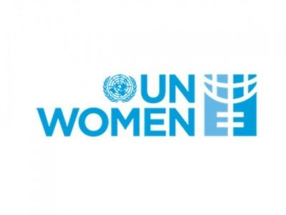 | United Nations Entity for Gender Equality and the Empowerment of Women
The UN Women Nepal Country Office was established in 2012. UN Women is mandated to be a lead driver and lead voice advocating for gender equality and women’s empowerment globally. UN Women in Nepal focuses on violence against women, leadership and participation and economic empowerment of women.
Organization
The United Nations Entity for Gender Equality and the Empowerment of Women, UN Women is a New York based UN organization established in July 2010 which became operational in January 2011. It works globally to make the vision of the Agenda 2030 and its Sustainable Development Goals (SDGs)[1]a reality for women and girls, standing behind women’s equal participation in all aspects of life.
Five key priority areas of UN Women are: expanding women’s leadership and political participation; ending violence against women; engaging women in all aspects of peace and security processes; enhancing women’s economic empowerment; and making gender equality central to national development planning and budgeting.[2]
UN Women is governed by a multi-tiered intergovernmental governance structure in charge of providing normative and operational policy guidance. The organization is led by an Under Secretary-General appointed by the Secretary-General in consultation with Member States, for a term of four years, with the possibility of renewal for one term.
UN Women implements programs in more than 90 countries in the world. Its funding comes from different donors either through governmental, organizational or individual contributions. In 2020, UNWOMEN received a total of US $ 548.6 million. This contribution consists of the contribution from Member States, business partners, philanthropists and individual donors.
Development Cooperation
The UN Women Nepal Country Office was established in April 2012 in Kathmandu, and received full Delegation of Authority in July 2013. The Country Office’s Strategic Note for 2018-2022 builds on lessons learned from past programming and adopts a holistic and integrated approach across its two thematic priorities, inclusive governance and leadership and women’s economic empowerment. Moreover, the Country Office explicitly pursues the objective of transforming discriminatory social norms and harmful practices.
The Strategic Note is guided by Nepal’s stated priorities, as described in Nepal’s Fourteenth Three-year Periodic Plan, and its commitments to relevant normative frameworks, the country’s United Nations Development Assistance Framework (UNDAF) for Nepal 2018-2022; the CEDAW[3] Concluding Observations 2011; as well as Agenda 2030 for Sustainable Development and UN Women’s Corporate Strategic Plan 2018-2021. The Country Office promotes national ownership, capacity development and institutionalization.
The Country Office seeks to advance women’s economic empowerment by promoting increased income security, better jobs and economic independence of vulnerable women. The Country Office is adopting a Communications for Development (C4D) approach to further mobilize awareness and action on transforming discriminatory social norms and harmful practices.
Major Support Sectors
The followings are the major support sectors of UN Women:
- Women, Children and Social Welfare
- Policy and Strategic
- Agriculture
- Home Affaires
- Education

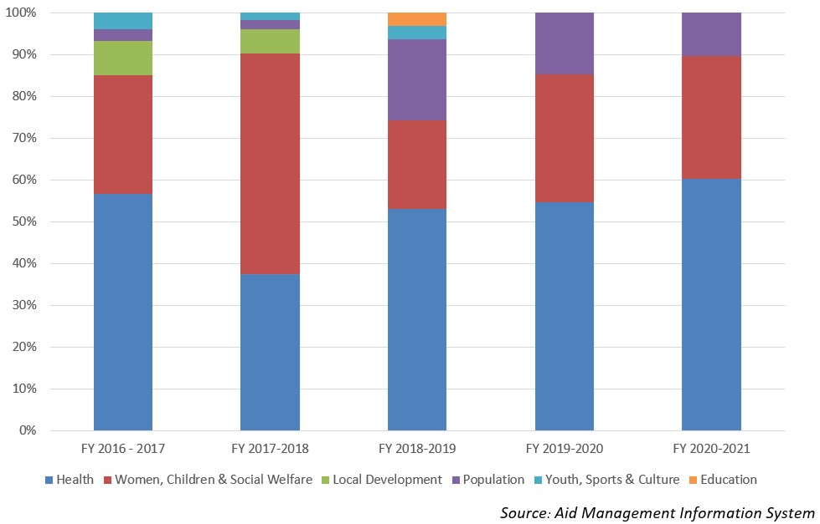
Disbursement during FYs 2016/17 to 2020/21 (in US$)
Over the period of five-year beginning from FY 2016/17 to FY 2020/21, UN Women’s Country Office in Nepal has disbursed US$ 5.2 million of ODA. The disbursement volume was highest with US$ 1.8 million in FY 2018/19. And the level of annual disbursement touched the lowest level in fiscal year 2017/18 with an amount of US$ 0.16 million. The average annual disbursement over the period stands at US $ 1 million during the last five year period.
The UN Women had agreed to provide a sum of US $ 7.5 million during the five year period through separate agreements with the government of Nepal. The highest level of annual commitment was made of US $ 2.2 million in fiscal year 2016/17 and the lowest level of commitment took place in 2019/20 at a level of US $ 0.33 million.
Fiscal Year | Agreement Amount | Disbursement
2015/16 | 1,710,858 | 1,108,091
2016/17 | 2,251,655 | 1,635,873
2017/18 | 2,187,659 | 164,984
2018/19 | 1,055,025 | 1,884,590
2019/20 | 333,472 | 413,472
Source: Aid Management Information System
Source: Aid Management Information System
Note: The Agreement Amount is not comparable with disbursement because disbursement here accounts for disbursement of each fiscal year only, whereas Agreement Amount refers to the project cost over the period (not only for single fiscal year but also beyond).
Country Partnership Strategy
Guided by UN Charter, the UN Women country office, Nepal works for the elimination of discrimination against women and girls; empowerment of women; achievement of equality between women and men as partners and beneficiaries of development, human rights, humanitarian action and peace and security.
The UN Women office in Nepal will provide substantive support to UN bodies working in Nepal on all aspects of gender equality issues. It is guided by CEDAW, BPfA and MDGs. UN Women in Nepal, will focus on the following key areas: i) Violence against women ii) Peace and security iii) Leadership and Participation iv) Economic Empowerment and v) National planning and budget.
Updated
Forest and Environment Sector/ IECCDJanuary 2022
References
- UN Women, headquarters, New York, USA: http://www.unwomen.org/en
- https://un.org.np/agency/un-women

[1] A set of 17 Sustainable Development Goals —as part of UN General Assembly Resolution A/RES/70/1 'Transforming our World: the 2030 Agenda for Sustainable Development' — were adopted in September 2015.
[2]More information about UN Women Strategic Plan priority areas is available at UN Women corporate website, http://www.unwomen.org/en/executive-board/documents/strategic-plan-2018-2021

[3] The Convention on the Elimination of all Forms of Discrimination against Women (CEDAW) is an international treaty adopted in 1979 by the UN General Assembly. Described as an international bill of rights for women, it was instituted on 3 September 1981 and has been ratified by 189 states.

