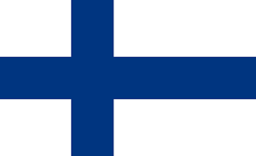 | Finland
Finland’s international Development Policy aims to support developing countries’ efforts to eradicate poverty and inequality. Nepal was among one of the ten biggest partner countries as a recipient of the funds in 2016.
Bilateral Relations
Nepal and Finland established diplomatic relations on 21 September 1974. The Finnish Embassy was opened in Kathmandu at the Chargé d’Affaires level in 1992. The Embassy was upgraded with the appointment of its Ambassador from September 2011.
Nepal has no residential Embassy in Helsinki. The Nepalese Embassy in Copenhagen is concurrently accredited to Finland. At present Mr. Pertti Anttinen is Finland’s Ambassador to Nepal (November 2021).
Development Cooperation
Finnish cooperation with Nepal commenced in 1982 with grant assistance of 6,000 MT of chemical fertilizers. Presently Nepal is one of Finland’s primary long-term development partner countries.
The Finnish development program in Nepal focused mainly on energy, forestry and water resources. Nepal has also received assistance from Finland for the detailed engineering design of the Kali Gandaki Hydropower Project, rural electrification, and the multi-fuel diesel plant.
According to the Country Strategy for Development Cooperation Nepal 2016-2019, Finland’s focus of support to Nepal is on access to clean drinking water and sanitation, developing education, and improving the influence of women and other vulnerable groups.
More recently, Finnish development cooperation has shifted towards a focus on alleviation of poverty, environmentally sustainable development, disaster risk reduction, and the promotion of democracy, human rights and a participatory system of governance.
Finnish Major Support to Nepal by Sector
Major sectors of economy supported by the Finnish aid during the last five years are:
- Education
- Local Development
- Women, Children and Social Welfare
- Labor
- General Administration
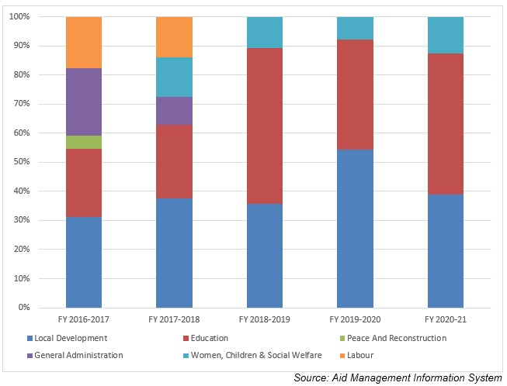
Finnish Aid Disbursement during FYs 2016/17 – 2020/21 (in US $)
Over the last five year period beginning from FY 2016/17 to FY 2020/21, a total of over US$ 59.0 million of Finnish ODA was disbursed to Nepal. The highest level of aid disbursement from Finnish Government was made in fiscal year 2019/20 amounting to US $ 13.9 million.
The average annual disbursement of the last five year period is US $11.8 million. During the last five year period Finland agreed to provide US $ 12.0 million to Nepal. The least amount of agreement was made of an amount of US $ 10 thousand in fiscal year 2017/18 whereas no events of agreement took place in fiscal year 2019/20. There is no direct relationship between the fiscal year, agreement amount and the disbursement amount.
Fiscal Year | Agreement Amount | Disbursement
2016/17 | 2,701,810 | 9,520,502
2017/18 | 10,000 | 12,779,120
2018/19 | 4,562,000 | 10,615,868
2019/20 | 0 | 13,910,781
2020/21 | 4,825,920 | 12,202,386
Source:Aid Management Information System
Note: The Agreement Amount is not comparable with disbursement because disbursement here accounts for disbursement of each fiscal year only, whereas Agreement Amount refers to the project cost over the period (not only for single fiscal year but also beyond).
Development Cooperation Strategy
Local development is one of the highest priority sectors of cooperation during the decade followed by the education sector. Finland’s contribution to RWSSP-WN II is 13.7 million euros for 2013-2019.
RVWRMP III (2016-2022) covers 10 districts in Provinces 6 and 7, aims to achieve universal access to basic WASH services, and improved livelihoods with the establishment of functional planning and implementation frameworks for all water users and livelihoods promotion in the project area.
Finland supports two programs: the School Sector Development Programme (SSDP) and the Technical Assistance for Soft Skills Development (TASS). Finland’s contribution to SSDP is 20 million euros for 2016-2020 and to TASS-project 1.7 million euros for 2016-2019.
Updated
Social Sector/ IECCDJanuary 2022

