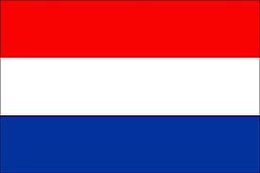 | The Netherlands
The Netherlands is committed at European level to collectively achieve a 0.7% ODA/GNI ratio by 2030. Geographically, Dutch development assistance is concentrated on sub-Saharan Africa and low-income countries.
Bilateral Relations
Nepal and the Netherlands established diplomatic relations in April 1960. The Netherlands Consulate in Nepal is located in Jawalakhel, Lalitpur. The Embassy of Nepal in Belgium is concurrently accredited to the Netherlands and the Netherlands Embassy in New Delhi is accredited to Nepal.
Development Cooperation
The Government of the Netherlands provides ODA to Nepal including other developing countries through SNV Netherlands Development Organization which opened its first Asia office in Nepal in 1980.
Economic cooperation between the two countries started earlier, in 1976, with the involvement of Dutch volunteers (technicians/engineers) to assist in various development sectors.
In 1983, Nepal and the Dutch government signed an agreement on the employment of Dutch volunteers for economic development and cooperation. The Biodiversity Sector Support Program (BSSP) was one of the major projects funded by SNV Nepal.
Major Support of the Netherlands to Nepal by Sector
The followings are the major sectors of Dutch support to Nepal during the last five-year period.
- Drinking water
- Energy
- Environment, Science and Technology
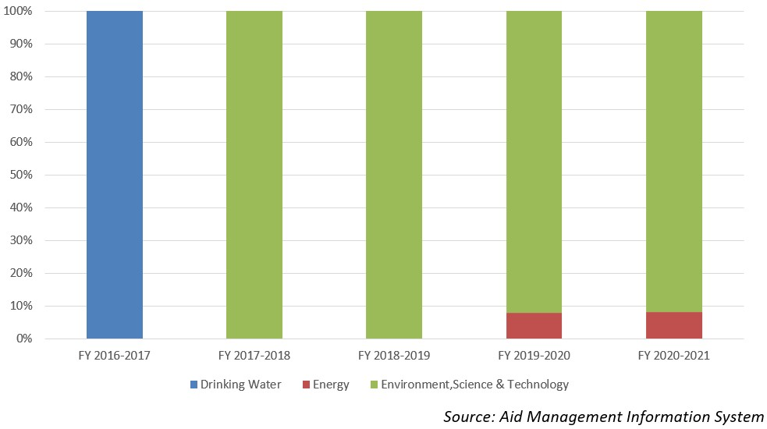
The Netherlands’ aid disbursement during FYs 2016/17-2020/21 (in US$)
Over the last five-year period beginning from FY 2016/17 to FY 2020/21, the Netherlands has disbursed US$ 3.77 million aid to Nepal. The highest annual disbursement was of US $ 1.4 million disbursed in fiscal year 2018/19. The average annual disbursement over the last five-year was US $ 0.75 million.
During the said five year period the Netherlands has agreed to provide financial support of US $ 3.15 million through five separate agreements. The highest level of annual commitment was made of US $ 1.2 million in 2020/21. There is not direct relationship between the commitment and the disbursed amount though amount disbursed are solely based on commitment.
Fiscal Year | Agreement Amount | Disbursement
2016/17 | 303795 | 303,795
2017/18 | 42,141 | 42,141
2018/19 | 679,125 | 1,478,866
2019/20 | 919,355 | 623,176
2020/21 | 1,215,501 | 1,322,302
Source: Aid Management Information System
Note: The Agreement Amount is not comparable with disbursement because disbursement here accounts for disbursement of each fiscal year only, whereas Agreement Amount refers to the project cost over the period (not only for single fiscal year but also beyond).
Development Cooperation Strategy
SNV Nepal programs are aligned with the development priorities of the Government of Nepal. In collaboration with the Government of Nepal and the International Fund for Agriculture Development, the Government of the Netherlands has also supported the High Value Agriculture Project (2010-2017).
In addition to domestic biogas, SNV, together with the Bank of Kathmandu, launched Biogas for Business (B4B) in 2012. It targeted support for the installation of medium to large scale biogas plants for waste management, energy production and production of organic fertilizer.
Updated
Social Sector/ IECCDJanuary 2022

