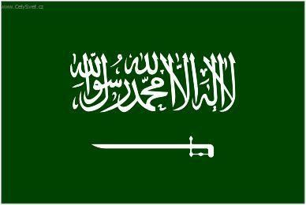 | Saudi Arabia
Saudi Arabia possesses 25% of the world’s proven petroleum reserves. It ranks as the largest exporter of petroleum and plays a leading role in OPEC. The petroleum sector accounts for roughly 75% of budget revenues, 45% of GDP, and 90% of export earnings.
Bilateral Relations
Nepal and the Kingdom of Saudi Arabia established their diplomatic relations on 15 March 1977. Nepal’s then-Prince Gyanendra visited Saudi Arabia on an official visit in 1983. Similarly, Prince Alwaleed Bin Talal Bin Abdulaziz Alsaud visited Nepal in November 2010.
Saudi Arabia maintains its Embassy at Maharajgunj, in Kathmandu. Mr. Abdulnaser bin Husien Al-Harthi is the present (December 2021) Saudi Arabian Ambassador to Nepal.
Development Cooperation
Economic cooperation between the two countries began in 1978 when Nepal opened its Embassy in Jeddah, Saudi Arabia. The economic cooperation extended by the Saudi Arabian Government in Nepal initially focused on uplifting the Muslim community, agricultural development and emergency assistance.
The assistance to Nepal from Saudi Arabia is currently being provided through the Saudi Fund for Development (SFD). The SFD is an official agency for development cooperation established by Royal Decree in 1974.
SFD commenced operations in 1975 with the objective of participating in the financing of development projects in developing countries through the granting of loans and encouraging national non-crude-oil exports. SFD operates from a capital base provided by the Government of Saudi Arabia.
Saudi Arabia provided emergency food assistance during FY 1982/83. For the rehabilitation of the earthquake victims, the SFD provided 1,380 units of tents and over 3,000 packages of foods, as well as a cash grant of US$ 1 million for the procurement of equipment.
Saudi Arabia’s Major Support to Nepal by Sector
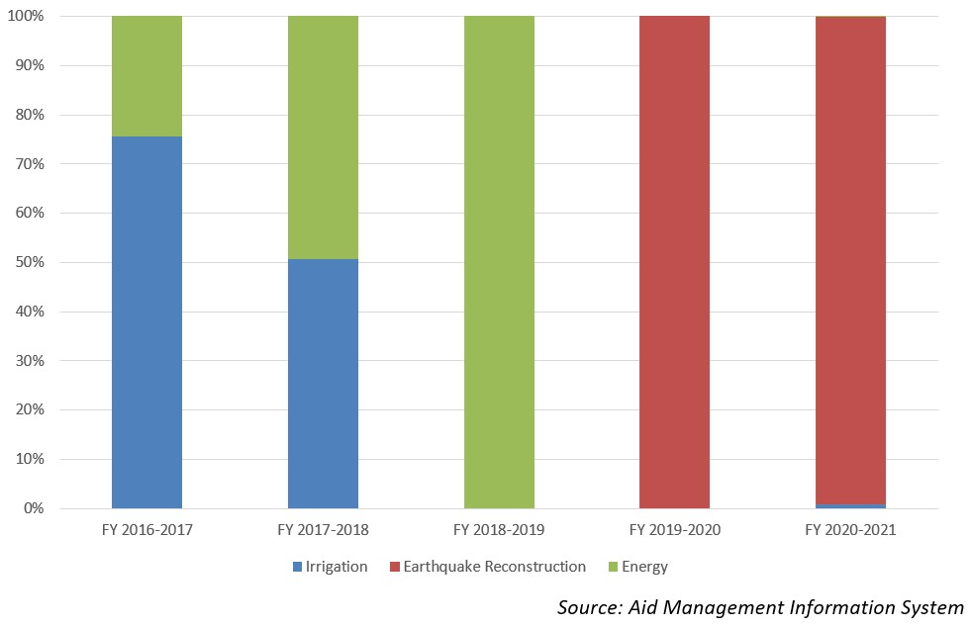
Disbursement from SFD during FYs 2016/17 to 2020/21 (in US$)
Over the last five-year period beginning from FY 2016/17 to FY 2020/21, SFD has disbursed a total of US $ 23 million. In terms of the volume of the disbursement the highest disbursement was of US $ 16.7 million in fiscal year 2020/21 whereas the lowest disbursement was limited to US $ 0.16 million in fiscal year 2017/18 which is less than the average annual disbursement of US $ 4.6 million during the five-year period.
Over the five-year period, SFD and GoN had an agreement of financial cooperation of US $ 29.1 million once in fiscal year 2020/21. There is no direct relationship between financial agreement amount and the disbursed amount though all the disbursed amount are based on agreed commitment.
Fiscal Year | Agreement Amount | Disbursement
2016/17 |  | 2,382,612
2017/18 |  | 168,108
2018/19 |  | 568,013
2019/20 |  | 3,110,778
2020/21 | 29,163,542 | 16,768,405
Source: Aid Management Information System

Note: The Agreement Amount is not comparable with disbursement because disbursement here accounts for disbursement of each fiscal year only, whereas Agreement Amount refers to the project cost over the period (not only for single fiscal year but also beyond).
Development Cooperation Strategy
SFD provides untied concessional loan which has no specific geographical or sectoral limitations. Nepal has been utilized SFD loan for the development of infrastructure such as power generation, road construction and irrigation development.
Loans extended by SFD carry a 15-25 year repayment period and a loan charge of 2-5% interest, depending upon the nature of the loan. The Saudi Charter allows the SFD to finance up to 50% of the project costs.
Updated
Agriculture and Industry Sector/ IECCDJanuary 2022

