Switzerland
Switzerland has one of the most competitive economies with one of the highest gross domestic product (GDP) per capita in the world. It has also a long tradition of international assistance, especially in humanitarian aid.
Bilateral Relations
Switzerland and Nepal established diplomatic relations in 1956. On the occasion of 50 years of development cooperation between the countries, the Government of Switzerland opened its Embassy in Nepal in 2009. Similarly, Nepal also opened its residential Embassy in Geneva, Switzerland. At present, Ms Elisabeth von Capeller is Swiss Ambassador to Nepal (November 2021).
Development Cooperation
The first cooperation initiative was in the field of cheese and diary development from 1956-1964. The construction of the Lamosanghu-Jiri Road, during 1974-1985 facilitated the transfer of knowledge of mountain road construction acquired over long experience in the Swiss Alps.
Since 1963 Nepal has been a priority country for Swiss development cooperation. Switzerland works closely with local authorities, other donors, and international organizations in Nepal. Its key partners include Helvetas Swiss Inter-cooperation, AF-ITECO AG, Swiss Contact.
Switzerland also works with multilateral organizations such as the World Bank, the Asian Development Bank and the International Centre for Integrated Mountain Development (ICIMOD). In the aftermath of catastrophic earthquake of 2015, the Swiss Humanitarian Aid in coordination with development cooperation actively supported the Government of Nepal
Swiss Major Support to Nepal by Sector
The followings are the top five sectors of Swill development cooperation in Nepal during the last five-year period.
- Agriculture
- Local Development
- Education
- Labor
- Road Construction
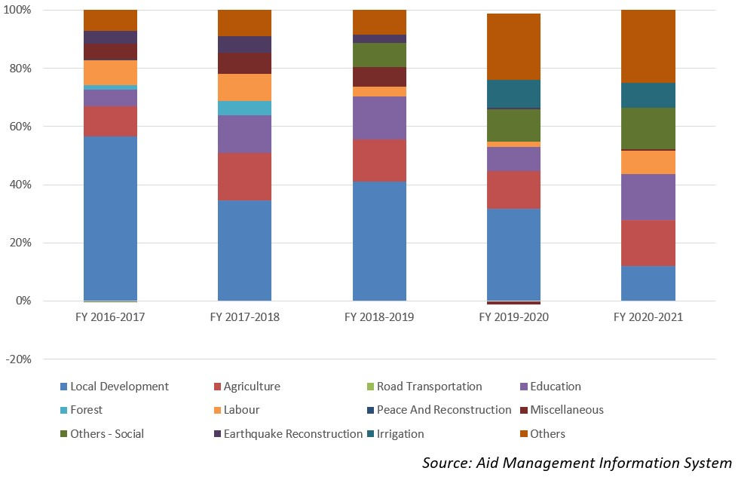
Swiss Aid Disbursement during FYs 2016/17-2020/21 (in US$)
During the last five-year period beginning from FY 2016/17 to FY 2020/21, the total Swiss aid disbursement stands at US $ 147.3 million. The highest level of disbursement, with a total amount of US$ 36.7 million took place in FY 2019/20.The average annual disbursement of the Swiss aid stands at US $ 29.4 million, during the last five year.
Regarding the financial cooperation agreement between the two countries, a sum of US $ 128.5 million aid was committed by the Switzerland Government in the last five-year period. In fiscal year 2017/18, both the nations did not conclude any financial cooperation agreement.
Fiscal Year | Agreement Amount | Disbursement
2016/17 | 24,713,653 | 34,941,429
2017/18 |  | 26,412,734
2018/19 | 24,648,289 | 25,880,596
2019/20 | 76,266,402 | 36,734,500
2020/21 | 27,667,089 | 24,397,709
Source: Aid Management Information System
Note: The Agreement Amount is not comparable with disbursement because disbursement here accounts for disbursement of each fiscal year only, whereas Agreement Amount refers to the project cost over the period (not only for single fiscal year but also beyond).
Development Cooperation Strategy
The Swiss cooperation strategy Nepal (2018-2021) has stipulated the objectives that women and men benefit from equitable socio-economic development and exercise their rights and responsibilities in an inclusive federal state. The Swiss government has earmarked CHF 130 million (equivalent to Rs. 14.7 billion) of disbursement during the four year period.
The areas of Swill involvement to achieve the overall goals are: i) all people at subnational level build an inclusive and accountable federal state, ii) the women and men, especially from disadvantaged groups, find employment and increase their income and iii) the migrants and their families are better protected by democratic institutions in Nepal and benefit from decent work conditions abroad.
Updated
Social Sector/ IECCDJanuary 2022

