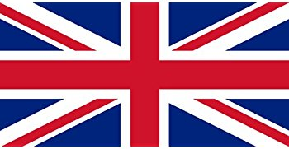 | United Kingdom
The UK Government is legally required to spend 0.7% of Gross National Income (GNI) on ODA. In 2020, the UK is the third largest donor in ODA behind the USA and Germany according to the Organization for Economic Co-operation and Development (OECD).
Bilateral Relations
The history of official relations between the UK and of Nepal dates back to 1816. Relations between the two countries grew with a Treaty of Perpetual Peace and Friendship which was signed in 1950.
The UK was the first country in the world with which Nepal established diplomatic relations and was also the first country to establish an Embassy in Kathmandu. Nepal had established its legation in London in 1934, which was elevated to the Ambassador level in 1947.
The UK has been offering fellowships to the Government of Nepal since the 1950’s, and British volunteers have been engaged in Nepal since 1964. The UK has been maintaining the British Embassy in Lainchaur, Kathmandu. Ms. Nicola Pollitt is serving as the British Ambassador to Nepal at present (November 2021) .
Development Cooperation
To support the development endeavor of Nepal, in April 1999 DFID established an in-country office staffed by a multi-disciplinary team of both UK nationals and staff appointed in country.
During FY 2015/16, foreign direct investment commitment from the UK stood at US$ 128.3 million, according to Nepal’s Department of Industry. An agreement for the promotion and protection of investment between Nepal and the UK was signed in March 1993.
Nepal has received generous support and assistance from the UK, especially in the aftermath of the devastating earthquakes of 2015 that claimed over 9,000 lives. The UK Government responded to the Nepal earthquakes immediately with the deployment of eight disaster response specialists under the Rapid Response Facility releasing US$ 6.55 million. It later pledged an additional US$ 110 million for the reconstruction and rebuilding of Nepal.
UK Government’s Major Support to Nepal by Sector
Over the last five-year period the UK Government has supported Nepal mainly in the following 5 sectors.
- Education
- Earthquake Reconstruction
- Economic Reform
- Health
- Home Affairs
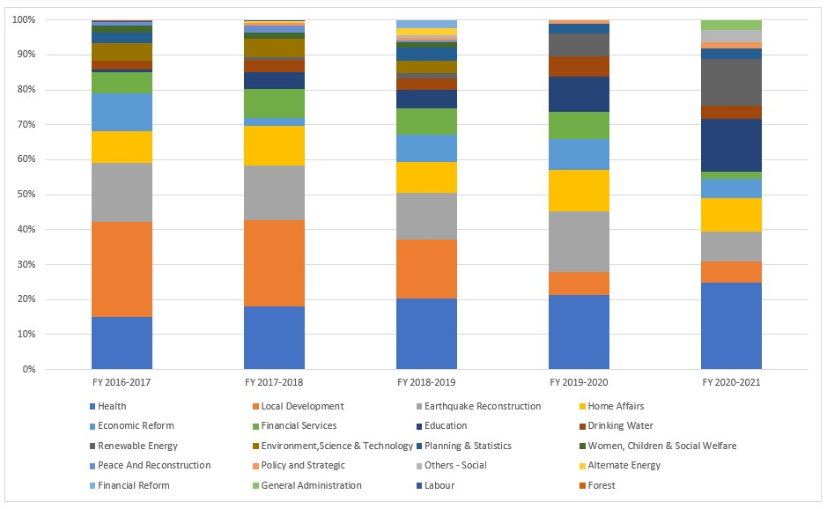
UK ODA disbursement during FYs 2016/17-2020/21 (in US$)
Over the last five-year period beginning from FY 2016/17 to FY 2019/20, the UK Government has disbursed US$ 548.6 million of ODA to Nepal. The highest level of annual disbursement of ODA took place in fiscal year 2016/17 with an amount of US $ 128 million. Likewise, in fiscal year 2020/21, ODA disbursement of US $ 83.9 million took place which is less than the annual average disbursement of UK ODA of US$ 109.7 million.
During the last five-year period the government of UK has agreed to provide assistance of US $ 473 million through different agreements. The highest level of support agreement was concluded in fiscal year 2016/17.
Fiscal Year | Agreement Amount | Disbursement
2016/17 | 371,023,684 | 128,313,164
2017/18 | 8,843,418 | 123,870,280
2018/19 | 19,693,407 | 117,238,011
2019/20 | 44,875,034 | 95,227,536
2020/21 | 28,742,392 | 83,974,701
Source: Aid Management Information System
Note: The Agreement Amount is not comparable with disbursement because disbursement here accounts for disbursement of each fiscal year only, whereas Agreement Amount refers to the project cost over the period (not only for single fiscal year but also beyond).
Development Cooperation Strategy
UK intends to support Nepal’s economic growth and economic inclusion so as to help increase incomes and access to finance for 650,000 rural poor people by 2021. The UK’s technical assistance is helping to harness FDI for large industrial projects such as hydro power generation to create an environment that is conducive to business and investments.
The UK supported the Strengthening Disaster Resilience and Responding to Humanitarian Emergencies in Nepal (US$ 60.2 million) and Climate Smart Development Program (US$ 59.6 million).
UK-support strategies include Accelerating Investment and Infrastructure in Nepal (AIIN) (US$ 9.7 million), UK/Nepal-Support to Nepal Health Sector Program III (NHSP) (US$ 8.6 million), Nepal Market Development Program (US$ 6.4 million) and Access to Finance for the Poor Program (US$ 6.1 million).
Updated
Social Sector/ IECCDJanuary 2022

